
UNIVERSITY EXAMINATIONS
EXAMINATION FOR SEPTEMBER/DECEMBER 2023/2024 FOR BACHELOR OF SCIENCE IN COMPUTER SCIENCE/BACHELOR OFBUSINESS IN INFORMATION TECHNOLOGY
RCS 102 OBJECT-ORIENTED PROGRAMMING
DATE: DECEMBER 2023 TIME: 2 HOURS
GENERAL INSTRUCTIONS:
Students are NOT permitted to write on the examination paper during Exam time.
This is a closed book examination. Text book/Reference books/notes are not permitted.
SPECIAL INSTRUCTIONS:
This examination paper consists Questions in Section A followed by section B.
Answer Question 1 and any Other Two questions.
QUESTIONS in ALL Sections should be answered in answer booklet(s).

PLEASE start the answer to EACH question on a NEW PAGE.

Keep your phone(s) switched off at the front of the examination room and NOT on your person.

Keep ALL bags and caps at the front of the examination room and DO NOT refer to ANY unauthorized material before or during the course of the examination.

ALWAYS show your working.

Marks indicated in parenthesis i.e. ( ) will be awarded for clear and logical answers.

Write your REGISTRATION No. clearly on the answer booklet(s).

For the Questions, write the number of the question on the answer booklet(s) in the order you answered them.
- Write your REGISTRATION No. clearly on the answer booklet(s).
- DO NOT use your PHONE as a CALCULATOR.
- YOU are ONLY ALLOWED to leave the exam room 30minutes to the end of the Exam.

SECTION A (Compulsory-30 MARKS)
QUESTION ONE (30 MARKS)
- Differentiate the following terms as used in Java.
    - Protected class and private variable (3 marks)
    - Instance method and Static Method (2 marks)
    - Base class and Derived class (2 marks)
    - Super and this (2 marks)
- State whether each of the following is true or false. If false, explain why.
- Methods declared public in a super class also must be public in all sub classes. (1mark)
- Methods declared protected in a super class must either be protected or public in sub classes and they cannot be private. • (1mark)
- Methods declared private are not inherited at all. (1mark)
- A constructor is a special method that does not return a type. (1mark)
- When a private modifier is used with instance variables getter and setter methods are used to read and write the memory location respectively. (1mark)
- When interfaces are communicating with classes they can do so using the keyword implement . (1mark)
- Final is a keyword that can be used with a class to signify that the class should remain as it is without any change (1mark)
- Extends is a keyword that can be used to demonstrate inheritance between two or more Interfaces. (1mark)
- The access specifiers used with classes are private, protected, and public. (1mark)
- In Java, memory locations created for the Users interact with at run time can do so without an object. (1mark)

- Study the portion of program below and answer the questions that follow
- public class Mpesa {
- public static void main(String[ ] args) {
- Scanner input=new Scanner(System.in);
- int options=input.nextInt();
- switch (options){
- case 1:
- SendMoney sendMpesaMoney=new SendMoney();
- sendMpesaMoney.sendMoney();
- break;
- case 2:
- WithdrawCash withdrawMpesaMoney=new WithdrawCash();
- withdrawMpesaMoney.withdrawcash( );
- break;
- default:
- System.out.println("No other option is available for now\n");
- break;
- }
- }

    - Outline the appropriate name to give to our file for the program above to run if we have to use any integrated development environment? (1 mark)
    - Identify the number of classes present in the program. (1mark)
    - From question (ii) above name the classes you have identified. (5marks)
    - State the purpose of the Scanner in the program. (2marks)
    - Outline the name of the objects that have been used in the program.. (2marks)
SECTION B (Answer Any TWO questions -30 MARKS)
QUESTION TWO (15 MARKS)
- State whether the following is a class name,Keyword, method name, variable or invalid. (9marks)
    - printsummary
    - totalMarks
    - throw
    - synchronize
    - System
    - Program-Flow-
    - total marks.
    - PrintSummary
    - Class.
- Assuming that x is -2 show the result of the following Boolean expressions.
(6marks)
        - (true) && (10 > 4)
        - (x > 0) | | (x < 0)
        - (x >= 0) | | (x < 0)
        - (x != 1) = = !(x = = 1)
        - !(x > 0) && (x > 0)
        - (x != 0) | | (x == 0)

QUESTION THREE (15 MARKS)
- As a developer you have been called upon to help identify the appropriate object that the compiler and interpreter would use in a, b, c and d. Give the reason for your answer. (8marks)
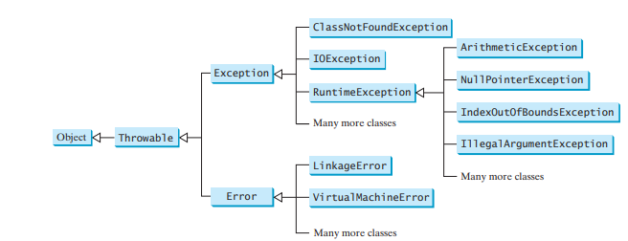

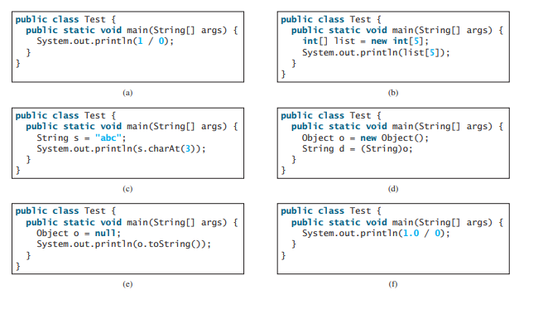
- As a Consultant in Programming you have been contracted to create the mpesa part of the entire project.Write program that instructs a user to enter the phone number they are sending money to and the amount. The program should be able to tell the user if the money is enough to send. If the money is not enough, it should notify the user that they have insufficient funds to transact. (7marks)
QUESTION FOUR (15 MARKS)
- State whether the following statements are true or false. If false state why.
  - To achieve encapsulation in Java one can create public setter and getter methods to modify and view the variables values. (1mark)
  - You cannot instantiate an abstract class. (1mark)
  - A class can extend more than one class, but implement many interfaces. (1mark)
  - The terms throw and throws in Java programming are the same. (1mark)
  - A signature of a method contains a return type, method name and parameters (1mark)
- Below is a snippet of a program. State the purpose of the snippet and convert it to use do while loop. (4marks)
int sum = 0;
System.out.println ("Enter an integer”);
int number = input.nextInt( );
while (number != 0) {
sum += number;
System.out.println("Enter an integer " );
number = input.nextInt( );
}
- Use a for loop structure to translate the snippet in question 4b. (4marks)
- Rewrite the following conditional expressions using if-else statements.
- score = (x > 10) ? 3 * scale : 4 * scale; (2marks)

QUESTION FIVE (15MARKS)
- Create an interactive program that allows a student to calculate the total marks and the average mark for 10 subjects they have done in a semester. Use an array and any loop of your own choice. (10marks)
- State whether each of the following is true or false. If false, explain why.
    - By convention, method names begin with a lowercase first letter, and all subsequent words in the name begin with a capital first letter. (1mark)
    - An import declaration is not required when one class in a package uses another in the same package. (1mark)
    - Arguments in parentheses following a method name in a method declaration indicate that the method requires parameters to perform its task. (1mark)
    - Methods overloading is the ability of a method to behave in various forms in the program. (1mark)
    - Variables declared in the body of a particular method are known as instance variables and can be used in all methods of the class . (1mark)

