
UNIVERSITY EXAMINATIONS
EXAMINATION FOR MAY-AUGUST 2023/2024 DIPLOMA IN INFORMATION & CYBER SECURITY
RCS 024: WEB DEVELOPMENT
DATE: 16th AUGUST 2024 TIME: 2 HOURS
GENERAL INSTRUCTIONS:
Students are NOT permitted to write on the examination question paper during exam time.
This is a closed book examination. Text book/Reference books/notes are not permitted.
SPECIAL INSTRUCTIONS:
This examination paper consists Questions in Section A followed by section B.
Answer Question 1 and any Other Two questions.
QUESTIONS in ALL Sections should be answered in answer booklet(s).

PLEASE start the answer to EACH question on a NEW PAGE.

Keep your phone(s) switched off at the front of the examination room.

Keep ALL bags and caps at the front of the examination room and DO NOT refer to ANY unauthorized material during the course of the examination.

ALWAYS show your working.

Marks indicated in parenthesis i.e. ( ) will be awarded for clear and logical answers.

Write your REGISTRATION No. clearly on the answer booklet(s).

For the Questions, write the number of the question on the answer booklet cover page in the order you answered them.
- DO NOT use your PHONE as a CALCULATOR.
- YOU are ONLY ALLOWED to leave the exam room 1hour to the end of the Exam.
- DO NOT write on the QUESTION PAPER. Use the back of your BOOKLET for any calculations or rough work.

SECTION A (COMPULSORY)
QUESTION ONE (30 Marks)
- Differentiate between Local Area Network and Wide Area Network. [2 Marks]
- Explain the following CSS selector options
- Name selector
- ID selector
- Class selector [3 Marks]
- Write a JavaScript user-defined function Multiply, that multiplies two numbers and returns the results. [5 Marks]
- Explain Four benefits of using internet. [4 Marks]
- Differentiate between front-end and back-end part of a web application. [2 Marks]
- Explain the following stages during a web application development
- Analysis,
- Design,
- Development,
- Testing and review,
- Deployment,
- Maintenance [6 Marks]
- Highlight Four key sections of a HTML page structure [4 Marks]
- Explain the effect of each of the following CSS script on a form’s input elements.
input {
width: 100%;
border: 2px solid blue;
background-color: red;
font-size: 12px;
} [4 Marks]
SECTION B (Answer ANY Two Questions)
QUESTION TWO (15 marks)
- Explain the use of the following tags as used in HTML
- <h1>
- <p>
- <br>
- <hr>
- <img> [5 Marks]
- Differentiate between internet and world wide web. [2 Marks]
- Define the following nested list using the appropriate html tags.
- Engineering Courses
- Mechanical engineering
- Electronic engineering
- Business Courses
- Business management
- Business Accounting [6 Marks]
- Differentiate between cell padding and cell spacing as used in HTML [2 Marks]
QUESTION THREE (15 Marks)
- Highlight five benefits of implementing an intranet in an organization. [5 Marks]
- Define the following table using the appropriate html tags
Patient Admission Records
Patient Name | Reg No. | Age | Gender
Abdi | P0001 | 20 | Male
Jackson | P0002 | 19 | Female
Alice | P0003 | 22 | Male
[5 marks]
- Explain the following attributes of form’s input elements.
- Readonly
- Autofocus
- Required
- Placeholder
- Multiple [5 Marks]
QUESTION FOUR (15 Marks)
- Differentiate between relative path name and absolute path name. [2 Marks]
- List Six input elements that can be used on a HTML form. [6 Marks]
- Explain the following methods of inserting a style sheet
- Internal
- External [2 Marks]

- Explain the outcome of each of the following CSS statements
table, th, td { border: 5px dotted blue; }
form { widht: 50%; }
p { text-align: right; color : red; } [3 Marks]
- Write a JavaScript statement that displays your first name on a heading 4 element that has an ID Fname [2 Marks]

QUESTION FIVE (15 Marks)
- Highlight any Three JavaScript events [3 Marks]
- Explain Three risks that internet users can be exposed. [3 Marks]
- Differentiate between Uniform resource locator and Domain name server [2 Marks]
- Write a HTML code that can generate the following form
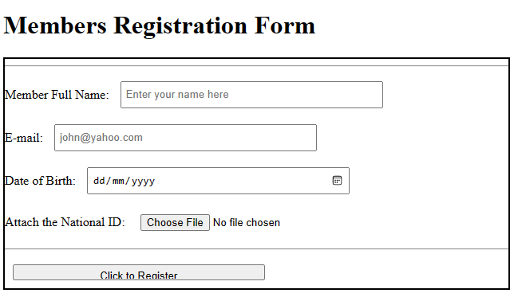
[7 Marks]

