

RIARA SCHOOL OF INTERNATIONAL RELATIONS & DIPLOMACY
NURTURING INNOVATORS
SEPTEMBER –DECEMBER 2023 TRIMESTER
EXAMINATIONS FOR BACHELOR / DIPLOMA OF ARTS IN INTERNATIONAL RELATIONS & DIPLOMACY
DAY / EVENINGPROGRAMME
RIR 104 A: INTRODUCTION TO ARABIC LANGUAGE

DATE: 28TH NOVEMBER 2023 TIME: 2 HOURS

GENERAL INSTRUCTIONS:
Students are NOT permitted to write on the examination paper during reading time.
This is a closed book examination. Text book/Reference books/notes are not permitted.

SPECIAL INSTRUCTIONS:
1 Write your REGISTRATION NO. Clearly on the answer booklet(s).
2 Answer Question One and ANY other TWO questions.
3 Questions in all sections should be answered in answer booklet(s).
4 Marks allocated to each question are shown at the end of the question.
5 PLEASE start the answer to EACH question on a NEW PAGE.
6 For the questions, write the number of the question on the answer booklet(s) in the order you answered them.
7 Write your answers in paragraph form unless stated otherwise.
8 Keep your phone(s) SWITCHED OFF at the front of the examination room.

9 Keep ALL bags and caps at the front of the examination room and do not refer to any unauthorized material before or during the course of the examination.
10 You are only allowed to leave the examination room 30minutes to the end of the Examination.

1
ANSWER question ONE and any other TWO QUESTIONS أجب عن خمسة أسئلة فقط
- (a) Discuss significance of studying Arabic Language for international relations students (20 marks)
1 b) – Write the following numbers and figures using Arabic script ?10mks.
- 1202223
- 12/12/2023
- 8642
- 21229124 …………………………………………….
- 0789375611
- 786110 ……………………………………………
- 1445 …………………………………………….
- 8642 ………………………………………………
- 492357816
- 12/06/2007

Q:2 : demonstrate your understanding of the Alqamariyyah and asshamsiyyah letters by writing a word with each letter in each category (20 marks)

Q 3 (a). Demonstrate your understanding of the three short Arabic vowels by writing TWO 3 letter word using each one of them in Arabic in the spaces provided and transliterate the words 6 marks
The vowel | Word in Arabic | Transliterated word
Fatha
Kasra
Dhammah

Q 3 (b). Demonstrate your understanding of the three long Arabic vowels by writing 3 letter word using each one of them in Arabic in the spaces provided and transliterate the words (6 marks)

The long vowel | Word in Arabic | Transliterated word
Alif
Waaw
Yaa/ ali maqswuurah

Q 3 c) discuss the work of three long vowels in Arabic (8 marks)
Q: 4 a) – construct twelve sentences using the personal pronouns in Arabic (12 marks)
Q: 4 b) – demonstrate your comprehension skills in Arabic by answering the following questions (8 marks)

محمد: السلام عليكم
محمد : كيف حالك ؟
محمد : ما إسمك ؟
محمد: من اين انت؟
محمد: :كم عمرك؟
محمد : مع السلامة
5. translate the following composition (20 marks)

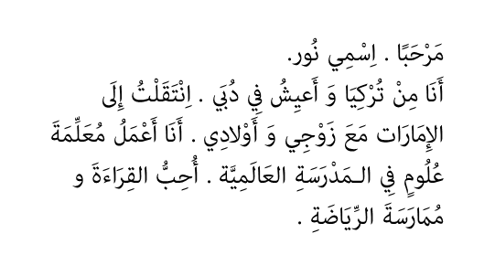
6. a) list the demonstrative articles in Arabic ( 4 marks)

b) construct 8 sentences using the above demonstrative articles (8 marks)

Q 6 a)- – Join the following letters to form Words? 8 marks
1- ك + ت + ا + ب =------------------
2- ط + ا + ل + ب = ----------------
3- م + س + ج + د = ----------------
4- م + ع + ل + م =-------------------
5- ق + ل + م = ------------------
6- ج + ا + م + ع + ة = ----------------
7- ب + خ + ي + ر = ------------------
8- م+ ك + ت + + ب +ة =------------------

