
UNIVERSITY EXAMINATIONS
EXAMINATION FOR MAY/AUGUST 2022/2023 FOR DIPLOMA IN COMPUTER SCIENCE / INFORMATION TECHNOLOGY

RCS 012/ RCT 004: DATA STRUCTURES AND ALGORITHM

DATE: 10TH AUGUST, 2023 TIME: 2 HOURS

GENERAL INSTRUCTIONS:
Students are NOT permitted to write on the examination paper during exam time.
This is a closed book examination. Text book/Reference books/notes are not permitted.
SPECIAL INSTRUCTIONS:
This examination paper consists Questions in Section A followed by section B.
Answer Question 1 and any Other Two questions.
QUESTIONS in ALL Sections should be answered in answer booklet(s).

PLEASE start the answer to EACH question on a NEW PAGE.

Keep your phone(s) switched off at the front of the examination room.

Keep ALL bags and caps at the front of the examination room and DO NOT refer to ANY unauthorized material before or during the course of the examination.

ALWAYS show your working.

Marks indicated in parenthesis i.e. ( ) will be awarded for clear and logical answers.

Write your REGISTRATION No. clearly on the answer booklet(s).

For the Questions, write the number of the question on the answer booklet(s) in the order you answered them.
- DO NOT use your PHONE as a CALCULATOR.
- YOU are ONLY ALLOWED to leave the exam room 30minutes to the end of the Exam.
- DO NOT write on the QUESTION PAPER. Use the back of your BOOKLET for any calculations or rough work.

SECTION A (COMPULSORY)

QUESTION ONE (30 marks)
- Define (5 marks)
- Traversal
- AVL Tree
- Pointer Variable
- Stack Underflow
- Asymptotic Analysis of Algorithms

- Describe the sequence when you traverse the following tree. (6 marks)
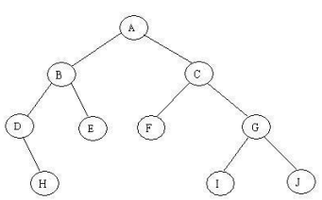
- Inorder
- Preorder
- Postorder

- What is the order of the following growth functions? (2 marks)
- 9x² + 7x + 12
- 8x + 3x³

- Analyse the worst-case behaviour of Quicksort and discuss possible ways of improving it. (4 marks)

- With examples, enumerate four ways in which algorithms can be represented.
(2 marks)

- What is the worst case time complexity of linear search algorithm? (2 marks)

- Differentiate between simple ADTs and Complex ADTs. Give examples. (4 marks)

- Develop an algorithm that helps a humanoid robot learn his environment and find an exit of a room. (3 marks)

- Compare standard Tri with Compressed Tri. (2 marks)

SECTION B (Answer ANY Two Questions)

QUESTION TWO (15 marks)
- Define (3 marks)

- Amortized Analysis
- Backtracking
- Greedy algorithms

- Discuss dynamic programming, an algorithm design technique.
(3 marks)
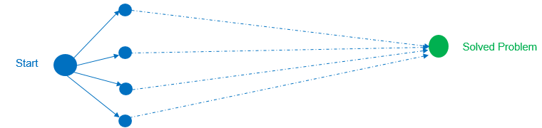

- List two properties of algorithms. (2 marks)

- How are Tries used by Word Processors? (2 marks)

- Draw a stack data structure following sequence: add(A), remove, add(B), remove, add(C), remove, add(D), add(E), remove, add(F), add(G), add (F), remove, add((H), add(K), add(L), remove, remove. (2 marks)

- Explain how recursive backtracking is used in a sack problem when you have different fruit sizes so that it is filled fully. These fruits are mangoes, watermelons and lemons. (3 marks)

QUESTION THREE (15 marks)

- Describe the following tree in terms of the nodes, height and degree. (3 marks)
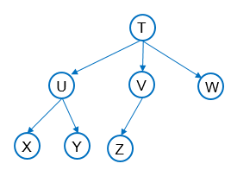
- Explain the following terms used in asymptotic analysis of algorithms. (3 marks)
- Best Case
- Average Case
- Worst Case

- Describe the steps in divide-and-conquer approach. (2 marks)

- State a disadvantage and an advantage of a brute force algorithm. (2 marks)

- Using an example illustrate how a bubble sort works. (3 marks)

- List the factors to consider when choosing a sorting algorithm. (2 marks)

QUESTION FOUR (15 marks)

- Using an example, discuss how Heap sort works. (3 marks)

- Define a biconnected graph. (1 marks)

- A heap is a special kind of balanced tree. Using a diagram, describe (4 marks)
- A balanced tree.
- MAX-heap

- Convert the given graph with weighted edges into minimal spanning tree. (3 marks)
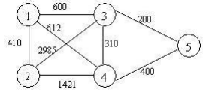

- Illustrate a queue ADT. Include all the four operations. (4 marks)

QUESTION FIVE (15 marks)
- Use a flow chart to represent the insertion sort operations. (3 marks)

- Describe the graph data structure. How is it applied in computer networks?
(5 marks)

- Compare the following. Include diagrams
- Directed and undirected graphs. (2 marks)
- Weakly and strongly connected graphs. (2 marks)

- Using diagrams explain as used in graphs:
i. Depth first traversal search (DFS). (2 marks)
ii. Breadth first traversal search (BFS) (2 marks)

