
UNIVERSITY EXAMINATIONS
EXAMINATION FOR SEPTEMBER/DECEMBER 2021/2022 DIPLOMA IN COMPUTER SCIENCE/INFORMATION TECHNOLOGY/BUSINESS INFORMATION TECHNOLOGY
COURSE CODE: Web Development
COURSE UNIT: RCS039/RCS024/RCT006
DATE: 3RD DECEMBER 2021 TIME: 2 HOURS
GENERAL INSTRUCTIONS:
Students are NOT permitted to write on the examination paper during exam time.
This is a closed book examination. Text book/Reference books/notes are not permitted.
SPECIAL INSTRUCTIONS:
This examination paper consists Questions in Section A followed by section B.
Answer Question 1 and any Other Two questions.
QUESTIONS in ALL Sections should be answered in answer booklet(s).

PLEASE start the answer to EACH question on a NEW PAGE.

Keep your phone(s) switched off at the front of the examination room.

Keep ALL bags and caps at the front of the examination room and DO NOT refer to ANY unauthorized material before or during the course of the examination.

ALWAYS show your working.

Marks indicated in parenthesis i.e. ( ) will be awarded for clear and logical answers.

Write your REGISTRATION No. clearly on the answer booklet(s).

For the Questions, write the number of the question on the answer booklet(s) in the order you answered them.
- DO NOT use your PHONE as a CALCULATOR.
- YOU are ONLY ALLOWED to leave the exam room 30minutes to the end of the Exam.
- DO NOT write on the QUESTION PAPER. Use the back of your BOOKLET for any calculations or rough work.

INSTRUCTIONS:
Answer Question One (Compulsory) and any other one questions
QUESTION ONE (20 MARKS)
- Briefly explain the following terms. (10 marks)
- Web Server
- Home page
- HTML
- HTTP
- World Wide Web
- Briefly state and discuss fundamentals of a good web design ,giving example
(6 marks)
- Outline five factors to consider when choosing content to be included on a web page? (4 marks)
QUESTION TWO (20 MARKS)
- Briefly explain any FOUR qualities of a good website (8 marks)
- Write a code in HTML whereby (4 marks)
- Title as image and is a line
- Background colour is red
- Image is called kenya.jpeg and acts as a line link to Riara university website
- Write out a HTML code you would use to display the page as shown (8 marks)

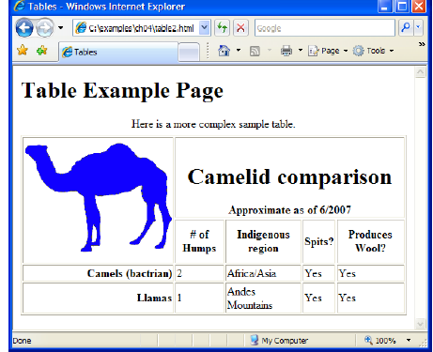

QUESTION THREE (20 MARKS)
- Using a function write a program in JavaScript that is called by a button to display “Hello world” (4 marks)
- Describe the steps followed while creating web pages? ( 4 marks)
- Highlight three security concerns of the internet today (6 marks)
- The internet is implemented using a layering protocol known as the TCP/IP. Draw the model and discuss it briefly (6 marks)

QUESTION FOUR (20 MARKS)
- Discuss five Website design consideration? (10 marks)
- Using the URL: htpp://www.equitybank.com.ke/repayments/masta.html, describe the parts of URL (4 marks)
- List sections of an HTML document (2marks)
- Briefly discuss the global name spaces for domains (4marks)

QUESTION FIVE ((20 MARKS)
- Define the term web portal, giving two examples of the same (4 marks)
- Create a simple but functional website to present information about yourself, department or other interest using HTML (8 marks)
- Describe the difference between the following terms, giving examples ; ( 4marks)
- HTML Title and HTML Heading
- HTML Ordered list and Unordered list
- Write a program in php that uses a function to display the difference of two numbers?
(4 marks)

