

RIARA SCHOOL OF INTERNATIONAL RELATIONS & DIPLOMACY
NURTURING INNOVATORS
SEPT –DEC 2024 TRIMESTER
EXAMINATIONS FOR BACHELOR / DIPLOMA OF ARTS IN INTERNATIONAL RELATIONS & DIPLOMACY
DAY / EVENINGPROGRAMME
UNIT CODE: RIR 104 A UNIT TITLE: INTRODUCTION TO ARABIC LANGUAGE

DATE:__________________________ TIME: 2 HOURS

GENERAL INSTRUCTIONS:
Students are NOT permitted to write on the examination paper during reading time.
This is a closed book examination. Text book/Reference books/notes are not permitted.

SPECIAL INSTRUCTIONS:
1 Write your REGISTRATION NO. Clearly on the answer booklet(s).
2 Answer Question One and ANY other TWO questions.
3 Questions in all sections should be answered in answer booklet(s).
4 Marks allocated to each question are shown at the end of the question.
5 PLEASE start the answer to EACH question on a NEW PAGE.
6 For the questions, write the number of the question on the answer booklet(s) in the order you answered them.
7 Write your answers in paragraph form unless stated otherwise.
8 Keep your phone(s) SWITCHED OFF at the front of the examination room.

9 Keep ALL bags and caps at the front of the examination room and do not refer to any unauthorized material before or during the course of the examination.
10 You are only allowed to leave the examination room 30minutes to the end of the Examination.

1
- (a) demonstrate your knowledge of Arabic Alphabets by writing all alphabets from Aalif to Yaa

(b) – Write the following numbers using Arabic script ?10mks.
- 445
- 364
- 867
- 2675686
- 0722375611
- 87654321
- 1444
- 8643
- 2022
- 02/28/1978

1 (c) : demonstrate your understanding of the Arabic vowels by writing 3 letter word USING Arabic script and transliterate the words? 10 marks
The vowel | Word in Arabic | Transliterated word
Fatha
Kasra
Dhammah
Sukuun
shadda

2 a) – demonstrate your comprehension skills in Arabic by answering the following questions (10 marks)
محمد: السلام عليكم
برهان: ……………………………………………………………………..

برهان : إسمي برهان
محمد: …………………………………………………….:
برهان: ……………………………………………………………
محمد : مع السلامة

2 b) translate the following sentences bearing in mind the personal pronoun in each (10marks)
هو معلم جديد
هي معلمة جديدة
هما معلمان جديدان
هم معلموان مجتهدون
هن معلمات مجتهدات
أنتَ معلم مجتهد
أنتِ معلمة مجتهدة
أنتما معلمان مجتهدان
انتم معلمون مجتهدون
أنتنَّ معلمات مجتهدات
أنا معلم مجتهد
نحن معلمون مجتهدون
3 a) Rewrite the following text using Arabic scripts (5marks)
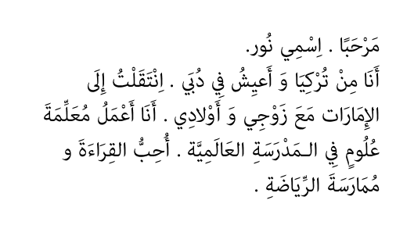
3. b) Translate the above text in to English language (15marks)
.
4 a)- Join the following letters to form Words? 10 marks
1- ك + ت + ا + ب =------------------
2- ط + ا + ل + ب = ---------------- -
3- م + س + ج + د = ----------------
4- م + ع + ل + م =-------------------
5- ق + ل + م = ------------------
6- ج + ا + م + ع + ة = ----------------
7- ب + خ + ي + ر = -------------------
8- ك+ ن+ ي + س+ ة =------------------
9-م+ ز+ ار+ ع ……………………………………
10-م+ ح+ ا+ ض+ ر………………………………………………

4 ( b( Translate the following English words to Arabic then transliterate the Arabic words in the table provided below using the example to help you? 10 marks
Example:
Book | Kitaab | كتاب
Fill this column
1 | A pen
2 | A doctor
3 | A farmer
4 | A lecturer
5 | A student
6 | A mosque
7 | A maternal uncle
8 | Husband
9 | Muhammad
10 | Peace be upon you

5. Discuss significance of studying Arabic Language for diplomats and international relations students (20 marks)
6. a) Write numbers 1-50 using Arabic scripts. (10 marks)

6 b) Write down the 12 months of the year using either Arabic scripts or transliteration. (10 marks)

