
UNIVERSITY EXAMINATIONS

EXAMINATION FOR MAY/AUGUST 2023/2024 FOR BACHELOR OF SCIENCE IN COMPUTER SCIENCE
RCS 108: COMPUTER ORGANIZATION & ASSEMBLY LANGUAGE.

DATE 6 / 8 /2024 TIME: 2 HOURS

GENERAL INSTRUCTIONS:
Students are NOT permitted to write on the examination question paper during examination time.
This is a closed book examination. Text book/Reference books/notes are not permitted.
SPECIAL INSTRUCTIONS:
This examination paper consists Questions in Section A followed by section B.
Answer Question 1 and any Other Two questions.
QUESTIONS in ALL Sections should be answered in answer booklet(s).

PLEASE start the answer to EACH question on a NEW PAGE.

Keep your phone(s) switched off at the front of the examination room.

Keep ALL bags and caps at the front of the examination room and DO NOT refer to ANY unauthorized material during the course of the examination.

ALWAYS show your working.

Marks indicated in parenthesis i.e. ( ) will be awarded for clear and logical answers.

Write your REGISTRATION No. clearly on the answer booklet(s).

For the Questions, write the number of the question on the answer booklet cover page in the order you answered them.
- DO NOT use your PHONE as a CALCULATOR.
- YOU are ONLY ALLOWED to leave the exam room 1 hour to the end of the Exam.
- DO NOT write on the QUESTION PAPER. Use the back of your BOOKLET for any calculations or rough work.
- Calculators may be required.
- Microprocessor Instruction sets will be provided.

SECTION A (COMPULSORY)

Question (1) - (30Marks)

- Define the following terms as used in computer systems. (5 Marks)
- I.S.A.
- Cache.
- B.I.O.S.
- P.O.S.T.
- Firmware.

- Describe FOUR major components found inside a microprocessor, stating their purposes. (4 Marks)

- Explain the purposes following computer systems components. (3 Marks)
    - Compiler.
    - Interpreter.
    - Assembler.

- State FIVE categories / types of instructions based on their functionality. (5 Marks)

- Describe the following forms of Memory access. (3 Marks)
- Sequential access.
- Direct access.
- Random access.

- What will be the effect of executing the following intel 8085 instructions. (5 Marks)
- LXI H, FFFF H
- LHLD 2000 H
- STA 2500 H
- XCHG
- IN 80 H

- Outline FIVE major differences between R.I.S.C. and C.I.S.C as referenced in microprocessors. (5 Marks)

SECTION B (ANSWER ANY TWO QUESTIONS)
Question (2) - (15 Marks).
- If a computer system has 18-bit control buses, 38 bits address buses, & 64 bits data buses.
- Calculate the maximum memory the system can handle. (2 Marks)
- What is the maximum size of word, the system can handle? (1 Marks)

- State the purposes of the following I/O ports as used in PC (personal computer) system. (6 Marks)
- DVI Port.
- PS/2 Port.
- VGA Port.
- Ethernet Port.
- Firewire Port.
- e-SATA Port.

- List THREE differences between the Harvard computer architectures and the Von Neumann computer architectures? (3 Marks)

- Name three major types of primary buses used by a computer system and hence describe their functionalities. (3 Marks)

Question (3) - (15 Marks).
- In details, discuss, the complex Fetch Execute Cycle process, as implemented during the instruction’s executions. (6 Marks)

- Explain the term Addressing Mode means as use in Low level Programming languages. (1 Marks)

- Discuss FIVE addressing modes used in the Intel 8085 microprocessor instruction sets, site an example, for each of the addressing mode. (5 Marks)

- Define the following terms as used in computer organization. (3 Marks)
- Multi-tasking.
- Multi-processing.
- Multi-programming.

Question (4) - (15 Marks).

- State and explain FOUR major hardware related factors that have an impact, on computer performance. (4 Marks)

- State and Describe SIX major types of registers used found in a microprocessor (CPU). (6 Marks)

- Study the Assembly language shown below for intel 8085 microprocessor.

ORG: 2000 |  | Comments
LXI SP, 4000 H | : | ?
LXI H, 2501 H | : | ?
MOV A, M | : | ?
INX H | : | ?
ADD M | : | ?
INX H | : | ?
MOV M, A | : | ?
HLT | : | ?

    - If the program is executed, what will it achieve? (2 Marks)
    - Comments on each of the statements to describe function. (3 Marks)

Question (5) - (15 Marks).

- Describe all the flag register bits of the Intel 8085 microprocessor. (5 Marks)

- Outline FOUR differences between the Microprocessors and Microcontrollers. (4 Marks)

- Given a memory space of 64 KB of RAM for the Intel 8085 microprocessor. Write an assembly Language program to fill all the locations from 2000 H to 20FF H, with (1s), i.e. FF H in each memory location. Use comments on your assembly language code statements, for easy understanding. (6 Marks)
(Refer to the instruction set for Intel 8085 provided on page 5 and 6).

Intel’s 8085 Microprocessors Instruction Set summary provided in the next two pages.

INTEL 8085 MICROPROCESSOR INSTRUCTION SET

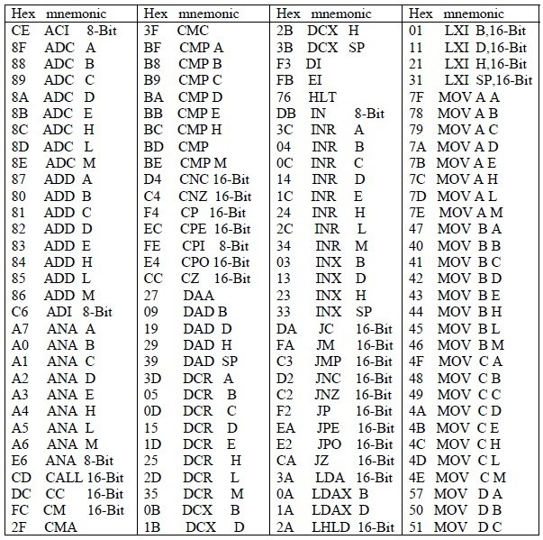

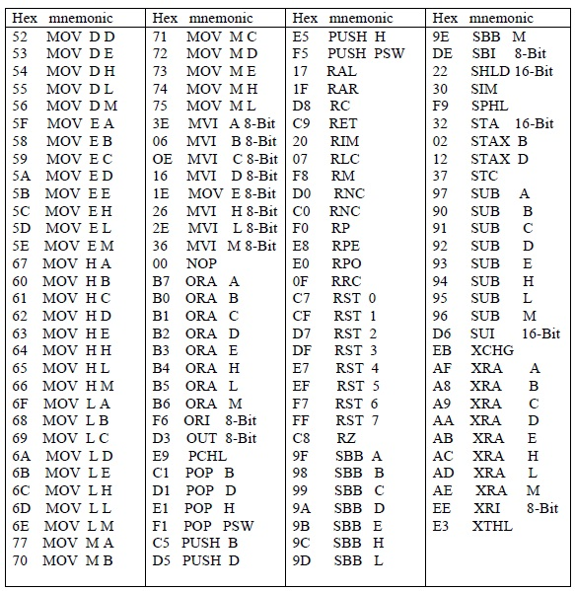

END

