
UNIVERSITY EXAMINATIONS
EXAMINATION FOR JANUARY / APRIL 2024/2025 FOR BACHELOR OF SCIENCE IN COMPUTER SCIENCE
RCS 101: DIGITAL LOGICS.

DATE 9TH APRIL 2025 TIME: 2 HOURS
GENERAL INSTRUCTIONS:
Students are NOT permitted to write on the examination question paper during examination time.
This is a closed book examination. Text book/Reference books/notes are not permitted.

SPECIAL INSTRUCTIONS:
This examination paper consists Questions in Section A followed by section B.
Answer Question 1 and any Other Two questions.
QUESTIONS in ALL Sections should be answered in answer booklet(s).

PLEASE start the answer to EACH question on a NEW PAGE.

Keep your phone(s) switched off at the front of the examination room.

Keep ALL bags and caps at the front of the examination room and DO NOT refer to ANY unauthorized material during the course of the examination.

ALWAYS show your working.

Marks indicated in parenthesis i.e. ( ) will be awarded for clear and logical answers.

Write your REGISTRATION No. clearly on the answer booklet(s).

For the Questions, write the number of the question on the answer booklet cover page in the order you answered them.
- DO NOT use your PHONE as a CALCULATOR.
- YOU are ONLY ALLOWED to leave the exam room 1 hour to the end of the Exam.
- DO NOT write on the QUESTION PAPER. Use the back of your BOOKLET for any calculations or rough work.
- Scientific CALCULATOR will be required.

SECTION A (COMPULSORY)

Question (1) - (30Marks)
- Define the acronyms ADC & DAC, and hence explain the purpose. (2 Marks)

- Describe the following terms as used in digital logics. (4 Marks)
- Digital Signals.
- Analog Signals.
- Semiconductors.
- Electromagnetic Spectrum.

- Express the circuit below as a Boolean function. (6 Marks)

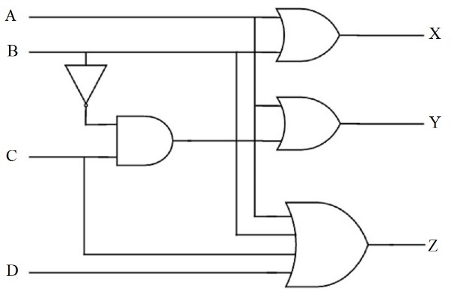

- Considering the Boolean function shown below, draw a digital logic circuit, for the Boolean function below. (6 Marks)
$Y_{o} =\left(A+B\right)C+ \overline{B}\left( A+\overline{C} \right)+\left(\overline{A}+B+\overline{C}\right)$

- Convert the following binary numbers, into Decimal Number. (3 Marks)
111000111.10101101₂ Show all the working.
- Convert the following Decimal numbers, into Binary Number. (3 Marks)
246.137₁₀ Show all the working.

- Simplify the logic circuit below; hence draw the simplified logic circuit. (6 Marks)
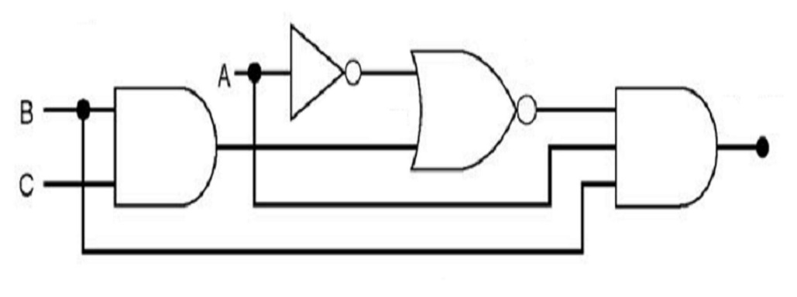

SECTION B (Answer Any Two Questions)

Question (2) - (15Marks)

- State the De-Morgan’s theorems. (2 Marks)

- Using suitable truth tables; prove the De-Morgan’s theorems. (4 Marks)

- Simplify the logic circuit below; hence draw the simplified logic circuit. (5 Marks)

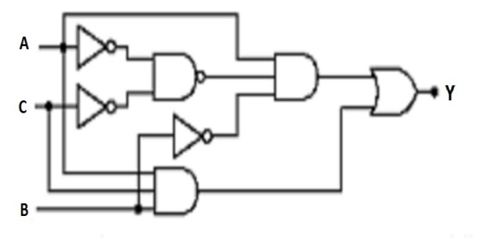

- The modern computers are able to process both digital and analog signals/data.
Discuss how this is achieved in voice processing of mobile phone devices. (4 Marks)

Question (3) - (15 Marks)
- Evaluate the following numbers Conversions, into the indicate formats.
NB: Show all the working, marks awarded on only working, not answers. (10 Marks)

- 11101010110011010_{bin} into Hexadecimal number.
- 1111111111_{bin} into gray code.
- 1101010100_{bin} into decimal number.
- 8A0BC_{hex} into octal number.
- 10101_{dec} into binary number.

- Compare encoders and decoders. (2 Marks)

- Digital logic circuits require simplification after designing using any appropriate method like Boolean Simplification or Karnaugh Mapping technique. Justify by giving THREE reasons. (3 Marks)

Question (4) - (15 Marks)
- Design a Four Bits Binary to Gray code converter, considering the first principle for digital circuit design procedures. (8 Marks)

- Describe the differences between the Multiplexers and De-multiplexers? (2 Marks)

- Considering the logic circuit diagram below, derive the output Boolean function for (Y). (5 Marks)

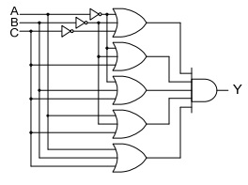

Question (5) - (15 Marks)
- Using Karnaugh Mapping or Boolean Simplification, technique of functions simplification, simplify the function below to the simplest term. (6 Marks)

$$Y=\overline{A}\overline{B}\overline{C}\overline{D}+\overline{A}\overline{B}\overline{C}D+\overline{A}\overline{B}CD+\overline{A}B\overline{C}\overline{D}+\overline{A}B\overline{C}D+\overline{A}BCD+AB\overline{C}\overline{D}+AB\overline{C}D+ABCD$$

- Describe the following types of counters used in digital Systems. (4 Marks)
- Synchronous Counters.
- Asynchronous Counters.

- Design a full adder, from the first principle of digital circuit designing. (5 Marks)

END

