
UNIVERSITY EXAMINATIONS
EXAMINATION FOR MAY/AUGUST 2024/2025 FOR BACHELOR OF SCIENCE IN COMPUTER SCIENCE
RCS 101 DIGITAL LOGICS.
DATE 06 / 08 /2025. TIME: 2 HOURS

GENERAL INSTRUCTIONS:
Students are NOT permitted to write on the examination paper during examination time.
This is a closed book examination. Text book/Reference books/notes are not permitted.
SPECIAL INSTRUCTIONS:
This examination paper consists Questions in Section A followed by section B.
Answer Question 1 and any Other Two questions.
QUESTIONS in ALL Sections should be answered in answer booklet(s).

PLEASE start the answer to EACH question on a NEW PAGE.

Keep your phone(s) switched off at the front of the examination room.

Keep ALL bags and caps at the front of the examination room and DO NOT refer to ANY unauthorized material before or during the course of the examination.

ALWAYS show your working.

Marks indicated in parenthesis i.e. ( ) will be awarded for clear and logical answers.

Write your REGISTRATION No. clearly on the answer booklet(s).

For the Questions, write the number of the question on the answer booklet(s) in the order you answered them.
- DO NOT use your PHONE as a CALCULATOR.
- YOU are ONLY ALLOWED to leave the exam room 1 hour to the end of the Exam.
- DO NOT write on the QUESTION PAPER. Use the back of your BOOKLET for any calculations or rough work.
- Calculator will be required.

SECTION A (COMPULSORY)
Question (1) - (30Marks)
- Define the following terms as used in digital systems? (6 Marks)
- Bits.
- Bytes.
- Encoder.
- Decoders.
- Multiplexers.
- De-Multiplexers.

- Answer the following Questions, by selecting the correct choice, in the following multiple-choice questions. (6 Marks)
- Which of the following gates, is a Universal gate?

(A) NOT | (B) AND | (C) X–OR | (D) NAND

- How many JK - Flip-Flops are required for mod–64 counter?

(A) 5 | (B) 6 | (C) 8 | (D) 4

- What is the binary equivalent of the decimal number 368_{dec}?
(A) 101110000 | (B) 110110000
(C) 111010000 | (D) 111100000

- In which of the following gates, the output is 1, if at least one input is 1
(A) NOT | (B) AND | (C) OR | (D) NAND

- The time required for a gate to change output state due to change in any inputs is referred to as?
(A) Fall time. | (B) Decay time.
(C) Propagation time. | (D) Rise time.

- Which of the following gates can be used in detecting Parity bits in error correction.
(A) OR gate | (B) AND gate | (C) NOR gate | (D) XOR gate

- Evaluate the following calculations. Show all the working. (10 Marks)

- DCBA_{hex} - Convert to Octal.
- 17_{dec} – 10_{dec} - Using twos complements.
- 11111111_{bin} - Convert to Gray code.
- 10011011_{bin} + 10110101_{bin} - Express the results in Decimal.
- FED_{hex} + CBA_{hex} - Express the results in Hexadecimal.

- Derive the Boolean functions output of Y, with respect to the inputs A, B, C and D for the logic circuit below. (4 Marks)
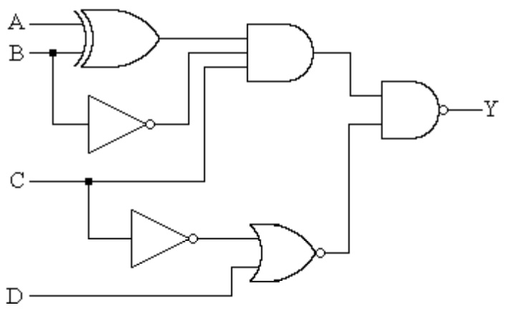

- Draw the logic Implement the Boolean expression below using suitable logic gates. (4 Marks)
Y_{out} = ((AB)C + (DE)(A̅BC) + A̅DE)

SECTION B (Answer Any Two Questions)
Question (2) - (15 Marks)
- Express the circuit below as a Boolean function. (6 Marks)

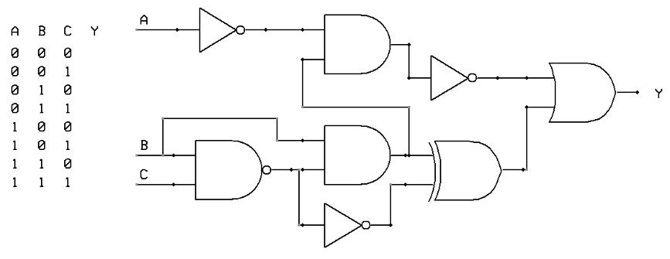
- Convert the following binary numbers, into Decimal Number. (3 Marks)
10101010.110011₂ Show all the working.
- Convert the following Decimal numbers, into Binary Number. (3 Marks)
135.531₁₀ Show all the working.

- Compare the Binary number codes and Gray code. (3 Marks)

Question (3) - (15 Marks)
- Design a three bits Binary to Gray code converter, and then implement the logic circuit. You can use either Boolean simplification or the K-Mapping technique. (6 Marks)
- Simplify the logic circuit below to its simplest form. (3 Marks)
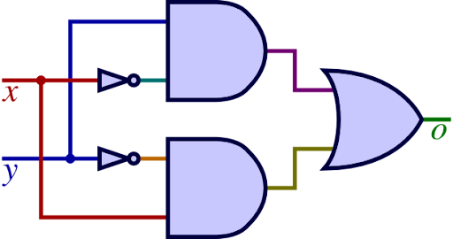
- Considering the logic circuit shown below, derive the Boolean function and hence a truth table, indicating all possible inputs (A, B and C) and specific output (Q). (6 Marks)
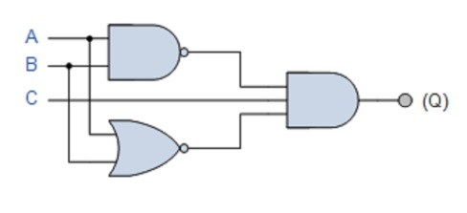

Question (4) - (15 Marks)

- Considering the Boolean function shown below, draw an equivalent Logic circuit diagram. (6 Marks)
$Y_{o} =\left(A⨁B\right)C+ \overline{B}\left( A⨁\overline{C} \right)+\overline{A}B\overline{C}D+ AD$C

- Define the De-Morgan’s theorem. (1 Marks)

- Using suitable truth tables, prove the De-Morgan’s theorem. (2 Marks)

- Design a Full adder from the first principle of digital circuit designing. (6 Marks)

Question (5) - (15 Marks)
- Using Karnaugh Mapping technique of Boolean simplification, simplify the Boolean function below to the simplest term. (5 Marks)
$$Y_{Out} = \overline{A}\overline{B}\overline{C}\overline{D}+\overline{A}\overline{B}C\overline{D}+A\overline{B}\overline{C}\overline{D}+A\overline{B}C\overline{D}+\overline{A}B\overline{C}D+\overline{A}BCD+AB\overline{C}D+ABCD$$

- Considering the logic circuit shown below, Simplify the circuit, and then draw an equivalent Logic circuit diagram for the simplified circuits. (5 Marks)
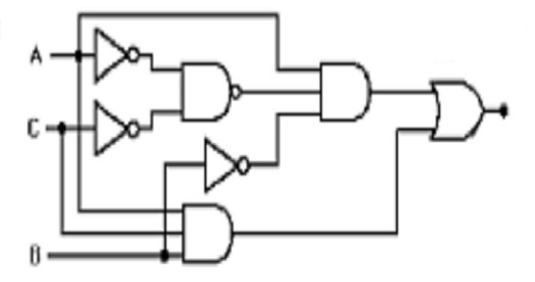
- Using any of the universal logic gates, implement the Exclusive NOR gates. (3 Marks)

- State any two types of ADC and DAC circuitry. (2 Marks)

END

