
UNIVERSITY EXAMINATIONS
EXAMINATION FOR SEPTEMBER/DECEMBER 2024/2025 FOR BACHELOR OF SCIENCE IN BUSINESS INFORMATION TECHNOLOGY
RCS 308: SYSTEM DEVELOPMENT METHODOLOGIES
DATE: 4TH DECEMBER, 2024. TIME: 2 HOURS
GENERAL INSTRUCTIONS:
Students are NOT permitted to write on the examination paper during examination time.
This is a closed book examination. Text book/Reference books/notes are not permitted.
SPECIAL INSTRUCTIONS:
This examination paper consists Questions in Section A followed by section B.
Answer Question 1 and any Other Two questions.
QUESTIONS in ALL Sections should be answered in answer booklet(s).

PLEASE start the answer to EACH question on a NEW PAGE.

Keep your phone(s) switched off at the front of the examination room.

Keep ALL bags and caps at the front of the examination room and DO NOT refer to ANY unauthorized material before or during the course of the examination.

ALWAYS show your working.

Marks indicated in parenthesis i.e. ( ) will be awarded for clear and logical answers.

Write your REGISTRATION No. clearly on the answer booklet(s).

For the Questions, write the number of the question on the answer booklet(s) in the order you answered them.
- DO NOT use your PHONE as a CALCULATOR.
- YOU are ONLY ALLOWED to leave the exam room 30minutes to the end of the Exam.
- DO NOT write on the QUESTION PAPER. Use the back of your BOOKLET for any calculations or rough work.

SECTION A - Compulsory
QUESTION ONE (30 Marks)
- Differentiate between: (6 Marks)
  - Critical path and critical task
  - Reverse Engineering and Forward Engineering
  - Optimistic time and pessimistic time as used in PERT

- Describe any two characteristics of a system. (2 Marks)

- Define: (3 Marks)
- Beta Testing
- Lean Development
- System Development Methodology

- Explain the following terms. (3 Marks)
- Iterations
- Project Sprint
- Elements of a system

- Outline the merits and drawbacks of Jackson’s Soft Systems Methodology and illustrate with an example.
(6 Marks)
- Explain the double V model if the single V model is as shown below (5 Marks)

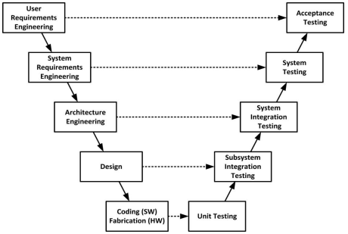

- Enumerate the three important elements when considering the IT environment issues during System Development. (3 Marks)

- Discuss V-Model as used in software development. (3 Marks)

- What is the importance of Software Development Methodologies? (1 Mark)

SECTION B - Answer ANY other TWO questions
QUESTION TWO (15 Marks)
- Outline three important considerations a development/acquisition team need to take into consideration when they are selecting a methodology to use for a project. (3 Marks)

- Define: (3 Marks)
- JAD methodology
- Delphi Technique

- Differentiate between Process management and project management. (2 Marks)
- Illustrate Capability Maturity Model (CMM). (5 Marks)
- Discuss Waterfall development methodology. (3 Marks)
QUESTION THREE (15 Marks)
- List two advantages of agile system development method. (2 Marks)

- Define: (2 Marks)
- Object oriented approach
- Jackson’s Soft Systems Methodology
- Discuss Throw Away prototyping methodology. (3 Marks)
- Differentiate between: (6 Marks)
- Gantt Chart and PERT
- Predictive and adaptive approach.
- Insourcing and self-sourcing system development.
- Describe two ways of identifying software development projects. (2 Marks)

QUESTION FOUR (15 Marks)
- Give a situation where Rapid Application Development is best suited. (2 Marks)

- Define: (3 Marks)
  - RAD
  - Prototyping
  - Project risk management

- Differentiate between Unit tests and functional tests. (2 Marks)

- Discuss Phased development methodology. (3 Marks)
- List the factors to consider when evaluating the development methodology used.
(3 Marks)
- Enumerate two reasons why system development projects fail. (2 Marks)

QUESTION FIVE (15 Marks)

- Differentiate: (6 Marks)
- Logical and physical design
- Physical and abstract system
- Open system and closed system

- Outline the ethical issues that arise from designing, developing and implementing information systems. (2 Marks)

- Define: (3 Marks)
  - CASE Tools
  - Slack as used in project tasks.
  - Test Process Improvement(TPI)
- List some of the cross life-cycle activities in systems development. (2 Marks)
- Discuss the Joint Application Development methodology. (2 Marks)

