

Riara School of Business

Nurturing business innovators

MAY- AUGUST 2021 TRIMESTER

EXAMINATION FOR BACHELOR OF SCIENCE IN COMPUTER SCIENCE

DAY PROGRAMME

RCS 404: STATISTICAL METHODS

DATE: AUGUST 2021 TIME: 2 HOURS

GENERAL INSTRUCTIONS:
Students are NOT permitted to write on the examination paper during examination time.
This is a closed book examination. Text book/Reference books/notes are not permitted.
SPECIAL INSTRUCTIONS:
This examination paper consists Questions in Section A followed by section B.
Answer Question 1 and any Other Two questions.
QUESTIONS in ALL Sections should be answered in answer booklet(s).

PLEASE start the answer to EACH question on a NEW PAGE.

Keep your phone(s) switched off at the front of the examination room.

Keep ALL bags and caps at the front of the examination room and DO NOT refer to ANY unauthorized material before or during the course of the examination.

ALWAYS show your working.

Marks indicated in parenthesis i.e. ( ) will be awarded for clear and logical answers.

Write your REGISTRATION No. clearly on the answer booklet(s).

For the Questions, write the number of the question on the answer booklet(s) in the order you answered them.
- DO NOT use your PHONE as a CALCULATOR.
- YOU are ONLY ALLOWED to leave the exam room 30minutes to the end of the Exam.
- DO NOT write on the QUESTION PAPER. Use the back of your BOOKLET for any calculations or rough work.
SECTION A (COMPULSORY)
QUESTION 1: (30 MARKS)
A computer science student provided a python code and output in prediction of stock index price (i.e., the dependent variable) of a Kenyan economy by using 2 independent/input variables:(Interest Rate and Unemployment Rate). Answer the question below the code and the output.
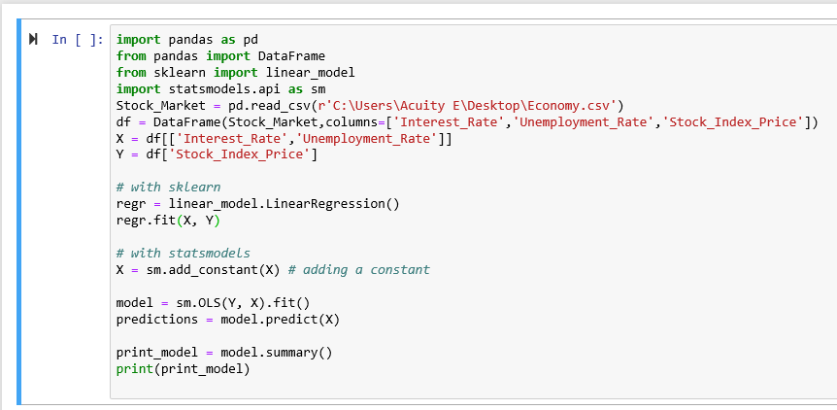
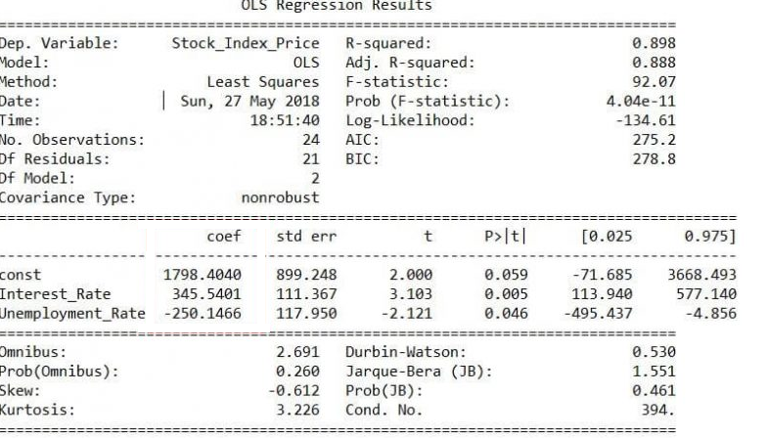

- Write the regression model stock index prediction [3 Marks]
- Give the predictive power of the stock index model [2 Marks]
- Is the regression model a good fit? justify [4 Marks]
- Comment on the linearity of the stock index model. [3 Marks]
- Which features are significant? justify and interpret the coefficients [8 Marks]
- Comment on the normality of the stock index model. [3 Marks]
- Which feature has the most leverage power? Justify [2 Marks]
- Comment on the autocorrelation of the stock index model [2 Marks]
- Comment on the significance of the confidence interval [3 Marks]

QUESTION 2 (20 MARKS)

a) When estimating parameters using regression analysis the following problematic issues are encountered, as a statistical methods student explain why it is important to check them during estimation, how they can be detected and how they can be solved:
i) Heteroscedasticity. [4 Marks]
ii) Serial / autocorrelation. [4 Marks]
ii) Multicollinearity [4 Marks]
iii) Linearity [4 Marks]
iv) Outliers [4 Marks]

QUESTION 3 (20 MARKS)
- Differentiate between Null hypothesis and alternative hypothesis then outline the steps in conducting hypothesis testing using the output provided in question 1. [10 Marks]
- Differentiate the usefulness of Neyman Pearson lemma and likelihood ratio testing sampling theory and give a practical computer science application [10 Marks]

QUESTION 4 (20 MARKS)
a) Differentiate between the following terms illustrating using a computer science example.

i. Point estimate and interval estimate [4 Marks]
ii. Multiple linear and logistic regression [6 Marks]
iii. Unbiased estimator and consistent estimator [4 Marks]
iv. P-value and level of significance [6 Marks]

