

Riara School of Business

Nurturing business innovators

SEPTEMBER – DECEMBER 2024 TRIMESTER EXAMINATIONS

DAY PROGRAMME

EXAMINATION FOR BACHELOR OF BUSINESS ADMINISTRATION

RFN 401: PORTFOLIO CONSTRUCTION MANAGEMENT AND PROTECTION

DATE: 14TH DECEMBER 2024 TIME: 2 HOURS

GENERAL INSTRUCTIONS:
Students are NOT permitted to write on the examination paper during reading time.
This is a closed book examination. Text book/Reference books/notes are not permitted.
SPECIAL INSTRUCTIONS
- Write your REGISTRATION NO. Clearly on the answer booklet(s).
- Answer Question One and ANY other TWO questions.
- Questions in all sections should be answered in answer booklet(s)
- PLEASE start the answer to EACH question on a NEW PAGE.
- For the questions, write the number of the question on the answer booklet(s) in the order you answered.
- Write on both sides of each leaf and indicate number of each question at the top of each page.
- Write the answers in a paragraph form unless stated otherwise.
- Marks allocated to each question are shown at the end of the question.
- All rough work must be done on the answer booklet and crossed through!
- Use supplementary pages only when you have exhausted those in this book.
- Fasten the supplementary pages to the inside back cover of this booklet

Question ONE
- Portfolio protection strategies are techniques used by investors to safeguard their portfolios against significant losses, especially during volatile market conditions. These strategies aim to minimize downside risk while allowing for some level of upside potential. Outline FIVE portfolio protection approaches. (10 marks).
- An investor expects a risk-free of return (rf) of 4.5% per annum and a market rate of return (rm) of 14.5% per annum. Two stocks, A and B have the following betas and estimated returns
Stocks | Beta | Estimated Return
A | 1.2 | 16%
B | 0.8 | 14%

Required:
Assuming stocks A and B are fairly valued under the capital assets pricing model (CAPM) use a graph to indicate the points where stocks would be plotted on the security market line (SML) (10 marks)
- Evaluate four ways in which behavioral biases could affect portfolio construction.
(10 marks)

Question TWO
- Lewis Mulwa, a financial analyst at Kiwa Capital is analyzing two investors, X and Y, whose portfolio performance is illustrated in the diagram below:
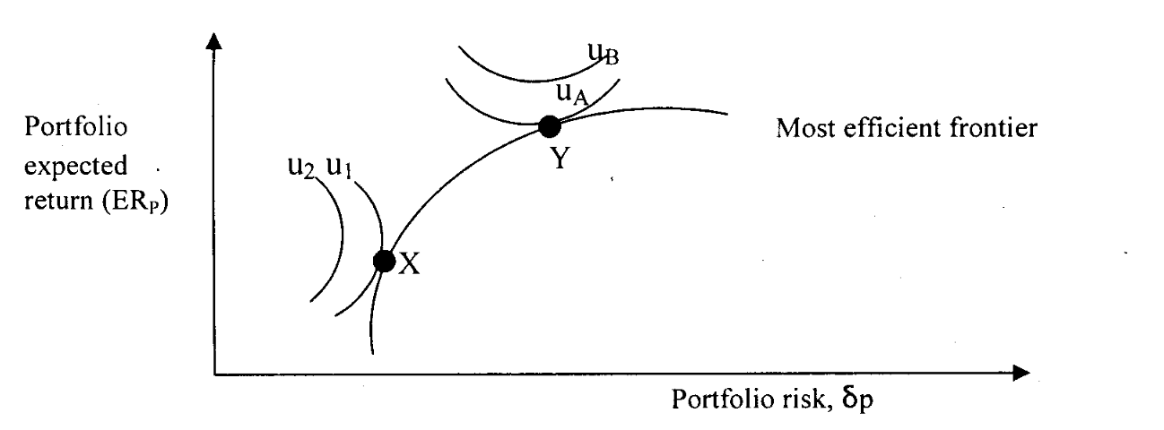
Where: u₁, u₂, and u_{A}, u_{B} are the utility curves for investors X and Y respectively.
Required:
Describe investor X and investor Y in terms of their utility and investment decisions. (8 marks)
- Giving examples, discuss exhaustively four performance evaluation measures
(12 marks)

QUESTION THREE (20 marks)
- Highlight four steps involved in the portfolio management process. (8 marks)
- Explain three forms of investment strategies that could be adopted by a portfolio manager in the management of a client portfolio. (6 marks)
- The following financial data relates to the performance of company X's shares against the market share index over the last three-year period
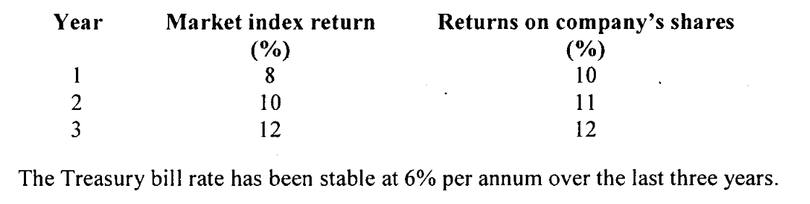
Using the capital asset pricing model (CAPM), determine the expected return for year 4 assuming that the market index return for the fourth year is forecasted at 14%.
(6 marks)

QUESTION FOUR (20 MARKS)
- Phan Limited wishes to buy Sh.1,000,000 worth of shares in each of two companies from a choice of three companies; X Ltd., Y Ltd. and Z Ltd. that it might wish to acquire at some future date. The three companies are in different industries. Historical data for 5 years on the risk and return of the three companies are provided below:
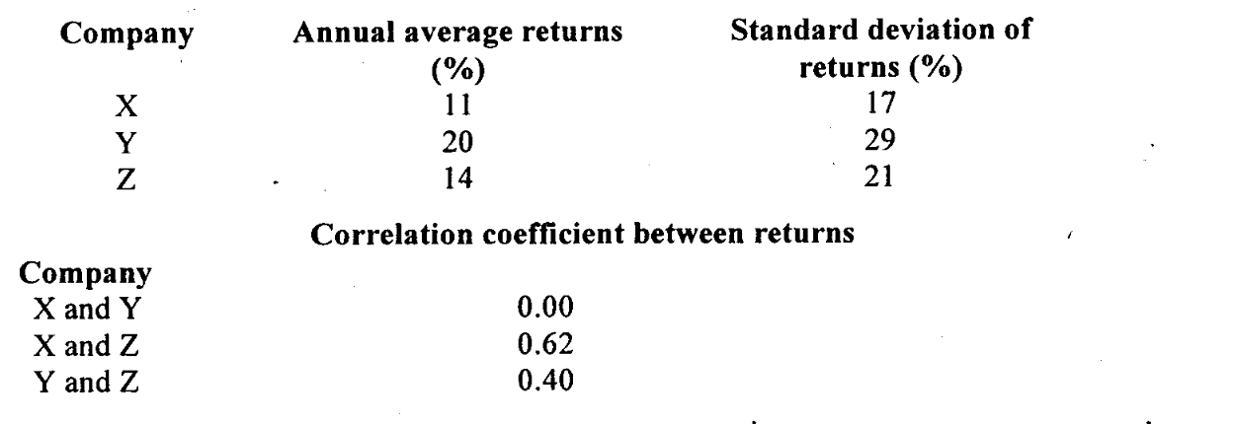
Required:
Using suitable computations, advise Phan Limited on the most efficient portfolio to select for investment. (10 marks)
- Explain the key assumptions and principles of the Arbitrage Pricing Theory. How does it differ from the Capital Asset Pricing Model (CAPM)? (10 marks)

