
UNIVERSITY EXAMINATIONS

EXAMINATION FOR JANUARY/APRIL 2025/2026 FOR DIPLOMA IN COMPUTER SCIENCE

RDCS6123 – OBJECT ORIENTED PROGRAMMING

DATE: 13TH APRIL 2026 TIME: 2 HOURS

GENERAL INSTRUCTIONS:
Students are NOT permitted to write on the examination paper during examination time.
This is a closed book examination. Text book/Reference books/notes are not permitted.

SPECIAL INSTRUCTIONS:
This examination paper consists Questions in Section A followed by section B.
Answer Question 1 and any Other Two questions.
QUESTIONS in ALL Sections should be answered in answer booklet(s).

PLEASE start the answer to EACH question on a NEW PAGE.

Keep your phone(s) switched off at the front of the examination room and NOT on your person.

Keep ALL bags and caps at the front of the examination room and DO NOT refer to ANY unauthorized material before or during the course of the examination.

ALWAYS show your working.

Marks indicated in parenthesis i.e. ( ) will be awarded for clear and logical answers.

Write your REGISTRATION No. clearly on the answer booklet(s).

For the Questions, write the number of the question on the answer booklet(s) in the order you answered them.
- DO NOT use your PHONE as a CALCULATOR.
- YOU are ONLY ALLOWED to leave the exam room 30minutes to the end of the Exam.
- DO NOT write on the QUESTION PAPER. Use the back of your BOOKLET for any calculations or rough work.

SECTION A (COMPULSORY)

QUESTION 1 ( 30 Marks)
PART I: You are given a Java program that contains a class used to assign grades based on student marks. Carefully study the code provided and answer the following tasks:
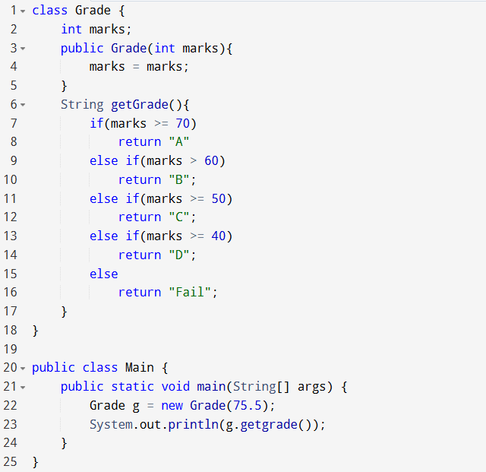
- Identify and correct ANY THREE (3) errors in the given code. For each error, Clearly indicate the line number where the error occurs and provide the corrected version of the code [6 Marks]
- Using a relevant example, explain what a class is in Java. [2 Marks]
- If a student scores 60 marks, determine the grade that the program will return.
Justify your answer based on the grading logic used in the code. [2 Marks]
- Modify the grading logic to
- Include a new grade "A-" for marks between 65 and 69. [2 Marks]
- Enhance the program to validate input marks, ensuring they fall within the range 0–100.If the marks are outside this range (e.g., 101), the program should display an appropriate message such as "Invalid score". [3 Marks]
- Rewrite the following Java constructor in C++ syntax: [2 Marks]
public Grade(int marks){
this.marks = marks;
}
- Explain the function of line 22 in the program. Your answer should clearly describe what the statement does during program execution. [2 Marks]
- State the data type of the marks variable as declared in the class. [1 Mark]

PART II: Including all the sections of a Java or C++ code, write a program that calls three other methods from the main method. When called, these methods should display three different statements based on the role of each method. [10Marks]

SECTION B (Answer ANY Two Questions)

QUESTION 2 (15 Marks)
- Write a Java or C++ program that uses nested if…else statements to determine an employee’s bonus category (High Bonus, Medium Bonus, Low Bonus, or No Bonus) based on their years of service and performance rating. (7 Marks)

- Study the diagram and explain any four forms of inheritance. (4 Marks)

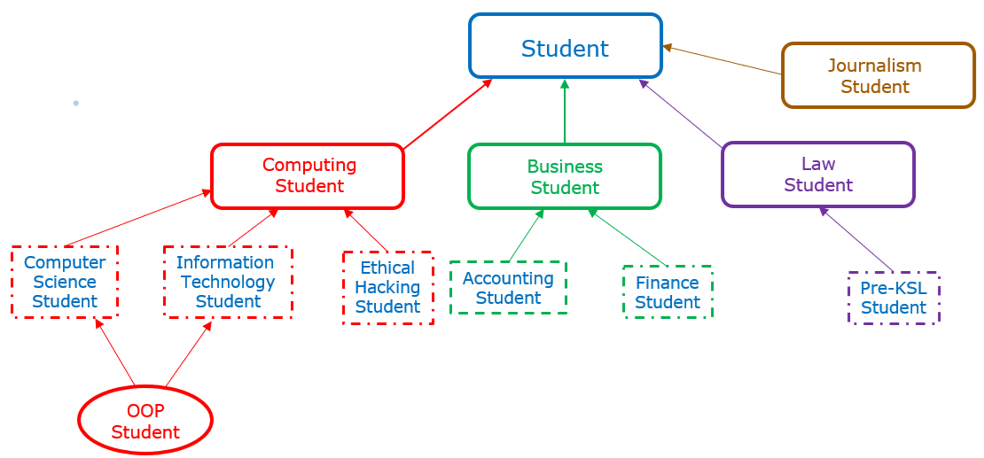

- Differentiate between: ( 4 Marks)
- Text Field and Text Area GUI components
- Static Binding and Dynamic Binding

QUESTION 3 (15 Marks)

- Using an example, illustrate an array of 5 integers. (3 Marks)

- Enumerate two ways of controlling and exiting loops. ( 2 Marks)

- Draw the flow chart of Switch Case decision control structure. (5 Marks)

- Write Java or C++ code for a bank account object that can allow users achieve the following: (5 Marks)
Deposit
Withdraw

QUESTION 4 (15 Marks)/

- Explain the structure of a for loop control structure. Include an example. (5 Marks)

- Demonstrate Polymorphism as used in Object-Oriented Programming graphical user interfaces. (4 Marks)

- Compare how public and private access specifies are implemented in C++ and Java. Include examples. (6 Marks)

QUESTION 5 (15 Marks)
- Explain the structure and output of a do while loop control structure. Include an example. (5 Marks)

- Write a Java or C++ programme that prompts the user to provide a random number, computes or carries out a logic operation and displays an output that is based on the provided information. (7 Marks)

- Define the terms variable declaration and variable initialization, and explain the difference between them. (3 Marks)

