
UNIVERSITY EXAMINATIONS
EXAMINATION FOR SEPTEMBER-DECEMBER 2025/2026 FOR BACHELOR OF SCIENCE IN COMPUTER SCIENCE
RBCS 7321:COMPILER CONSTRUCTION

DATE; 11TH DECEMBER 2025 TIME: 2 HOURS

GENERAL INSTRUCTIONS:
Students are NOT permitted to write on the examination paper during examination period.
This is a closed book examination. Text book/Reference books/notes are not permitted.

SPECIAL INSTRUCTIONS:

This examination paper consists Questions in Section A followed by section B.
Answer Question 1 and any Other Two questions.

QUESTIONS in ALL Sections should be answered in answer booklet(s).

PLEASE start the answer to EACH question on a NEW PAGE.

Keep your phone(s) switched off at the front of the examination room.

Keep ALL bags and caps at the front of the examination room and DO NOT refer to ANY unauthorized material before or during the course of the examination.

ALWAYS show your working.

Marks indicated in parenthesis i.e. ( ) will be awarded for clear and logical answers.

Write your REGISTRATION No. clearly on the answer booklet(s).

For the Questions, write the number of the question on the answer booklet(s) in the order you answered them.
- DO NOT use your PHONE as a CALCULATOR.
- YOU are ONLY ALLOWED to leave the exam room 30minutes to the end of the Exam.
- DO NOT write on the QUESTION PAPER. Use the back of your BOOKLET for any calculations or rough work.

SECTION A (30 marks)

Question 1 (Compulsory)
- Define the following terms: (4 marks)
  - Compiler front end
  - Bottom-up parsing
  - Symbol table
  - Kleene closure

- Contrast a compiler and an interpreter. (2 marks)
- Using a program MyProgram.java, explain the process of a Java compiler. (4 marks)
- Give two advantages of separating the front end and back end of a compiler.
(2 marks)
- Given sum = 25 + total; tokenize it (2 marks)

- Write down three different outputs that are valid for the finite state machine below: (3 marks)

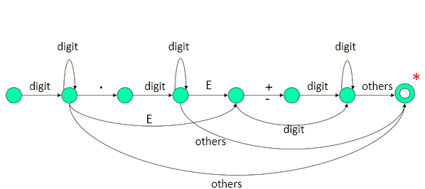

- Let a Context-Free Grammar {N,T,P,S} be N = {S}, T = {a, b}, Starting symbol = S,
Production rule = S → SS | aSb | ε
Draw a parse tree that produces abaabb (5 marks)

- Why are abstract syntax trees important in the compilation process? (2 marks)
- Name the three implementation strategies for Symbol tables. (3 marks)
- What is dead-code and what is the importance of its elimination? (3 marks)

SECTION B (Answer any two questions)

Question 2 (15 marks)

- Using a diagram, briefly explain the purpose of each phase of a compiler.
(8 marks)
- if x1 == y2 then total = total + 1 ; else total = 0 ;
i. List all identifiers that would be entered into the symbol table.
ii. Explain why maintaining the symbol table is important for later phases of compilation.
(5 marks)
- Draw the finite state machine diagram that produces the word ‘Banana’ in three states.
(2 marks)

Question 3 (15 marks)

- Convert the following NFA to DFA (11 marks)

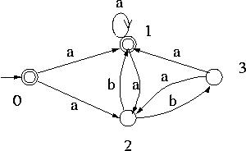

- There are four common error-recovery strategies that can be implemented in the parser to deal with errors in the code. Which are these strategies? (4 marks)

Question 4 (15 marks)
  - State three limitations of syntax analysers. (3 marks)
  - Which are the three tasks that must be performed in semantic analysis? (3 marks)
  - Runtime environment manages runtime memory requirements for three entities. Which are these entities? (3 marks)
  - A code optimization process must follow three rules. Describe these three rules.
(6 marks)

