
UNIVERSITY EXAMINATIONS
EXAMINATION FOR MAY/AUGUST 2023/2024 FOR BACHELOR OF SCIENCE IN COMPUTER SCIENCE AND BACHELOR OF BUSINESS INFORMATION TECHNOLOGY
RFC 201: ETHICS CULTURE AND DEVELOPMENT
DATE: 15TH AUGUST 2024 TIME: 2 HOURS

GENERAL INSTRUCTIONS:
Students are NOT permitted to write on the examination paper during reading time.
This is a closed book examination. Text book/Reference books/notes are not permitted.
SPECIAL INSTRUCTIONS
- Write your REGISTRATION NO. Clearly on the answer booklet(s).
- Answer Question One and ANY other TWO questions.
- Questions in all sections should be answered in answer booklet(s)
- PLEASE start the answer to EACH question on a NEW PAGE.
- For the questions, write the number of the question on the answer booklet(s) in the order you answered.
- Write on both sides of each leaf and indicate number of each question at the top of each page.
- Write the answers in a paragraph form unless stated otherwise.
- Marks allocated to each question are shown at the end of the question.
- All rough work must be done on the answer booklet and crossed through!
- Use supplementary pages only when you have exhausted those in this book.
- Fasten the supplementary pages to the inside back cover of this booklet.
QUESTION ONE (COMPULSORY – (30 MARKS)
Kenya: Journalist exposes how supermarkets endanger consumers' health by lacing beef with chemicals to increase shelf life
"NTV Exposes How Supermarkets Use Harmful Chemicals to Preserve Meat"
An exposé by NTVs Dennis Okari, that aired on Sunday night, showed how rogue supermarket officials use chemicals, to increase the shelf life of products, putting at risk the lives of millions of Kenyans. Okari spoke to a supermarket attendant who disclosed that sometimes meat is laced with food sulphites, also referred to as dawa ya nyama, to make it appear fresh longer. “Meat shouldn’t get spoilt in the supermarket. It is considered a loss. We try to minimise losses by using the chemicals on fresh, minced and diced beef,” he spoke. “Every morning before the doors open for customers, we take packaged meat that stayed overnight, remove the cling film and change the date labels to reflect the current date. If the packaging is stained with blood, we change it and put a new wrapping,” he added.
Food experts say sulphites are generally safe if used within recommended limits, but they can cause negative side effects like nasal congestion, itchy throat, runny nose, skin rash, and hives in some people. To demonstrate the effects of the preservatives, the NTV team bought the chemical from Nairobi's industrial area and proceeded to mix it with two portions of meat.
The two separate portions were then left to for a couple of days and true to the prediction, the meat with the dawa still looked fresh and juicy as opposed to the other portion that had already begun to discolour and smell. “Management expects sales even if the meat stays for three or five days. They want profits, that is why we lace the meat with the chemicals. "New mothers prefer to buy either fish fillet or minced meat to wean their babies as they introduce them to solid foods, but I normally feel guilty because I know the meat has chemicals and is not safe," explained the attendant...
15 Jul 2019
Author:
Denis Mwangi,
Accessed from: https://www.business-humanrights.org/en/latest-news/kenya-journalist-exposes-how-supermarkets-endanger-consumers-health-by-lacing-beef-with-chemicals-to-increase-shelf-life/

Required
- Elaborate the type of ethical theory that best suits the Shrewd supermarkets affected as per the case study. (5 marks)

- Justify the ethical moral development level for the affected supermarkets as depicted under the corporate moral development model (5 marks)
- Justify the moral development stage under which the supermarket attendant would be fitted under Kohlberg’s moral development’s theory. (5 marks)

- Based on this case study discuss Lewins model of change in as an advisory turnaround strategy to such entities in correcting the amoral business practice witnessed. ( 5 marks)

QUESTION TWO

- Discuss the EIGHT critical concepts in sociology of culture and their relation to ethics (16 marks)

- Label accordingly the FOUR culture typologies as per the figure below ( 4 marks)

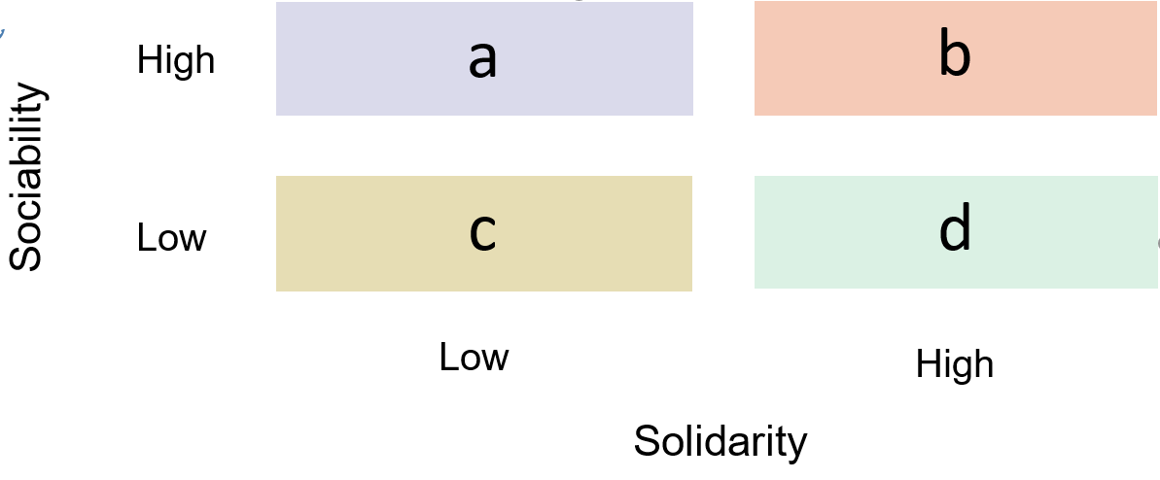
QUESTION THREE

a) Discuss any FOUR Ethical Theories discussed in course (12 marks)
b) Discuss for or against the effect of Culture, Ethics and Development (8 marks)

QUESTION FOUR

- Elaborate any FOUR International Cultural Dimensions and how they relate to both the developed economies and less developed economies. (8 marks)

- Discuss any FOUR (4) models of development and how they affect various countries

(12 marks)

