

RIARA SCHOOL OF INTERNATIONAL RELATIONS & DIPLOMACY
NURTURING INNOVATORS
SEPTEMBER - DECEMBER 2022 TRIMESTER
EXAMINATIONS FOR DIPLOMA IN ARTS IN INTERNATIONAL RELATIONS & DIPLOMACY
DAY PROGRAMME
RFC 041: ENVIRONMENTAL SUSTAINABILITY

DATE: 30TH NOVEMBER 2022 TIME: 2 HOURS

SPECIAL INSTRUCTIONS:
- Write your REGISTRATION NO. Clearly on the answer booklet(s).
- Answer Question One and ANY other TWO questions.
- Questions in all sections should be answered in answer booklet(s).
- PLEASE start the answer to EACH question on a NEW PAGE.
- For the questions, write the number of the question on the answer booklet(s) in the order you answered.
- Write on both sides of each leaf and indicate number of each question at the top of each page.
- Write the answers in paragraph form unless stated otherwise.
- Marks allocated to each question are shown at the end of the question.
- All rough work must be done on the answer booklet and crossed through!

- Use supplementary pages only when you have exhausted those in this booklet.
- Fasten the supplementary pages to the inside back cover of this booklet.

SECTION A: ANSWER ALL QUESTIONS IN THIS SECTION (30 MARKS)
QUESTION ONE
- Define the following Terms:
i) Environmental Sustainability (1¹/₂ marks)
ii) Point source pollution (1¹/₂ marks)
- Differentiate the following terms:
- Development and sustainable Development (2 marks)
- Biotic and Abiotic components of environment (2 marks)
- Environmental conflict is one of the key causes of political instability in many regions in the world. In East African region such conflicts have manifested themselves in different border areas, a common one is shown in the diagram below.
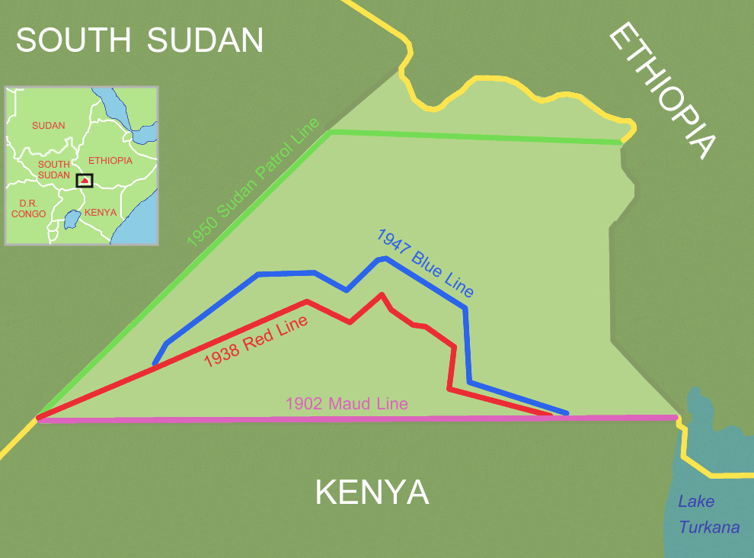
- Name the disputed area between Kenya and South Sudan shown in the diagram above.
(1 mark)
- You have been appointed by Kenya as one of the arbitrators in the resolution committee for the above land conflict, suggest at most three ways of resolving such conflict without affecting the good diplomatic relations that exists between the two countries.

(6 marks)
- Environmental Management and Coordination Act of 1999 in Kenya gave forth several environmental regulations in Kenya since its enactment for environmental protection and conservation.
State and explain three of these regulations that are helping Kenya as a country in achieving environmental sustainability. (6 marks)
- ‘The concept of sustainability has evolved along with our worries about the possible impact of our lifestyle on the environment. The various strategies strive to draw people’s attention to problems that development leads/brings about as it heavily depends on intensification of the industry/agriculture. The main reason why we should care about the issue is that for future generation, it is becoming harder to meet the basic needs as clean drinking water, food and clean air. The concept of sustainability has thus been changed from a more concentration on environmental problems towards comprehension of three different factors: social, economic and environmental.’ Anonymous
Critically discuss the contents of the above statement basing your answer on the principles of sustainable development. (10 marks)

SECTION B- ANSWER ANY TWO QUESTIONS (40 MARKS)
QUESTION TWO
As a major sector in the economy, the hotel sector accounts for a significant amount of the overall resource consumption and generates a substantial portion of waste to the environment.
Critically propose five suitable waste minimization techniques which hotel operators should adopt to mitigate the pressure on the environment. Use relevant examples to illustrate your answer. (20 marks)

QUESTION THREE
- Complete the table below.
- Fill in the first column of the table by inserting the name of the layer of the atmosphere that best fits the description. (5 marks)
- Underline the correct word (decreases or increases) in the last column.
(3 marks)

Layer of the  atmosphere | Altitude above  Earth's surface | Properties
 | 0 - 10 km | Weather occurs in this layer. Temperature decreases / increases  with altitude.
 | 10 - 50 km | Temperature decreases / increases with altitude, due to the absorption of  UV by the ozone layer.
 | 50 - 100 km | Temperature decreases with altitude.
 | 85 - 500 km | Temperature decreases / increases with altitude, due to absorption of solar  radiation.
 | 500 - 10,000 km | Outermost layer of the atmosphere.

- Discuss the relationship between environment and poverty. (12marks)

QUESTION FOUR
- “Development and Environment have long been considered to be contradictory.” Justify (10 marks)
- Explain ways in which covid-19 shaped Environmental sustainability in the world.
(10 marks)

QUESTION FIVE
- Evaluate five factors hindering sustainable development in Eastern Africa region. (10 marks)

- Using suitable examples, examine the role of the UN Environment in environmental sustainability. (10 marks)

