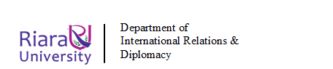
RIARA SCHOOL OF INTERNATIONAL RELATIONS & DIPLOMACY
NURTURING INNOVATORS
JANUARY-APRIL 2024 TRIMESTER
FINAL EXAMINATION FOR DIPLOMA PROGRAM
RFC 041: ENVIRONMENTAL SUSTAINABILITY
Date: APRIL 2024 Duration: 2 Hours
GENERAL INSTRUCTIONS:
Students are NOT permitted to write on the examination paper during reading time.
This is a closed book examination. Text book/Reference books/notes are not permitted.

SPECIAL INSTRUCTIONS:
1 Write your REGISTRATION NO. Clearly on the answer booklet(s).
2 Answer Question One and ANY other TWO questions.
3 Questions in all sections should be answered in answer booklet(s).
4 Marks allocated to each question are shown at the end of the question.
5 PLEASE start the answer to EACH question on a NEW PAGE.
6 For the questions, write the number of the question on the answer booklet(s) in the order you answered them.
7 Write your answers in paragraph form unless stated otherwise.
8 Keep your phone(s) SWITCHED OFF at the front of the examination room.

9 Keep ALL bags and caps at the front of the examination room and do not refer to any unauthorized material before or during the course of the examination.
10 You are only allowed to leave the examination room 30minutes to the end of the Examination.

SECTION A: COMPULSORY (30 MARKS)

QUESTION ONE
a) Define the following Terms:
- 'Green House Effect' (2 marks)
- Environmental Sustainability (2 marks)

b) The motto “Think Global, Act Local” was coined by Patrick Geedes, a Scottish urban planner of the early 20th century. Explain the meaning of the motto in relation to Environmental Sustainability with relevant examples
(4 marks)
c) Environmental conflict is one of the key causes of political instability in many regions in the world. In East African region such conflicts have manifested themselves in different border areas, an example of one is shown in the diagram below.
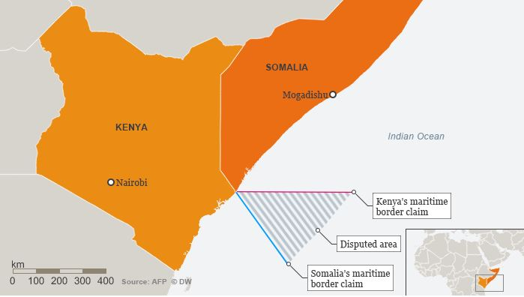
- Name the type of environmental conflict shown in the diagram above (1 mark)
- You have been appointed by Kenya as one of the arbitrators in the resolution committee for the above conflict, suggest at most three ways of resolving such conflict without compromising the good diplomatic relations that exists between the two countries ( 6 marks)

d) Explain factors responsible for the water crisis in Kenya and how this is exacerbating conflicts in some part of the country (6 marks)

e) Elaborate any FIVE sustainable development goals and make a projection of the possibility of Kenya achieving them by the year 2030
(10 marks)

SECTION B: CHOOSE TWO QUESTIONS FROM THIS SECTION (40 MARKS)

QUESTION TWO
- “Development and Environment have long been considered to be contradictory” Justify (10 marks)
- Explain ways in which covid-19 shaped Environmental sustainability in the world (10 marks)

QUESTION THREE
Environmental Impact Assessment/Environmental Audit regulation has revolutionized environmental management in Kenya in several ways. Explain
(20 marks)

QUESTION FOUR
a) Densely populated areas are suffering major issues in the field of solid waste and waste water management.
- Relate this statement with the current situation in Kenya ( 8 marks)

- Suggest any three sustainable methods each for the solid waste and waste water management system (6 marks)

b) Explain the significance of carbon footprint and suggest some methods for reducing the carbon footprint of your house ( 6 marks)

QUESTION FIVE
- Evaluate five factors hindering sustainable development in Eastern Africa region (10 marks)
- Using suitable examples, examine the role of the UN Environment in environmental sustainability (10 marks)

***END OF QUESTION PAPER***

