
UNIVERSITY EXAMINATIONS
EXAMINATION FOR MAY/AUGUST 2020/2021 DIPLOMA IN COMPUTER SCIENCE/DIPLOMA IN INFORMATION TECHNOLOGY/ DIPLOMA IN BUSINESS INFORMATION TECHNOLOGY
COURSE CODE: RCS 016 / RCT 003: COURSE TITLE: INTRODUCTION TO DIGITAL ELECTRONICS.

DATE _____________ TIME: 2 HOURS
GENERAL INSTRUCTIONS:
Students are NOT permitted to write on the examination paper during examination time.
This is a closed book examination. Text book/Reference books/notes are not permitted.

SPECIAL INSTRUCTIONS:
This examination paper consists Questions in Section A followed by section B.
Answer Question 1(Mandatory) and any other two questions.
QUESTIONS in ALL Sections should be answered in answer booklet(s).

PLEASE start the answer to EACH question on a NEW PAGE.

Keep your phone(s) switched off at the front of the examination room.

Keep ALL bags and caps at the front of the examination room and DO NOT refer to ANY unauthorized material before or during the course of the examination.

ALWAYS show your working.

Marks indicated in parenthesis i.e. ( ) will be awarded for clear and logical answers.

Write your REGISTRATION No. clearly on the answer booklet(s).

For the Questions, write the number of the question on the answer booklet(s) in the order you answered them.
- Calculator will be required, DO NOT use your PHONE as a CALCULATOR.
- YOU are ONLY ALLOWED to leave the exam room 30minutes to the end of the Exam.
- DO NOT write on the QUESTION PAPER. Use the back of your BOOKLET for any calculations or rough work.
- Calculator will be required.
SECTION A (COMPULSORY)

Question (1) - (30Marks)
- Define the following terminologies as used in digital logics. (10 Marks)
- Bit.
- Byte.
- Parity.
- Nibble.
- Overflow.
- The modern computers are able to process both digital and analog signals/data, discus how that is achieved. (4 Marks)

- Describe the following digital logic circuits and state how they are used in computers.
(4 Marks)
- Encoder.
- Decoders.
- Multiplexers.
- De-Multiplexers.

- List FOUR Number systems used in digital electronics, state their bases and showing all character ranges. (4 Marks)

- Evaluate the following Conversions for the following numbers, into the indicate format. Show all the working. (5 Marks)

- 10101011001101₂ into Hexadecimal number.
- 10101010101010_{bin} into Gray code.
- 101010101₂ into decimal number.
- ABC0₁₆ into octal number.
- 157₁₀ into binary number.

- What are the universal logic gates? Give examples. (3 Marks)

SECTION B (Answer Any Two Questions)

Question (2) - (20Marks)
- State and prove the De-Morgan’s theorem. You can use truth table. (6 Marks)

- Considering the logic circuit below.
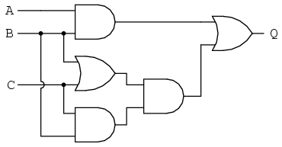
- Derive its output function (Q). (3 Marks)
- Simplify the function to its simplest form. (4 Marks)
- Draw the logic circuit for the simplified function. (3 Marks)

- With reference to Analog to Digital Converters (ADC) and Digital to Analog Converters (DAC) discus the concept of DSP (Digital Signal Processing). (4 Marks)

Question (3) - (20Marks)
- Discus the following level of integration scales as used in Digital Integrated Chips (ICs) fabrication. (5 Marks)
- Small Scale Integration (S.S.I).
- Medium Scale Integration (M.S.I).
- Large Scale Integration (L.S.I).
- Very Large Scale Integration (V.L.S.I).
- Ultra Large Scale Integration. (U.L.S.I).

- Perform the following conversions. (6 Marks)
- 1011010.101011_{bin} - to decimal format.
- 135.245_{dec} - to binary format.
- Considering the Boolean logic function below.
Y_{o} = { A̅BC + AB̅C + ABC̅ + ABC }.

- Draw an equivalent digital circuit. (4 Marks)
- Simplify the function to have lowest number of gates. (5 Marks)

Question (4) - (20Marks)
- Describe the following terms as used in digital circuits. (5 Marks)
- Propagation Delay.
- Fall Time.
- Rise time.
- Fan Out.
- Fan In.

- Derive the output function (X) for the Combination circuit below. (5 Marks)

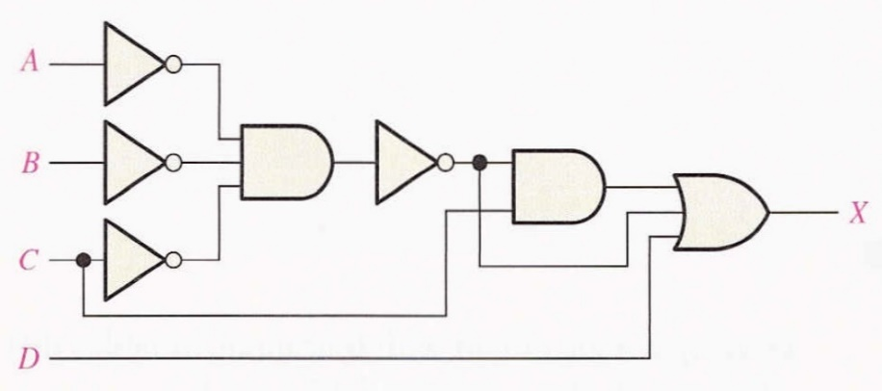

- Draw five basic logic gates, used in digital designs and derive the Truth tables and Boolean functions. (10 Marks)

Question (5) - (20Marks)
- Using Karnaugh-Mapping, design a four bits - binary to gray code converter and implement the logic circuit. (10 Marks)

- Simplify the Boolean expression illustrated below. (4 Marks)

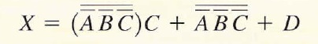

- Explain how the Successive-Approximation, Analog to Digital Converter function/operates. (4 Marks)

- Differentiate between the combinational and sequential logic circuits. (2 Marks)

END

