
UNIVERSITY EXAMINATIONS

EXAMINATION FOR SEPTEMBER/DECEMBER 2024/2025 FOR BACHELOR OF SCIENCE IN COMPUTER SCIENCE
RCS 108: COMPUTER ORGANIZATION & ASSEMBLY LANGUAGE.

DATE 3RD /12 /2024 TIME: 2 HOURS

GENERAL INSTRUCTIONS:
Students are NOT permitted to write on the examination question paper during examination time.
This is a closed book examination. Text book/Reference books/notes are not permitted.
SPECIAL INSTRUCTIONS:
This examination paper consists Questions in Section A followed by section B.
Answer Question 1 and any Other Two questions.
QUESTIONS in ALL Sections should be answered in answer booklet(s).

PLEASE start the answer to EACH question on a NEW PAGE.

Keep your phone(s) switched off at the front of the examination room.

Keep ALL bags and caps at the front of the examination room and DO NOT refer to ANY unauthorized material during the course of the examination.

ALWAYS show your working.

Marks indicated in parenthesis i.e. ( ) will be awarded for clear and logical answers.

Write your REGISTRATION No. clearly on the answer booklet(s).

For the Questions, write the number of the question on the answer booklet cover page in the order you answered them.
- DO NOT use your PHONE as a CALCULATOR.
- YOU are ONLY ALLOWED to leave the exam room 1 hour to the end of the Exam.
- DO NOT write on the QUESTION PAPER. Use the back of your BOOKLET for any calculations or rough work.
- Calculators may be required.
- Microprocessor Instruction sets will be provided.

SECTION A (COMPULSORY)

Question (1) - (30Marks)
- Describe the following computer hardware, stating the purposes. (6 Marks)
- CPU.
- RAM.
- ROM.
- Cache.
- North Bridge.
- South Bridge.

- State FIVE categories / types of instructions based on their functions. (5 Marks)

- Compare between R.I.S.C. and C.I.S.C, by outline FIVE major differences. (5 Marks)

- Name three major types of primary buses used by a computer system and hence describe their functionalities. (3 Marks)

- State FOUR major hardware related factors that impact on computer performance. (4 Marks)

- State and Describe SEVEN major registers used in CPUs. (7 Marks)

SECTION B (Answer Any Two Questions)
Question (2) - (15 Marks).
- Define the following terminologies as used in computer organization. (5 Marks)

- Multi - Tasking.
- Multi - Processing.
- Parallel Processing.
- Multiprogramming.
- Parallel Computing.

- State the differences between the Harvard computer architectures and the Von Neumann computer architectures? (3 Marks)

- Explain the purposes of the following CPU hardware components. (3 Marks)
- Interrupt controller.
- Instruction decoder.
- Serial I/O controller.

- Considering the B.I.O.S. and P.O.S.T., discuss the computer booting process. (4 Marks)

Question (3) - (15 Marks).
- Describe the following terms, and hence state their purposes. (3 Marks)
    - Compiler.
    - Interpreter.
    - Assembler.

- In details discuss, the Fetch Execute Cycle as implemented during the instruction’s executions. (7 Marks)

- If a computer system has 64 bits data buses, 38 bits address buses, & 16-bit control buses.
- How much of RAM size can be addressed by the system? (2 Marks)
- What is the maximum size of word, the system can handle? (1 Marks)

- State the difference between computer architecture and computer organisation. (2 Marks)

Question (4) - (15 Marks).

- Describe all the flag bits used in the Intel 8085 microprocessor, and explain how they are used in data processing. (5 Marks)

- Discuss FIVE addressing modes used in the Intel 8085 microprocessor instruction sets, site an example, for each of the addressing mode. (5 Marks)

- With referencing to 8085 microprocessor, instructions, state one (single) instruction to perform the following operations. (5 Marks)

 | OPERATION TO EXECUTE. | INSTRUCTION
 | Transfer Accumulator content to memory location 84FF _{hex}. | ?
 | Add the content of memory indirectly. | ?
 | Read data from port 80 _{hex} | ?
 | Increment content of memory by one, indirectly. | ?
 | Exchange contents of registers DE and HL. | ?
 | Clear the content of the Accumulator. | ?

Question (5) - (15 Marks).

- Outline FOUR major differences between the high-level language and the low-level programming languages and hence give an example in each. (4 Marks)

- Using Intel-8085 microprocessor ISA, and a suitable flow-chat, write a program to multiply two numbers (8 and 6) stored in the RAM, memory locations 2000_{hex} & 2001_{hex} respectfully, and then store the results from the operation into the memory location 2010_{hex}. (5 Marks)
(Refer to the instruction set for Intel 8085 provided on page 5 and 6).

- Assembled the program you wrote in the question above and show how much (Bytes) of the memory, the program will use. (3 Marks)

- State and describe THREE types of RAMs and THREE types of ROMs. (3 Marks)

Intel’s 8085 Microprocessors Instruction Set summary provided in the next two pages.

INTEL 8085 MICROPROCESSOR INSTRUCTION SET

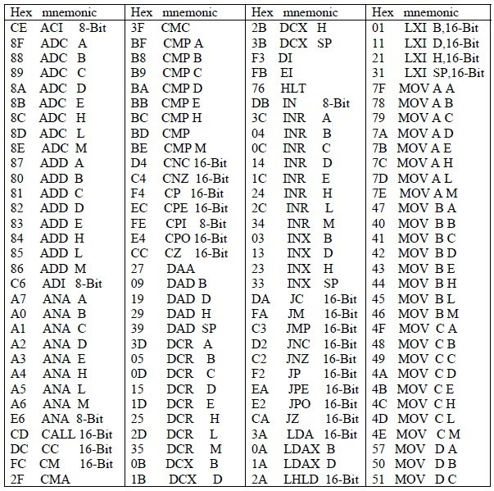

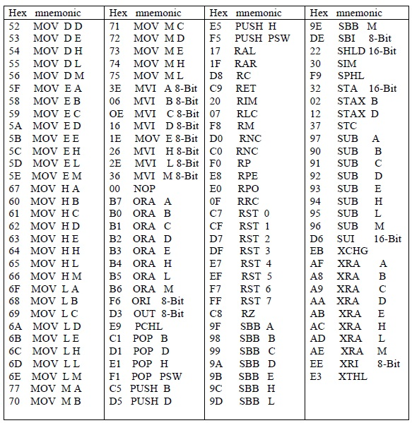

END

