
UNIVERSITY EXAMINATIONS

EXAMINATION FOR JANUARY / APRIL 2024/2025 FOR BACHELOR OF SCIENCE IN COMPUTER SCIENCE
COURSE CODE: RCS 108. COURSE TITLE: COMPUTER ORGANIZATION & ASSEMBLY LANGUAGE.

DATE -- / -- /2025 TIME: 2 HOURS

GENERAL INSTRUCTIONS:
Students are NOT permitted to write on the examination question paper during examination time.
This is a closed book examination. Text book/Reference books/notes are not permitted.
SPECIAL INSTRUCTIONS:
This examination paper consists Questions in Section A followed by section B.
Answer Question 1 and any Other Two questions.
QUESTIONS in ALL Sections should be answered in answer booklet(s).

PLEASE start the answer to EACH question on a NEW PAGE.

Keep your phone(s) switched off at the front of the examination room.

Keep ALL bags and caps at the front of the examination room and DO NOT refer to ANY unauthorized material during the course of the examination.

ALWAYS show your working.

Marks indicated in parenthesis i.e. ( ) will be awarded for clear and logical answers.

Write your REGISTRATION No. clearly on the answer booklet(s).

For the Questions, write the number of the question on the answer booklet cover page in the order you answered them.
- DO NOT use your PHONE as a CALCULATOR.
- YOU are ONLY ALLOWED to leave the exam room 1 hour to the end of the Exam.
- DO NOT write on the QUESTION PAPER. Use the back of your BOOKLET for any calculations or rough work.
- Calculators may be required.
- Microprocessor Instruction sets will be provided.

SECTION A (COMPULSORY)
Question (1) - (30Marks)
- Describe the following terms as used in computer systems. (7 Marks)
- I.S.A.
- Cache.
- B.I.O.S.
- P.O.S.T.
- Software.
- Firmware.
- Hardware.

- Describe FOUR major components of a microprocessor, stating their purposes. (4 Marks)
- Discus the purposes following components. (3 Marks)
    - Compiler.
    - Interpreter.
    - Assembler.

- A computer system has 18-bit control buses, 38 bits address buses, & 64 bits data buses.
- How much memory can the system handle? (2 Marks)
- What is the maximum size of word, the system can handle? (1 Marks)

- What will be the effect of executing the following intel 8085 instructions. (4 Marks)
- XCHG
- STA 2500 H
- LHLD 2000 H
- LXI H, FFFF H

- Considering the CPUs and their Associated Addressing Modes.
- Explain what the term Addressing Mode means. (2 Marks)
- Describe FIVE Addressing modes used in intel’s 8085 Processors. (5 Marks)

- Differentiate between Parallel-Processing and Multi-Programming. (2 Marks)

SECTION B (Answer Any Two Questions)
Question (2) - (15 Marks).
- In details, discuss, the complex Fetch Execute Cycle process, as implemented during the instruction’s executions. (7 Marks)

- State FIVE categories / types of instructions based on their functionality. (5 Marks)

- Name three major types of primary buses used by a computer system and hence describe their functionalities. (3 Marks)

Question (3) - (15 Marks).
- List THREE differences between the Harvard computer architectures and the Von Neumann computer architectures? (3 Marks)

- State the purposes of the following I/O ports as used in computer. (4 Marks)
- Firewire Port.
- e-SATA Port.
- PS/2 Port.
- DVI Port.

- Assuming that the registers of Intel’s 8085 already have the data shown in the table below.
Registers | Reg A | Reg B | Reg C | Reg D | Reg E | Reg H | Reg L
Data | FF_{hex} | 06_{hex} | 04_{hex} | AB_{hex} | CD_{hex} | F3_{hex} | 8E_{hex}

- What will be the data in the same register after executing the code / instructions below? (4 Marks)

Instructions
XRA A
MVI B, F7 _{Hex}
MOV D,A
MOV E,A
ADC B
INX D
XCHG

- Assemble the code above, and hence state amount of memory used. (4 Marks)

Question (4) - (15 Marks).

- Compare high-level programming languages and Low-level Programming. (2 Marks)

- State and explain FOUR major hardware related factors that have an impact, on computer performance. (2 Marks)

- Outline FIVE major differences between R.I.S.C. and C.I.S.C as referenced in microprocessors. (5 Marks)

- State and Describe SIX major types of registers used found in a microprocessor (CPU). (6 Marks)
Question (5) - (15 Marks).

- Describe all the flag register bits of the Intel 8085 microprocessor. (5 Marks)

- Write a program to multiply two numbers stored in the memory locations 2000_{hex} & 2001_{hex} respectfully, and then store the results from the operation into the memory location 2010_{hex}. (6 Marks)
(Refer to the instruction set for Intel 8085 provided on page 5 and 6).

- Considering the assembly code below:

;<Program > | Comments:
JMP START
; data
; code
START:
MVI A, FF_{hex}
LXI H, 20FF_{hex}
Loop:
MOV M, A
DCR L
JNZ Loop
HLT

- State what the code is used for. (2 Marks)
- Comment on each statement to describe purpose. (2 Marks)

(Refer to the instruction set for Intel 8085 provided on page 5 and 6).

Intel’s 8085 Microprocessors Instruction Set summary provided in the next two pages.

INTEL 8085 MICROPROCESSOR INSTRUCTION SET:

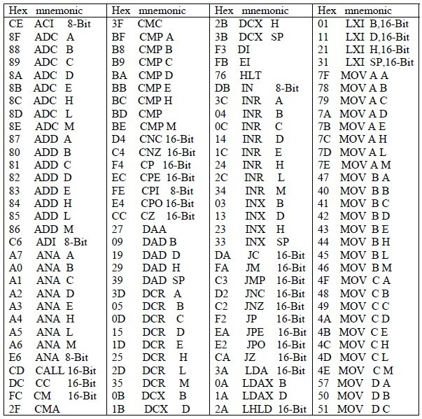

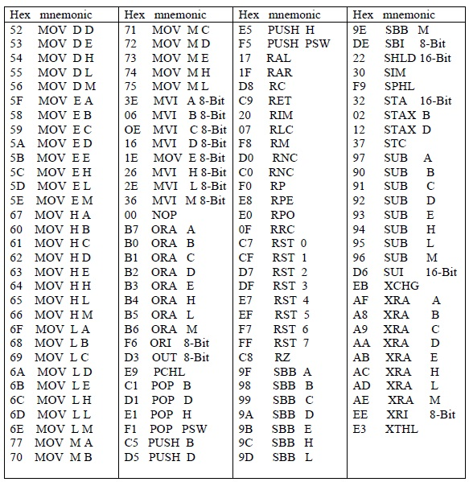

END

