

RIARA SCHOOL OF BUSINESS
NURTURING INNOVATORS
SEPTEMBER-DECEMBER 2023 TRIMESTER
EXAMINATION FOR BACHELOR OF LAWS PROGRAMME
RFC 105: FOUNDATIONS OF AFRICA’S CIVLIZATION

DATE: 28TH NOVEMBER 2023 TIME: 9:00AM TO 11:00AM

GENERAL INSTRUCTIONS:
Students are NOT permitted to write on the examination paper during reading time.
This is a closed book examination. Text book/Reference books/notes are not permitted.

SPECIAL INSTRUCTIONS:
1 Write your REGISTRATION NO. Clearly on the answer booklet(s).
2 Answer Question ONE and ANY other FOUR questions.
3 Questions in all sections should be answered in answer booklet(s).
4 Marks allocated to each question are shown at the end of the question.
5 PLEASE start the answer to EACH question on a NEW PAGE.
6 For the questions, write the number of the question on the answer booklet(s) in the order you answered them.
7 Write your answers in paragraph form unless stated otherwise.
8 Keep your phone(s) SWITCHED OFF at the front of the examination room.

9 Keep ALL bags and caps at the front of the examination room and do not refer to any unauthorized material before or during the course of the examination.
10 You are only allowed to leave the examination room 30minutes to the end of the Examination.

“True Size of Africa”
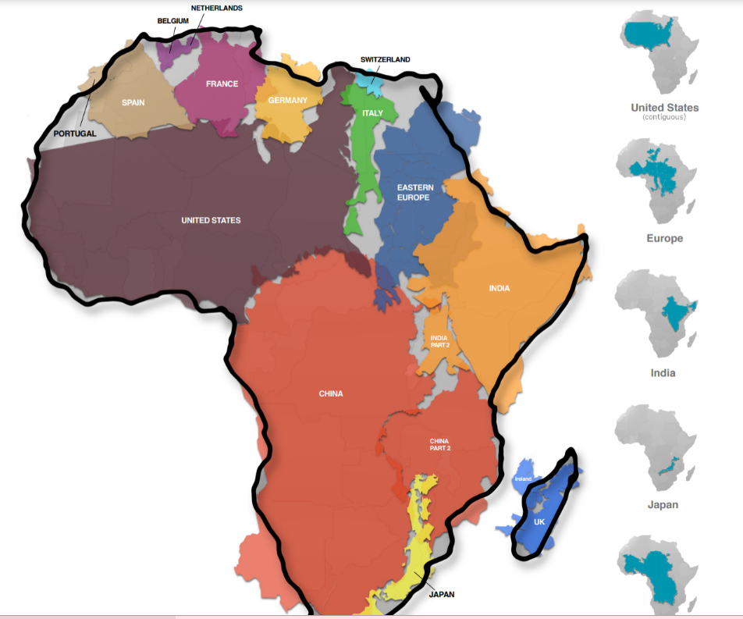
https://www.visualcapitalist.com/map-true-size-of-africa/

QUESTION ONE: (20 MARKS)
Based on the image above on the 'True size of Africa' discuss against the 'pseudo/false' arguments that have been stereotyped or levelled to Africa/Africans as inferior based on the lessons that you have learnt in this course and the image that strikes you with this reality of the true size of Africa. (20 marks)

QUESTION TWO:
Africa, from Hegel’s point of view is devoid of morality, religion, and political constitution; counter this argument applying the knowledge you have learnt in this course. (10 marks)
QUESTION THREE:
Outline the FOUR African Philosophies as proposed by H. Odera Oruka (10 marks)

QUESTION FOUR:
Compare the ethnophilosophy and sage philosophy as means to which African philosophers proposed to counter the negative perceptions by colonial masters and western philosophers (10 marks)

QUESTION FIVE:
Briefly compare the features witnessed in Triangular Slave trade and the features that are witnessed in modern forms of slavery. (10 marks)

QUESTION SIX:
Discuss any FOUR themes identified under Nationalist Ideological Philosophy as proposed by African Philosophers: (10 marks)

----------------------------END----------------------------

