
UNIVERSITY EXAMINATIONS
EXAMINATION FOR SEPTEMBER/DECEMBER 2023/2024 FOR BACHELOR OF SCIENCE IN COMPUTER SCIENCE
RCS207: DATABASE SYSTEMS
DATE _____________ TIME: 2 HOURS
GENERAL INSTRUCTIONS:
Students are NOT permitted to write on the examination question paper during examination time.
This is a closed book examination. Text book/Reference books/notes are not permitted.

SPECIAL INSTRUCTIONS:
This examination paper consists Questions in Section A followed by section B.
Answer Question 1 and any Other Two questions.
QUESTIONS in ALL Sections should be answered in answer booklet(s).

PLEASE start the answer to EACH question on a NEW PAGE.

Keep your phone(s) switched off at the front of the examination room.

Keep ALL bags and caps at the front of the examination room and DO NOT refer to ANY unauthorized material before or during the course of the examination.

ALWAYS show your working.

Marks indicated in parenthesis i.e. ( ) will be awarded for clear and logical answers.

Write your REGISTRATION No. clearly on the answer booklet (s).

For the Questions, write the number of the question on the answer booklet (s) in the order you answered them.
- DO NOT use your PHONE as a CALCULATOR.
- YOU are ONLY ALLOWED to leave the exam room 1 hour to the end of the Exam.
- DO NOT write on the QUESTION PAPER. Use the back of your BOOKLET for any calculations or rough work.

SECTION A (COMPULSORY)
QUESTION 1 (COMPULSORY, 30 MARKS).
- Given the Scenario below, normalize the Student_Grade_Report table to the 3rd normal form using a functional dependency diagram to show the steps you have followed. (6 Marks)
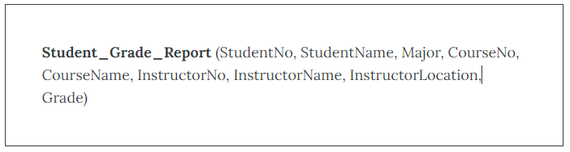
- Write an sql statement to retrieve the student name and the grade attained in a certain unit from the normalized tables. (2 Marks)

- Study the snapshot below and answer the questions that follow
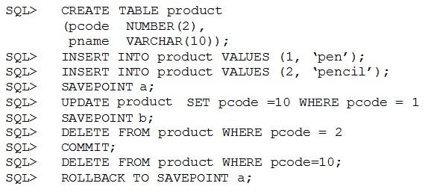
- Explain the effects of the commit statement above. (2 Marks)
- Explain the effects of the “Savepoint b” statement. (2 Marks)

- Expand the acronym ACID and explain each of the components. (4 Marks)
- Highlight four Computer-Based Controls which can be used in safeguarding data in a database (4 Marks)
- List Eight Functions and Service of DBMS (4 Marks)
- Construct an E-R diagram for a hospital with a set of patients and a set of medical doctors. Associate with each patient a log of the various tests and examinations conducted.
(6 Marks)

SECTION B (ANSWER ANY TWO QUESTIONS)
QUESTION 2 (15 MARKS)
UPS prides itself on having up-to-date information on the processing and current location of each shipped item. To do this, UPS relies on a company-wide information system. Shipped items are the heart of the UPS product tracking information system. Shipped items can be characterized by item number (unique), weight, dimensions, insurance amount, destination, and final delivery date. Shipped items are received into the UPS system at a single retail center. Retail centers are characterized by their type, uniqueID, and address. Shipped items make their way to their destination via one or more standard UPS transportation events (i.e., flights, truck deliveries). These transportation events are characterized by a unique scheduleNumber, a type (e.g, flight, truck), and a deliveryRoute.
- Draw an entity relationship diagram for the above scenario showing cardinality (8 Marks)

- State any two assumptions that you have made in question (a) above (2 Marks)

- Draw a logical design of the above system and propose some possible fields (5 Marks)

QUESTION 3 (15 MARKS)
- Describe the ANSI-SPARC Architecture (5 Marks)
- Differentiate between the following terms (10 Marks)
- Network and Hierarchical model
- Immediate (in place) Update and Deferred Update
- Primary key and foreign key
- Candidate key and composite key
- Conceptual and external level of ANSI-SPARK Architecture

QUESTION 4 (15 MARKS)
- Study the cars table below and write Sql statements to do the following
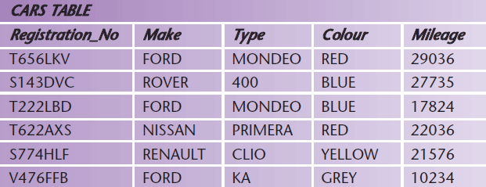
  - To select Registration_No, make, type, color for all red cars whose mileage is less than 20000 (3 Marks)
  - To select Registration_No, make, type, color for non_Ford cars that are red in colour (3 Marks)
  - To select Registration_No, make, type, color for Renault cars that are grey in colour with a mileage between 22,000 and 25,000 (3 Marks)

- Describe the three phases of Database design methodology (6 Marks)

QUESTION 5 (20 MARKS)
- There are a number of problems that concurrency can cause. Discuss three such problems with the aid of a diagram and an example for each. (12 marks)
- Explain how the locking mechanism can solve the lost update problem (3 Marks)

