
UNIVERSITY EXAMINATIONS
EXAMINATION FOR JANUARY/APRIL 2024/2025 FOR SCHOOL OF COMPUTING SCIENCES
RFC 111: COMPUTER ESSENTIALS

DATE: 11TH APRIL 2025 TIME: 2 HOURS

GENERAL INSTRUCTIONS:
Students are NOT permitted to write on the examination paper during examination time.
This is a closed book examination. Text book/Reference books/notes are not permitted.

SPECIAL INSTRUCTIONS:
This examination paper consists Questions in Section A followed by section B.
Answer Question 1 and any Other Two questions.
QUESTIONS in ALL Sections should be answered in answer booklet(s).

PLEASE start the answer to EACH question on a NEW PAGE.

Keep your phone(s) switched off at the front of the examination room.

Keep ALL bags and caps at the front of the examination room and DO NOT refer to ANY unauthorized material before or during the course of the examination.

ALWAYS show your working.

Marks indicated in parenthesis i.e. ( ) will be awarded for clear and logical answers.

Write your REGISTRATION No. clearly on the answer booklet(s).

For the Questions, write the number of the question on the answer booklet(s) in the order you answered them.
- DO NOT use your PHONE as a CALCULATOR.
- YOU are ONLY ALLOWED to leave the exam room 30minutes to the end of the Exam.
- DO NOT write on the QUESTION PAPER. Use the back of your BOOKLET for any calculations or rough work.

SECTION A (COMPULSORY)

QUESTION ONE (30 MARKS)

- The use of Artificial Intelligence in the manufacturing industry has grown tremendously. Explain the benefits it has introduced to the industry. (4 Marks)
- A School administrator intends to use a database to manage school records. Outline four advantages of using the database (4 Marks)
- List TWO key factors that can result in RSI. (Repetitive Strain Injury) (2 Marks)
- Differentiate between “utility software” and “system software” using appropriate examples (4 Marks)
- Organizations have embraced the use of cloud computing in conducting their businesses
  - Explain the term cloud computing (2 Marks)
  - State two advantages that organizations would gain from this technology (2 Marks)
- Discuss any THREE-safety rules to observe when using a computer and explain why they should be followed (3 Marks)
- List THREE major elements of Cybersecurity (3 Marks)
- Describe the key operations of a (CPU) central processing unit (4 Marks)
- Digital Marketing is a fast-growing phenomenon in the world today. Briefly explain its benefits to the business community. (2 Marks)

SECTION B (ANSWER ANY TWO QUESTIONS IN THIS SECTION)

QUESTION TWO (15 MARKS)
- Sate the difference between a magnetic tape and a magnetic disk (4 Marks)
- Give TWO examples of unethical behavior related to computer use. (2 Marks)
- This function =SUM(A1:A5) is used in a spreadsheet program. Identify three components of the function (3 Marks)
- Describe absolute cell referencing as used in worksheets with the aid of an example (2 Marks)
- Explain four major types of transmission media used in computer networks. (4 Marks)
QUESTION THREE (15 MARKS)
- Demonstrate your understanding of the following terms
- Social Engineering (2 Marks)
- Cold booting (2 Marks)
- Cache Memory (2 Marks)
- Explain five network topologies that you are familiar with (5 Marks)
- Outline the keyboard combination that could be used to achieve each of the following in MS word: (4 Marks)
  - Underline a word in a document
  - Save the current document
  - Align Left content of a document
  - To print a document

QUESTION FOUR (15 MARKS)

- Name the types of networks found within the following geographical areas; Continent, City and College (3 Marks)
- Describe the data processing cycle (2 Marks)
- State THREE main ethical issues in computer use? (6 Marks)
- Differentiate between SRAM and DRAM (4 Marks)

QUESTION FIVE (15 MARKS)

- With the aid of a sketch, outline three parts of a computer mouse (3 Marks)
- The below document was created using a word processor program. Identify eight formats that have been applied on the text in the document (8 Marks)
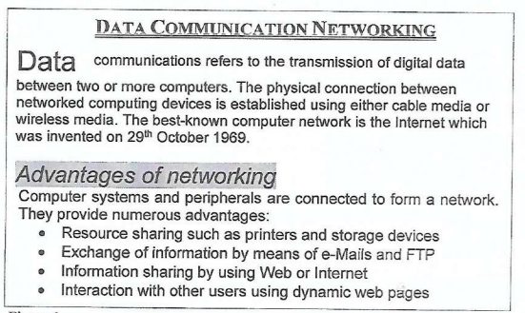
- We have different types of computers. Explain the following types of computers
  - Main frame computer (2 Marks)
  - Quantum computer (2 Marks

