
UNIVERSITY EXAMINATIONS

EXAMINATION FOR JANUARY/APRIL 2024 /2025 FOR BACHELOR OF SCIENCE IN COMPUTER SCIENCE / BUSINESS INFORMATION TECHNOLOGY

RCS 307 - EVENT PROGRAMMING

DATE: 11TH APRIL 2025 TIME: 2 HOURS

GENERAL INSTRUCTIONS:
Students are NOT permitted to write on the examination paper during examination time.
This is a closed book examination. Text book/Reference books/notes are not permitted.

SPECIAL INSTRUCTIONS:
This examination paper consists Questions in Section A followed by section B.
Answer Question 1 and any Other Two questions.
QUESTIONS in ALL Sections should be answered in answer booklet(s).

PLEASE start the answer to EACH question on a NEW PAGE.

Keep your phone(s) switched off at the front of the examination room and NOT on your person.

Keep ALL bags and caps at the front of the examination room and DO NOT refer to ANY unauthorized material before or during the course of the examination.

ALWAYS show your working.

Marks indicated in parenthesis i.e. ( ) will be awarded for clear and logical answers.

Write your REGISTRATION No. clearly on the answer booklet(s).

For the Questions, write the number of the question on the answer booklet(s) in the order you answered them.
- DO NOT use your PHONE as a CALCULATOR.
- YOU are ONLY ALLOWED to leave the exam room 30minutes to the end of the Exam.
- DO NOT write on the QUESTION PAPER. Use the back of your BOOKLET for any calculations or rough work.

SECTION A (COMPULSORY)

QUESTION ONE (30 Marks)

- Define exception handling of events. (2 Marks)

- Describe how the five dimensions of interaction Design’s that were first defined by a professor at London’s Royal College of Art, Gillian Crampton Smith, and a senior interaction designer, Kevin Silver that could improve the usability of an event driven system. (5 Marks)

- Write a Java code segment with all the parts that demonstrates the implementation of MVC approach in designing Event Driven solutions. Clearly show the sections of that represent each part of the approach. (3 Marks)

- Using a diagram, illustrate Java Class AWTEvent and its events subclasses.
(5 Marks)

- The diagram below shows a logical computer network topology. Data communication allows users to communicate when using computing devices. List any four data communication events. (4 Marks)
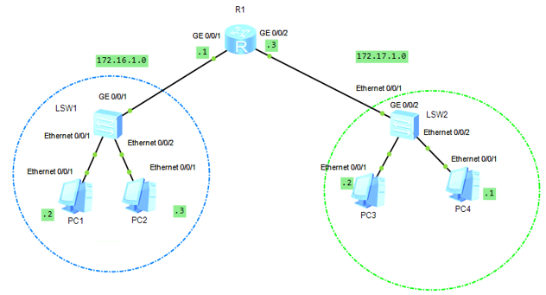
- Programming languages have both strengths and weaknesses. List three benefits of Events Driven Programming Languages. (3 Marks)

- When creating event driven user graphical interfaces, highlight situations where you will use a list box and not a combo box. (4 Marks)

- Events occur even in production plants. Explain the industrial process represented by the ladder diagram of a PLC, highlighting possible events that can be initiated.
(4 Marks)
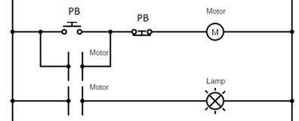

SECTION B (Answer ANY Two Questions)

QUESTION TWO (15 Marks)

- Highlight situations where the following components can be used in industrial event driven systems. (2 Marks)
- Push Button
- Toggle Switch

- Enumerate the importance of cognitive psychology in designing event driven interfaces. (3 Marks)

- Compare Java Swing with Java AWT. (4 Marks)

- Even at a glance, event driven systems interfaces should be understandable. Outline two factors you use to measure the learnability of a user interface in event driven systems. (2 Marks)

- Differentiate between PaintEvents and ContainerEvents in Java. (4 Marks)

QUESTION THREE (15 Marks)

- Differentiate between General Purpose Containers from Top Level Swing containers in Java. Give examples. (4 Marks)

- Study the following section of an embedded C code and describe the sequence of events in controlling a motor. (4 Marks)
void loop() {

digitalWrite(in_1,HIGH) ;
digitalWrite(in_2,LOW) ;
analogWrite(pwm,255) ;

delay(3000) ;

digitalWrite(in_1,HIGH) ;
digitalWrite(in_2,HIGH) ;

delay(1000) ;

digitalWrite(in_1,LOW) ;
digitalWrite(in_2,HIGH) ;

delay(3000) ;

digitalWrite(in_1,HIGH) ;
digitalWrite(in_2,HIGH) ;
delay(1000) ;
}

- Event driven systems interact with users. Discuss any five best practices for designing interactions especially for event driven systems. 5 Marks)

- To manage event loops, describe to popular methods of controlling and exiting loops.
(2 Marks)

QUESTION FOUR (15 Marks)

- Define interaction design as used in event driven systems. (2 Marks)

- Showing all dependencies, illustrate JComponent Class in Java. (3 Marks)

- Study the following AVR assembly code and highlight the two events being executed.
(2 Marks)

main:
in r16, PINB
mov r17, r16
in r16, PINB
mov r18, r16

add r17, r18

out PORTD, r17

rjmp main

- Discuss a scenario where autonomous event sources provide inputs to an event-driven program. (3 Marks)

- Describe FocusListener as used in event driven systems. (2 Marks)

- Using a Java code segment with all the parts, explain the structure and output of a for loop control structure that controls the painting of vehicle parts in a car assembly plant. (3 Marks)

QUESTION FIVE (15 Marks)

- There are components in either AWT of Swing class hierarchy, enumerate three methods in Java, used to work with or format components for better look and feel of event driven interfaces. (3 Marks)

- Using a Java program segment with all the parts, explain the structure and output of a for loop control structure, in events that include the starting and stopping a posh mill with Alternating Current ( AC) motor. (4 Marks)

- Including an illustration of all components, discuss Swing class hierarchy in Java.
(4 Marks)

- Events use models to accomplish tasks. Using examples, explain Polling and Delegating models of event handling. (4 Marks)

