
UNIVERSITY EXAMINATIONS
EXAMINATION FOR MAY/AUGUST 2022/2023 FOR BACHELOR OF SCIENCE IN COMPUTER SCIENCE AND BACHELOR OF BUSINESS INFORMATION TECHNOLOGY
COURSE CODE: RCS303 COURSE UNIT: WIRELESS NETWORKS
DATE _____________ TIME: 2 HOURS
GENERAL INSTRUCTIONS:
Students are NOT permitted to write on the examination question paper during examination time.
This is a closed book examination. Text book/Reference books/notes are not permitted.

SPECIAL INSTRUCTIONS:
This examination paper consists Questions in Section A followed by section B.
Answer Question 1 and any Other Two questions.
QUESTIONS in ALL Sections should be answered in answer booklet(s).

PLEASE start the answer to EACH question on a NEW PAGE.

Keep your phone(s) switched off at the front of the examination room.

Keep ALL bags and caps at the front of the examination room and DO NOT refer to ANY unauthorized material during the course of the examination.

ALWAYS show your working.

Marks indicated in parenthesis i.e. ( ) will be awarded for clear and logical answers.

Write your REGISTRATION No. clearly on the answer booklet(s).

For the Questions, write the number of the question on the answer booklet cover page in the order you answered them.
- DO NOT use your PHONE as a CALCULATOR.
- YOU are ONLY ALLOWED to leave the exam room 1 hour to the end of the Exam.
- DO NOT write on the QUESTION PAPER. Use the back of your BOOKLET for any calculations or rough work.

QUESTION ONE (30 MARKS)
(a) Describe how each of the following emerging communication theories are driving innovations in the Wireless Networks technologies (Give examples for each):

- Users’ Choice (3 Marks)
- Users’ Convenience (3Marks)
- Convergence of Technologies (3 Marks)
- Backchannel Communications (3 Marks)
- Artificial Intelligence (3 Marks)
- Discuss the main differences between Wireless Information Networks and Wireless Pervasive Networks (2 Marks)
- Based on your understanding of wireless networks description compare and contrast the following two groups of communication technologies:

- A tethered desktop computer in Small Office Home Office (SOHO) verses your Personal Digital Assistant (PDA) ( 2 Marks)
      - A laptop in a hotel room verses an Access Point connected to WLAN in legacy building
( 2 Marks)

- Describe FOUR ways in Riara University (RU) my adapt Radio Frequency Identifications Device (RFID) technology within its campus environment ( 4 Marks)

- Explain FIVE critical issues that RU should include in its wireless network policy for effective learning and teaching practices (Give examples) (5 Marks)
QUESTION TWO (20 Marks)

- Explain how a smartphone user who arrives in an SGR coach at railway station that s/he has never visited before is capable of using the wireless networking with the same device IP Address (5 Marks)
(b) Explain what may happen to your device MAC address and the IP address when your wireless device is moved from one WLAN location to another WLAN location at RU (5 Marks).

(c) CASE STUDY 2.1: When the smartphone user (a) arrives at the ‘new’ railway station s/he would be able to determine how far away his host friend who is outside that SGR railway station would be. Discuss how the smartphone user and his friend could share their respective locations without entering the station’s name or attributes. (10 Marks)

QUESTION THREE (20 Marks)

(a) Using a sketch diagram, define the role and importance of each layer in a five layers Open Systems Interconnection (OSI) protocol suite for Wireless Network (10 Marks)

(b) For each of the Wireless Networks OSI layer discuss its main applications: the physical layer address, network layer address, and domain name layer at RU (Give examples) (6 Marks)

(c) Define the applications for UDP and TCP Protocols in wireless packets routing (4 Marks)

QUESTION FOUR (20 Marks)
- Discuss FIVE ways in which an employer may track his employee device’s whereabout while engaging him in the Bring Your Own Device (BYOD) wireless networks (10 Marks)

- CASE STUDY 4.1: On August 6, 2022, Moja Expressway Company opened a modern Nairobi Expressway motorway that uses three modes of payment: Electronic Toll Collection (ETC) service, Manual Toll Collection (MTC) card and on Cash basis. Figure 4.1 below is a sample of a ticket recently obtained from one of the toll stations along the new road. Describe FIVE ways in which the company have adopted the wireless network technologies (10 Marks)
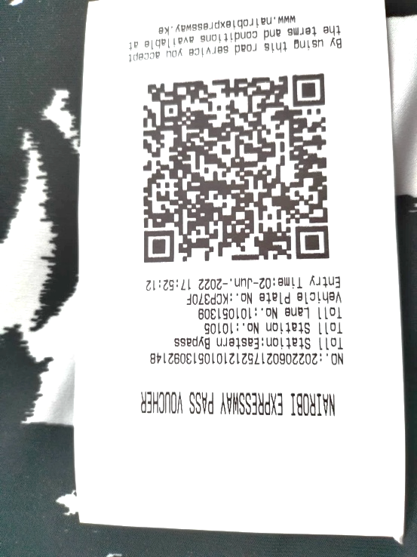

Figure 4.1 Nairobi Expressway Payment Voucher

QUESTION FIVE (20 Marks)

(a) Figure 5.1 is a Riara University (RU) flagship project concept for connecting wireless network Access Points (AP1 and AP2) on top of two buildings on each side of Raila Odinga Road. Discuss THREE challenges you may face when implementing this new project. Give to mitigation procedures any two you have discussed (10 Marks)


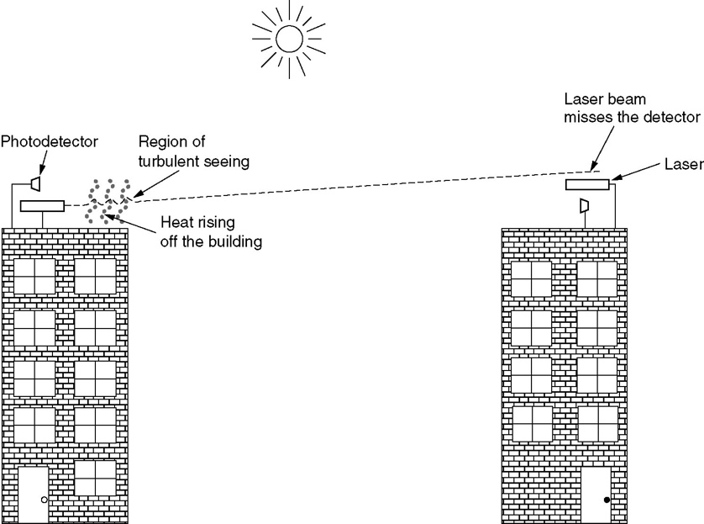
AP 2
AP 1
Raila Odinga Road
Satellite Campus
Main Campus

Figure 5.1 New RU Wireless Network Project Design

(b) One disadvantage of an IP broadcast subnetting in a wireless network is the capacity wastage when multiple hosts attempt to access the channel at the same time. Discuss how it is possible for a sequence of packets transmitted through a wide area wireless network such as GSM 4.5 G to arrive at their destination in an order that differs from that in which they were sent in comparison to a local WLAN network (10 Marks)

