
UNIVERSITY EXAMINATIONS
EXAMINATION FOR SEPTEMBER-DECEMBER 2023/2024 CERTIFICATE/DIPLOMA IN INFORMATION TECHNOLOGY/DIPLOMA IN COMPUTER SCIENCE
COURSE CODE: RCT 006 - WEB APPLICATIONS
RCS 024 - WEB DEVELOPMENT

DATE: __________ TIME: 2 HOURS
GENERAL INSTRUCTIONS:
Students are NOT permitted to write on the examination paper during exam time.
This is a closed book examination. Text book/Reference books/notes are not permitted.
SPECIAL INSTRUCTIONS:
This examination paper consists Questions in Section A followed by section B.
Answer Question 1 and any Other Two questions.
QUESTIONS in ALL Sections should be answered in answer booklet(s).

PLEASE start the answer to EACH question on a NEW PAGE.

Keep your phone(s) switched off at the front of the examination room.

Keep ALL bags and caps at the front of the examination room and DO NOT refer to ANY unauthorized material before or during the course of the examination.

ALWAYS show your working.

Marks indicated in parenthesis i.e. ( ) will be awarded for clear and logical answers.

Write your REGISTRATION No. clearly on the answer booklet(s).

For the Questions, write the number of the question on the answer booklet(s) in the order you answered them.
- DO NOT use your PHONE as a CALCULATOR.
- YOU are ONLY ALLOWED to leave the exam room 30minutes to the end of the Exam.
- DO NOT write on the QUESTION PAPER. Use the back of your BOOKLET for any calculations or rough work.

SECTION A (COMPULSORY)
QUESTION ONE (30 Marks)
- Explain Four categories of computer networks based on geographical coverage. [4 Marks]
- Discuss Four components of an HTML document structure. [4 Marks]
- Write a JavaScript statement that would display the text “web development” on a page document. [2 Marks]
- Explain Four challenges that come with the use Internet in education [4 Marks]
- Differentiate between a front-end developer and a back-end developer. [2 Marks]
- Describe the following stages during a web application development process
- Analysis,
- Design
- Development,
- Testing and review,
- Deployment,
- Maintenance [6 Marks]
- Outline the use of the following HTML tags.
- <form>
- <button>
- <table>
- <image> [4 Marks]
- Explain Two uses of JavaScript during web application development. [2 Marks]

SECTION B (Answer ANY Two Questions)
QUESTION TWO (15 Marks)
- Explain the need for a web server when writing the back-end part of a web application. [2 Marks]
- Differentiate between a Domain Name Server and Internet Services Provider [2 Marks]
- Define the following list using the appropriate HTML tags
- Public Universities
- JKUAT
- UON
- Private Universities
- Riara
- USIU [6 Marks]
- Differentiate between cell spacing and cell padding as used in HTML. [2 Marks]
- Explain the use of the following dialog boxes in JavaScript
- Alert box
- Prompt box
- Confirm box [3 Marks]
QUESTION THREE (15 Marks)
- Differentiate between block and inline elements [2 Marks]

- Define the following table using the appropriate html tags.
Stock Sheet
Item Code | Item Name. | Category | Price
1000 | Harddisk 1TB | Storage | 6500
1001 | 19” HP TFT | Screens | 10000
[5 Marks]
- Explain the following types of domains
- Top-level domains
- Country code Top-level domains
- Second-level domains
- Third-level domains [4 Marks]
- State Two layout overflow options in CSS. [2 Marks]
- Distinguish between logical and arithmetic operators as used in PHP. [2 Marks]

QUESTION FOUR (15 Marks)
- Explain Any Four qualities of a web application. [4 Marks]
- List three attributes you can set on the form’s input elements. [3 Marks]
- Explain the following types of computer networks
- Internet
- Intranet
- Extranet [3 Marks]
- Write a CSS script that gives a table a solid red border of size 3px. [2 Marks]
- Write a PHP program that adds 2 numbers and displays the result on the page. [3 Marks]
QUESTION FIVE (15 Marks)
- Explain Any Five JavaScript events through which JavaScript code can be executed. [5 Marks]
- Differentiate between unordered and ordered list [2 Marks]
- Discuss the use of the following internet-related protocols [3 Marks]
- TCP/IP
- HTTP
- FTP
- Using HTML and CSS, write a script that would generate the form below

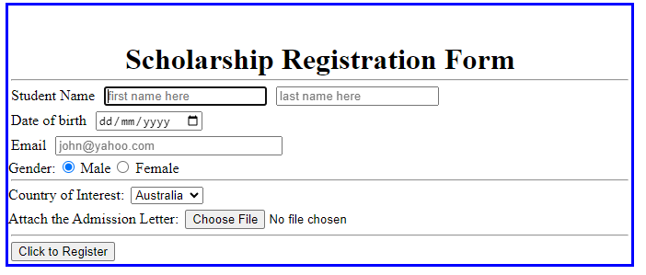
[5 Marks]

