

RIARA SCHOOL OF INTERNATIONAL RELATIONS & DIPLOMACY
NURTURING INNOVATORS
JANUARY-APRIL 2025 TRIMESTER
EXAMINATIONS FOR BACHELOR OF ARTS IN INTERNATIONAL RELATIONS & DIPLOMACY
DAY PROGRAMME
RFC 041: ENVIRONMENTAL SUSTAINABILITY
DATE: 12TH APRIL, 2025 TIME: 2 HOURS

GENERAL INSTRUCTIONS:
Students are NOT permitted to write on the examination paper during reading time.
This is a closed book examination. Text book/Reference books/notes are not permitted.
SPECIAL INSTRUCTIONS
- Write your REGISTRATION NO. Clearly on the answer booklet(s).
- Answer Question One and ANY other TWO questions.
- Questions in all sections should be answered in answer booklet(s)
- PLEASE start the answer to EACH question on a NEW PAGE.
- For the questions, write the number of the question on the answer booklet(s) in the order you answered.
- Write on both sides of each leaf and indicate number of each question at the top of each page.
- Write the answers in a paragraph form unless stated otherwise.
- Marks allocated to each question are shown at the end of the question.
- All rough work must be done on the answer booklet and crossed through!
- Use supplementary pages only when you have exhausted those in this book
- Fasten the supplementary pages to the inside back cover of this booklet

SECTION A: ANSWER ALL QUESTIONS IN THIS SECTION (30 MARKS)
QUESTION ONE
- Define the following Terms:
i) Environmental Sustainability (1¹/₂ marks)
ii) Point source pollution (1¹/₂ marks)
- Differentiate the following terms
- Development and sustainable Development (2 marks)
- Biotic and Abiotic components of environment ( 2 marks)
- Environmental conflict is one of the key causes of political instability in many regions in the world. In East African region such conflicts have manifested themselves in different border areas, a common one is shown in the diagram below.
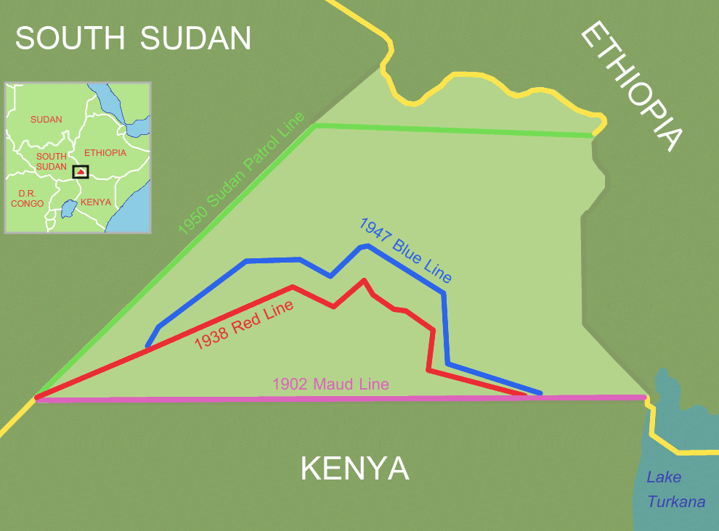
- Name the disputed area between Kenya and South Sudan shown in the diagram above
(1 mark)
- You have been appointed by Kenya as one of the arbitrators in the resolution committee for the above land conflict, suggest at most three ways of resolving such conflict without affecting the good diplomatic relations that exists between the two countries
(6 marks)
- Environmental Management and Coordination Act of 1999 in Kenya gave forth several environmental regulations in Kenya since its enactment for environmental protection and conservation.
State and explain three of these regulations that are helping Kenya as a country in achieving environmental sustainability (6 marks)
- As a Small Island Developing State (SIDS), Mauritius is highly vulnerable to the effects of climate change and its adverse impacts on socio-economic development. While SIDS contribute only 1% of the global greenhouse gases emission, they are the ones to suffer most from the adverse impacts of climate change. In response to decisions adopted at the 19th and 20th sessions of the Conference of the Parties to the United Nations Framework Convention on Climate Change (UNFCCC) which invites Parties to communicate to the Secretariat their Intended Nationally Determined Contribution, Mauritius has elaborated a series of measures
based on the participatory multi-stakeholder and cross-sectoral consultative processes involving relevant partners.
One of the key activities proposed is the shift towards renewable and green technologies.
- Explain how green technologies help in mitigating climate change. (6 marks)
- Evaluate the key challenges to the development and adoption of green technologies in Global South countries. (4 marks)

SECTION B- ANSWER ANY TWO QUESTIONS (40 MARKS)
QUESTION TWO
As a major sector in the economy, the hotel sector accounts for a significant amount of the overall resource consumption and generates a substantial portion of waste to the environment.
Critically propose five suitable waste minimization techniques which hotel operators should adopt to mitigate the pressure on the environment. Use relevant examples to illustrate your answer
(20 marks)

QUESTION THREE
- Using suitable examples, evaluate the role of the UN Environment in environmental sustainability
(10 marks)
- Elaborate the role of politics in Environmental Management, giving case examples in Kenya
(10 marks)

QUESTION FOUR
- “Development and Environment have long been considered to be contradictory” Justify
(10 marks)
- Explain ways in which covid-19 shaped Environmental sustainability in the world
(10 marks)

QUESTION FIVE
- Evaluate five factors hindering sustainable development in Eastern Africa region
(10 marks)
- Using suitable examples, examine the role of the UN Environment in environmental sustainability (10 marks)

