
UNIVERSITY EXAMINATIONS
EXAMINATION FOR SEPTEMBER/DECEMBER 2025/2026 FOR BACHELOR OF SCIENCE IN COMPUTER SCIENCE
RBCS 7314: INTRODUCTION TO ARTIFICIAL INTELLIGENCE
DATE 9th DECEMBER 2025 TIME: 2 HOURS
GENERAL INSTRUCTIONS:
Students are NOT permitted to write on the examination paper during examination time.
This is a closed book examination. Text book/Reference books/notes are not permitted.
SPECIAL INSTRUCTIONS:
This examination paper consists Questions in Section A followed by section B.
Answer Question all questions in section A and two questions in Section B .
QUESTIONS in ALL Sections should be answered in answer booklet(s).

PLEASE start the answer to EACH question on a NEW PAGE.

Keep your phone(s) switched off at the front of the examination room.

Keep ALL bags and caps at the front of the examination room and DO NOT refer to ANY unauthorized material before or during the course of the examination.

ALWAYS show your working.

Marks indicated in parenthesis i.e. ( ) will be awarded for clear and logical answers.

Write your REGISTRATION No. clearly on the answer booklet(s).

For the Questions, write the number of the question on the answer booklet(s) in the order you answered them.
- DO NOT use your PHONE as a CALCULATOR.
- YOU are ONLY ALLOWED to leave the exam room 30minutes to the end of the Exam.
- DO NOT write on the QUESTION PAPER. Use the back of your BOOKLET for any calculations or rough work.
SECTION A: ( COMPULSORY)
QUESTION ONE[30 MARKS]
1 Explain the following Artificial Intelligence concepts, and discuss their significance in real-world applications: (3 Marks)
a) Intelligent Agent
b) Deep Learning
c) Computer Vision
2. Explain the concept of a "Utility Function" for an intelligent agent and how it relates to rational decision-making. (2 Marks)

3. Describe FOUR key properties that are used to classify different types of environments in AI.
(4 Marks)
4. Briefly discuss the following AI techniques (4 Marks)
a) Genetic Algorithms
b) Expert Systems

5. Discuss the application of AI in the following domains: (4 Marks)
a) Autonomous Vehicles
b) Recommender Systems

6. Represent the following natural language statements in First-Order Predicate Logic: (5 Marks)

a) All students are hardworking.
b) Some computers are portable.
c) Mary owns a book.
d) No fish can fly.
e) If it is raining, then the ground is wet.

7. You are an AI agent in a
2×2 grid world. You start at position (1,1) and your goal is to reach (2,2). There is a obstacle at (1,2). You can move Up, Down, Left, or Right. Highlight the steps you would take to find a path from the initial state to the goal state, stating the name of a suitable search algorithm.(4 Marks)

8. A manufacturing plant wants to develop a system that can automatically inspect products on an assembly line and classify them as "Faulty" or "Non-Faulty" based on camera images.
a) Explain the type of machine learning most suitable for this task. (2 Marks)
b) State two specific algorithms that fall into the category you named in (a) above.(2 Marks)

QUESTION TWO [15 MARKS]
1. Explain FOUR real-world application areas of Natural Language Processing (NLP).(4 Marks)

2. Discuss THREE fundamental steps or tasks involved in Morphological Analysis as used in natural language processing. Provide a suitable example for each. (6Marks)

3. Apply the following inferencing system using backward chaining to determine if the patient has pneumonia. Clearly indicate your reasoning procedure. (5 Marks)

Rule 1: IF patient has cough AND patient has high fever THEN patient has respiratory infection.

Rule 2: IF patient has respiratory infection AND patient has difficulty breathing THEN suspect pneumonia.

Rule 3: IF patient's chest X-ray is cloudy THEN confirm pneumonia.

Facts:

The patient has a cough.

The patient has a high fever.

The patient has difficulty breathing.

QUESTION THREE [15 MARKS]
1. Show the validity of the following logical statements using a truth table:
- P∨(Q∨R) ⇔ (P∨Q) ∨ R (3Marks)
ii) ((P∨H)𝖠¬H)⇒ P (De Morgan's Law) (3Marks)

2. Describe THREE popular programming languages used for AI development and state one key advantage of each.
(3 Marks)

3. Perform a breadth first search on the tree below to show how the nodes shall be visited.(9Marks)
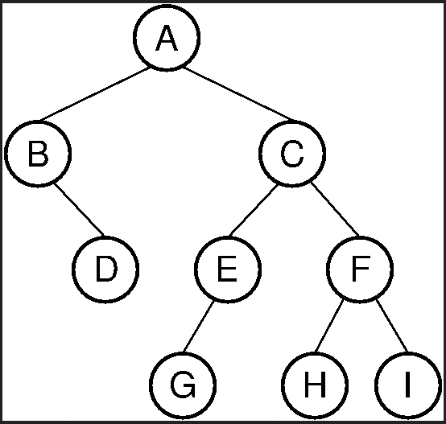

QUESTION FOUR [15 MARKS]
1. Frames and Semantic Networks are knowledge representation schemes. Highlight TWO advantages and TWO disadvantages of each scheme. (4 Marks)

2. Discuss the application of machine learning in the following areas: (6 Marks)
a) Predictive Maintenance in Industry
b) Medical Diagnosis

3. Represent the following knowledge into a semantic network: (5 Marks)

* All cars are vehicles.
* Vehicles have engines.
* Toyota Corolla is a car.
* Cars are used for transportation.
* John owns a Toyota Corolla.
* That Toyota Corolla is red.

QUESTION FIVE [15 MARKS]
1. Explain FIVE different domains or types of problems where Artificial Intelligence techniques are successfully applied. (5 Marks)

2. Discuss the Minimax algorithm used in game-playing AI. Your explanation should include the concepts of MAX and MIN players, game trees, and the objective of the algorithm.(3 Marks)

3. You have been tasked with developing an AI-powered virtual tutor for a high school mathematics course. Describe the SIX key steps your team would take to design, develop, and deploy this system. (3 Marks)

4. Explain the difference between Supervised and Unsupervised learning. Provide one example of a task for each type of learning. (4 Marks)

