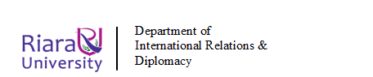
RIARA SCHOOL OF INTERNATIONAL RELATIONS & DIPLOMACY
NURTURING INNOVATORS
JANUARY-APRIL 2024 TRIMESTER
FINAL EXAMINATION FOR DEGREE PROGRAM
RIR 114: ENVIRONMENTAL SUSTAINABILITY
Date: APRIL 2024 Duration: 2 Hours
GENERAL INSTRUCTIONS:
Students are NOT permitted to write on the examination paper during reading time.
This is a closed book examination. Text book/Reference books/notes are not permitted.

SPECIAL INSTRUCTIONS:
1 Write your REGISTRATION NO. Clearly on the answer booklet(s).
2 Answer Question One and ANY other TWO questions.
3 Questions in all sections should be answered in answer booklet(s).
4 Marks allocated to each question are shown at the end of the question.
5 PLEASE start the answer to EACH question on a NEW PAGE.
6 For the questions, write the number of the question on the answer booklet(s) in the order you answered them.
7 Write your answers in paragraph form unless stated otherwise.
8 Keep your phone(s) SWITCHED OFF at the front of the examination room.

9 Keep ALL bags and caps at the front of the examination room and do not refer to any unauthorized material before or during the course of the examination.
10 You are only allowed to leave the examination room 30minutes to the end of the Examination.

SECTION A: COMPULSORY (30 MARKS)

QUESTION ONE
a) The diagram shows part of the structure of the atmosphere.

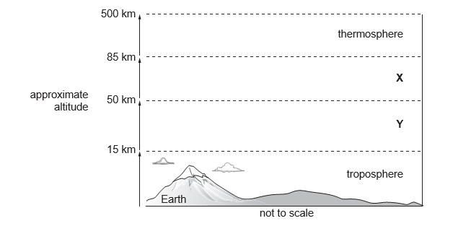

(i) Name the layers of the atmosphere labelled X and Y. (2 Mrks)
X................................................................
Y ................................................................

(ii) The atmosphere can be polluted by industrial emission. These emissions can cause acid rain.

Explain the formation and impacts of acid rain on the environment.
(6 Mrks)

b) “Biodiversity provides us with life sustaining services.” Justify the statement giving examples. (8 Mrks)

c) The table shows the population structure for two countries in 2015
country | population structure (percentage in each age group)
country | 0–14 years | 15–59 years | 60 years and over
Japan | 13 | 54 | 33
Niger | 51 | 45 | 4

- Justify why Niger’s population structure means its population may increase rapidly (2 marks)
- Suggest two problems that Niger may have as a result of a rapid population increase (2 marks)
- Can a less economically developed country (LEDC), such as Niger, feed its increasing population sustainably? (Give reasons for your answer)
(3 marks)
d) Thermohaline circulation plays a vital role in aquatic ecosystem. Justify this statement. (7 Marks)

SECTION B: CHOOSE TWO QUESTIONS FROM THIS SECTION (40 MARKS)

QUESTION TWO
Environmental Management and Coordination Act has revolutionized environmental management in Kenya in several ways. Explain (20 mrks)

QUESTION THREE
Using suitable examples, discuss the causes and effects of the following global environmental concerns

- Climate change (5 marks)
- Ocean acidification (5 marks)
- Acid rain (5 marks)
- Waste management (5 marks)

QUESTION FOUR
“Development and Environment have long been considered to be contradictory”. Discuss. (20 Marks)

QUESTION FIVE
- Explain the three vital functions of environment (6 Marks)

- Evaluate the relationship between politics and environmental conservation initiatives in Kenya (8Marks)

- What impact does inequality have on sustainable development? (6 Marks)

***END OF QUESTION PAPER***

