
UNIVERSITY EXAMINATIONS
EXAMINATION FOR SEPT/DEC 2024/2025 FOR BACHELOR OF SCIENCE IN COMPUTER SCIENCE AND BACHELOR OF BUSINESS INFORMATION TECHNOLOGY
RCS 208: OBJECT ORIENTED ANALYSIS AND DESIGN
DATE: 2ND DECEMBER 2024 TIME: 2 HOURS
GENERAL INSTRUCTIONS:
Students are NOT permitted to write on the examination paper during examination time.
This is a closed book examination. Text book/Reference books/notes are not permitted.

SPECIAL INSTRUCTIONS:
This examination paper consists Questions in Section A followed by section B.
Answer Question 1 and any Other Two questions.
QUESTIONS in ALL Sections should be answered in answer booklet(s).

PLEASE start the answer to EACH question on a NEW PAGE.

Keep your phone(s) switched off at the front of the examination room.

Keep ALL bags and caps at the front of the examination room and DO NOT refer to ANY unauthorized material before or during the course of the examination.

ALWAYS show your working.

Marks indicated in parenthesis i.e. ( ) will be awarded for clear and logical answers.

Write your REGISTRATION No. clearly on the answer booklet(s).

For the Questions, write the number of the question on the answer booklet(s) in the order you answered them.
- DO NOT use your PHONE as a CALCULATOR.
- YOU are ONLY ALLOWED to leave the exam room 30minutes to the end of the Exam.
- DO NOT write on the QUESTION PAPER. Use the back of your BOOKLET for any calculations or rough work.

Section A: Compulsory (30 marks)
Question One
- Riara University is developing a new student management system using Object-Oriented Programming principles. Understanding these principles is essential for designing an efficient and maintainable system. Outline how any four OOP principles can assist in designing an efficient system. (8 marks)
- Discuss the difference between association, aggregation, and composition in object-oriented design. Provide a UML diagram that illustrates these relationships. (10 marks)

- Compare and contrast use case diagrams and activity diagrams in the context of OOAD. When and how are these diagrams used to model different aspects of system behavior? (4 marks)
- Create a use case diagram for an e-commerce system. Have 3 actors and show inheritance, includes and extends relationships. (6 marks)
- Differentiate the Singleton and Factory Method design patterns, including when and how they should be used. (2 marks)

SECTION B: SECTION B (OPTIONAL 2 OUT OF 4)
Question Two (15 Marks)
- Illustrate with examples how the use of design patterns enhances the design and architecture of software systems. (6 marks)
- Imagine you are tasked with designing an Activity Diagram for the checkout process in an Online Shopping System. Design an Activity Diagram for the checkout process in the Online Shopping System based on the scenario provided. Include activities, decision points, and transitions between activities. Use at least 5 different notations. (9 marks)
Question Three (15 marks)
- Design a State Diagram for the ticket booking process in the Online Ticket Booking System based on the scenario provided. Identify states, events, and transitions between states. Have at least 5 different notations. (10 marks)
- Differentiate using an example of the Riara University student management systems:
  - Component and Sequence Diagrams (4 marks)
  - Object diagram and class diagrams (1 marks)
  - Analysis and design (4 marks)
Question Four (15 marks)
- Develop a sequence diagram for the scenario below: (10 marks)
Imagine you are designing a Sequence Diagram for an Online Banking System. The system allows users to perform various transactions securely. The process begins with a user logging into the system by entering their username and password through the User Interface. Upon submission, the User Interface sends a login request to the Authentication Service, which verifies the credentials against stored data. If authentication is successful, the Authentication Service notifies the User Interface, allowing the user to proceed. Subsequently, the user requests to check the balance of a specific account. The User Interface forwards this request to the Account Service, which retrieves the account information and returns the current balance to the User Interface for display. Upon reviewing the balance, the user decides to transfer funds to another account. The User Interface initiates the fund transfer process by sending a transaction request to the Transaction Service. This service validates the transaction details, deducts the specified amount from the user's account, updates both accounts' balances, and confirms the successful transfer to the User Interface. Finally, when the user decides to log out from the system, the User Interface triggers a logout sequence, and the Authentication Service securely ends the session.
- Explain the importance of sequence diagrams. Have three well explained answers,
(3 marks)
- Outline two purposes of state diagrams in software modeling and design. (2 marks)

Question Five (15 marks)
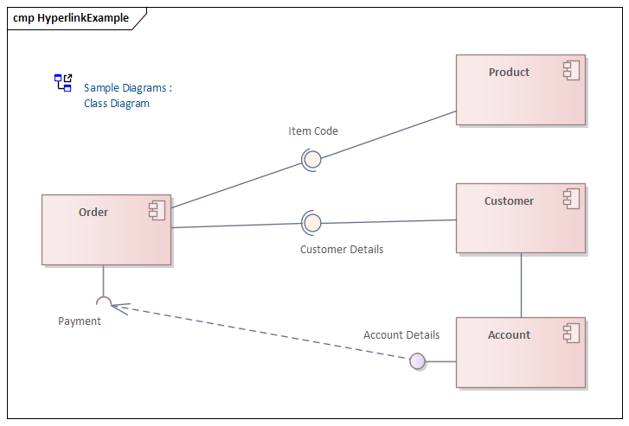
- Comprehensively explain the component diagram above. (9 marks)
- Discuss the integration of Sequence Diagrams with other diagrams in system design, such as Use Case Diagrams and Component Diagrams. (6 marks)

