
UNIVERSITY EXAMINATIONS
EXAMINATION FOR JANUARY-APRIL 2024/2025 FOR BACHELOR OF SCIENCE IN BUSINESS INFORMATION TECHNOLOGY
RCS 438: E-COMMERCE

DATE: 9TH APRIL, 2025. TIME: 2 HOURS
GENERAL INSTRUCTIONS:
Students are NOT permitted to write on the examination paper during examination time.
This is a closed book examination. Text book/Reference books/notes are not permitted.
SPECIAL INSTRUCTIONS:
This examination paper consists Questions in Section A followed by section B.
Answer Question 1 and any Other Two questions.
QUESTIONS in ALL Sections should be answered in answer booklet(s).

PLEASE start the answer to EACH question on a NEW PAGE.

Keep your phone(s) switched off at the front of the examination room.

Keep ALL bags and caps at the front of the examination room and DO NOT refer to ANY unauthorized material before or during the course of the examination.

ALWAYS show your working.

Marks indicated in parenthesis i.e. ( ) will be awarded for clear and logical answers.

Write your REGISTRATION No. clearly on the answer booklet(s).

For the Questions, write the number of the question on the answer booklet(s) in the order you answered them.
- DO NOT use your PHONE as a CALCULATOR.
- YOU are ONLY ALLOWED to leave the exam room 30minutes to the end of the Exam.
- DO NOT write on the QUESTION PAPER. Use the back of your BOOKLET for any calculations or rough work.

SECTION A - Compulsory
QUESTION ONE (30 Marks)
- The challenge that business owners and clients constantly face is the security of the E-Commerce website. Outline five ways to mitigate security threats. (5 Marks)

- Define: (6 Marks)
- A/B Test as used in E-Commerce Marketing
- Toyota’s “Just-in-time” Philosophy
- Telnet as used in Computer Networking
- Reserve Price as used in Online Actions
- Tort as used in E-Commerce Legal Issues
- Active Attack as used in E-Commerce Security

- List three characteristics of a successful E-payment method. (3 Marks)

- Call to action forms are embedded on E-Commerce platforms. Give examples of two types of embedded forms. (2 Marks)

- How is Generative PreTraining Transformer (GPT) technology affecting E-Commerce.
(3 Marks)

- Explain the use of a De-Militarized Zone (DMZ) within an organization in relation to E-Commerce applications. (4 Marks)

- Enumerate legal considerations you should keep in mind if you were to develop a
subscription-based business model? (2 Marks)

- Internet connectivity has enabled E-Commerce adoption and transition to online businesses, describe key elements of adoption and transition strategy of a Garage business.
(3 Marks)

- Compare cryptography and cryptocurrency. (2 Marks)

SECTION B - Answer ANY other TWO questions
QUESTION TWO (15 Marks)
- Discuss the internal network used by an E-commerce organization shown below.
(3 Marks)
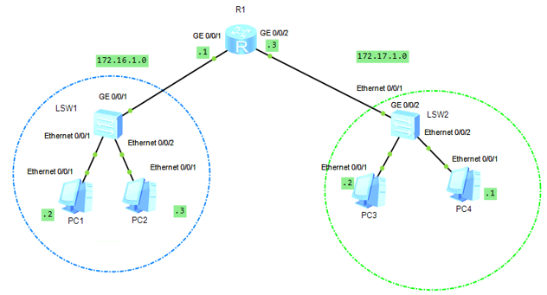
- Differentiate between. (4 Marks)
- Subject-matter jurisdiction and Personal jurisdiction
- Auctions and Barter Trade

- Explain any three variables in the general model of customer behavior and how they affect purchase decisions. (3 Marks)

- Define: (3 Marks)
- SSL
- Non-Repudiation
- Half-duplex Communication

- List two benefits of ICT Policies in E-Commerce. (2 Marks)

QUESTION THREE (15 Marks)
- Define: (3 Marks)
- Digital Certificate
- Capital Expenditure
- Clickstream Behaviour

- Describe freemium business model. (2 Marks)

- Consumer behavior is influenced by a number of factors. Enumerate three intervening variables. (3 Marks)

- Explain the tactical phase as used in strategic market planning. (3 Marks)

- In a business that sells farm machinery items such as tractors, ploughs and sprayers, discuss the four support activities in Porter’s value chain as used in E-commerce. (4 Marks)

QUESTION FOUR (15 Marks)

- Explain Value Added Networks (VANs) as used in online business strategies. (3 Marks)

- Define: (2 Marks)
- Work-in-progress Inventory
- Electronic Data Interchange (EDI)

- Enumerate three main factors shaping online decision to purchase products or services.
(3 Marks)

- Differentiate between: (4 Marks)
- Virtual Auction and Reverse Auction
- Bandwidth and Throughput as used in Data Communication

- Discuss the three main flows in supply chain. (3 Marks)

QUESTION FIVE (15 Marks)

- Explain the five stages in consumer decision making process. (5 Marks)
b) Define: (1 Marks)
- Port Forwarding as used in Computer Networks
b) Discuss the three spheres of sustainability in supply chain. (3 Marks)

c) Differentiate between: (2 Marks)
- Conversion Rate and Click Through Rate

- Discuss the SOAR business analysis when considering E-commerce of Shoes selling shop.
(4 Marks)

