
UNIVERSITY EXAMINATIONS
EXAMINATION FOR JANUARY/APRIL 2024/2025 BACHELOR OF SCIENCE IN BUSINESS INFORMATION TECHNOLOGY
RCS 104: SYSTEM ANALYSIS AND DESIGN
DATE: 16TH APRIL 2025 TIME: 2 HOURS
GENERAL INSTRUCTIONS:
Students are NOT permitted to write on the examination paper during exam time.
This is a closed book examination. Text book/Reference books/notes are not permitted.
SPECIAL INSTRUCTIONS:
This examination paper consists Questions in Section A followed by section B.
Answer Question 1 and any Other Two questions.
QUESTIONS in ALL Sections should be answered in answer booklet(s).

PLEASE start the answer to EACH question on a NEW PAGE.

Keep your phone(s) switched off at the front of the examination room.

Keep ALL bags and caps at the front of the examination room and DO NOT refer to ANY unauthorized material before or during the course of the examination.

ALWAYS show your working.

Marks indicated in parenthesis i.e. ( ) will be awarded for clear and logical answers.

Write your REGISTRATION No. clearly on the answer booklet(s).

For the Questions, write the number of the question on the answer booklet(s) in the order you answered them.
- DO NOT use your PHONE as a CALCULATOR.
- YOU are ONLY ALLOWED to leave the exam room 30minutes to the end of the Exam.
- DO NOT write on the QUESTION PAPER. Use the back of your BOOKLET for any calculations or rough work.

QUESTION ONE (30 Marks - COMPULSORY)

- Define the following terms (4 marks)
  - Data
  - Information
  - System
  - Information System Analysis and Design
- Describe the distinguishing feature(s) of each of the following information systems
(6 marks)
  - Transaction Processing Systems (TPS)
  - Management Information Systems (MIS)
  - Decision Support Systems (DSS)
- As a systems analyst you should be highly skilled in order to perform your professional roles perfectly. Analyze the following table by matching each skill of the system analyst with the appropriate functional role. (5 marks)

i) | Analytical Skills | A) Interviewing, Listening, Written and Oral presentations
ii) | Management Skills | B) Problem identification, analyzing, and solving
iii) | Technical skills | C) Requires continuous learning and keeping skills up-to-date
iv) | Interpersonal skills | D) Working alone and with a team and facilitating groups
v) | Communication skills | E) Decomposing project into independent tasks and  determining relationships between tasks

- A system development project is about to be undertaken for a client organization that is currently running its business operations entirely manually.
As a consultant systems analyst, analyze each of the following methodologies by giving three characteristics of project that would make you select the methodology.
(9 marks)

SDLC  Methodology | Two project characteristic influencing the selection of methodology
Waterfall | i)
Waterfall | ii)
Waterfall | iii)
Prototype | i)
Prototype | ii)
 | iii)
Spiral | i)
Spiral | ii)
Spiral | iii)
- Construct a decision table based on the following statements. Use the sketch blank table below (6 marks)
In a wholesale business;
- No discount is given if the customer pays after 2 weeks or the order is less than
$20
- If the order is less than $50, the customer gets a 4% discount
- If the order is at least $50, the customer gets a 5% discount

Conditions
Actions

SECTION B(ANSWER ANY TWO QUESTIONS)
QUESTION TWO (15 Marks)
- State two advantage and one disadvantage for each of the following methods of requirements elicitation (6 marks)
  - Questionnare
  - Interview

  - On-site observation
- Explain the seven phases of the systems development life cycle (SDLC) highlighting the major activities and deliverables at each stage (9marks)

QUESTION THREE (15 Marks)
- Differentiate among technical, operational, and economic feasibility. (3 marks)
- Listed below are possible problems or opportunities when considering the feasibility of a new project. As a professional systems analyst, analyze the table by accordingly indicating(YES/NO) if the problem or opportunity is economic, technical, operational, schedule, legal or political.(*Problem or opportunity may fulfill several of these factors*) (6marks)

 | Factors
Problem or opportunity | Economic | Technical | Operational | Schedule | Legal | Political
The system will process the year-end accounting.
The staff turnover in the IT department has
increased
Customers’ credit card information will be stored
The new distributed system will replace a
centralized one.
Users disagree about the functionality needed
Management predicts a great increase in user
efficiency.
Labour unions are threatening to strike against the
new system
Users need extensive training.
- Using the information in table shown below, assuming that the project team will work a standard working week (5 working days in 1 week) and that all tasks will start as soon as possible:
  - Determine the critical path of the project (2marks)
  - Calculate the planned duration of the project in weeks (2 marks)
  - Identify any non-critical tasks and the float (free slack) on each. (2marks)

Task | Activity Description | Duration (Working Days) | Predecessor(s) Activity
A | Requirements Analysis | 5
B | System Design | 15 | A
C | Programming | 25 | B
D | Telecoms | 15 | B
E | Hardware Installation | 30 | B
F | Integration | 10 | C, D
G | Systems Testing | 10 | E, F
H | User Training & Support | 5 | G
I | Handover & Go-live | 5 | H

QUESTION FOUR (15 Marks)
- i) Highlight the general strategy an analyst should use to gather information
(3 marks)
ii) Give three main sources of information of an organization (3 marks)
- Differentiate between logical system diagrams and physical system diagrams.
(4 marks)
- Construct an entity relationship diagram based only on the following information. The information describes the functional transactions at PonaTwakupenda nursing home where patients recover from an illness or an operation. (5 marks)

  - When a patient is admitted, the patient is assigned a room and a nurse.
  - The patients assigned to a nurse can be in any room.
  - Rooms can have more than one patient.
  - A nurse looks after several patients.
  - A patient has at least one doctor.
  - Doctors each have more than one patient.
  - Doctors may subscribe medications to their patients. Each prescription is for a specific medication, for a specific dosage and with specific instructions.
  - A patient may take more than one medication.
  - Only the nurse assigned to the patient gives medications to the patient.
  - There are no relationships between nurses and doctors (at least as far as this assignment is concerned) nor between nurses and rooms.

QUESTION FIVE(15 Marks)
- State four objectives of system tests (2 marks)
- IT projects may fail for one or more reasons. Give two reasons for:

  - Failure in product quality (2 marks)
  - Failure in IT team productivity. (2 marks)
- i) Define the term physical DFD in the context of systems analysis and design
(2 marks)
iii) Describe the role and usefulness of DFD as a systems documentation aid
(2 marks)
- Mambo-Leo KarHire is a firm that deals with renting cars and trucks to individuals and to other businesses. The systems analyst working to develop a rental system for Mambo-Leo KarHire have drawn DFD shown below.
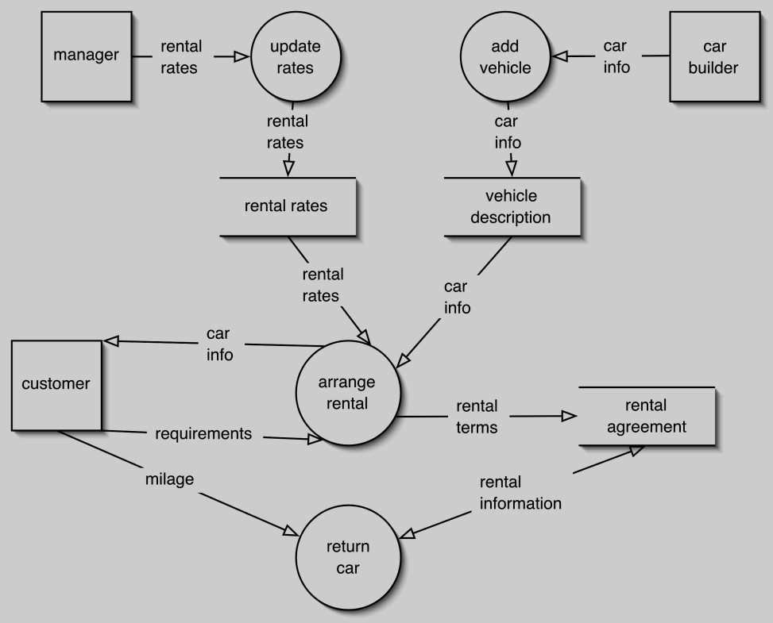
Later, at a meeting with clients the systems analyst learns the following:
- Rental agreements with individuals renting vehicles are quite different from agreements with businesses renting vehicles (they carry different information);
  - Individuals renting a vehicle must pay when they return the vehicle
  - Businesses renting a vehicle pay to an Accounts Receivable system (it already exists and is not in the scope for this system) and this rental system just sends the rental agreement information to that Accounts Receivable system
ii) Managers not only set rental rates, but they also change them from time to time
As a qualified professional systems analyst, redraw the DFD to reflect the new requirements (5 marks)

SECTION B

QUESTION TWO (15 Marks)

a) Data flow diagrams (DFDs) are commonly used in system analysis. Discuss the components of DFDs and their importance in modelling system processes. [4 Marks]

b) Interviews are a common fact-finding technique in system analysis. Explain TWO advantages and TWO disadvantages of using interviews during data collection. [4 Marks]

c) Change management is critical during system implementation. Describe the role of change management in the SDLC and explain THREE strategies for managing change effectively.

[7 Marks]

QUESTION THREE (15 Marks)

a) Joint Application Development (JAD) is a collaborative approach in system design. Discuss the key elements of JAD and its benefits in the system development process. [5 Marks]

b) Testing is an essential part of the SDLC to ensure quality. Discuss FIVE types of testing that should be conducted during system implementation. [10 Marks]

QUESTION FOUR (15 Marks)

a) Define the following terms as used in System Analysis and Design:

i. System Requirement

ii. Use Case

iii. Stakeholder

iv. Prototyping

v. Functional Specification [5 Marks]

b) Structured methodologies provide a framework for system development. Discuss structured methodologies and list THREE advantages and THREE disadvantages of using this approach.

[6 Marks]

c) The analysis stage of SDLC is crucial for successful project outcomes. Discuss the key components and activities involved in the analysis stage. [4 Marks]

QUESTION FIVE(15 Marks)

a) Briefly explain the concept of system theory. [2 Marks]

b) In system analysis, stakeholders play a crucial role. Identify SIX potential stakeholders in a hospital management system and discuss their expectations from the system.

[6 Marks]

c) System failures can arise from various factors. Identify and explain four reasons why systems may fail during or after development. [4 Marks]

d) Documentation is vital in system development. State FOUR key reasons for maintaining system documentation throughout the project lifecycle. [3 Marks]

