
UNIVERSITY EXAMINATIONS
EXAMINATION FOR JANUARY-APRIL 2025 / 2026 DIPLOMA IN COMPUTER SCIENCE/DIPLOMA IN INFORMATION TECHNOLOGY/DIPLOMA IN BUSINESS INFORMATION TECHNOLOGY/DIPLOMA IN CYBER SECURITY
COURSE CODE: RDCS 6221 COURSE UNIT: LINUX.
DATE: -- /-- /2026. TIME: 2 HOURS
GENERAL INSTRUCTIONS:
Students are NOT permitted to write on the examination paper during examination time.
This is a closed book examination. Text book/Reference books/notes are not permitted.
SPECIAL INSTRUCTIONS:
This examination paper consists Questions in Section A followed by section B.
Answer Question 1(Mandatory) and any other two questions.
QUESTIONS in ALL Sections should be answered in answer booklet(s).

PLEASE start the answer to EACH question on a NEW PAGE.

Keep your phone(s) switched off at the front of the examination room.

Keep ALL bags and caps at the front of the examination room and DO NOT refer to ANY unauthorized material before or during the course of the examination.

ALWAYS show your working.

Marks indicated in parenthesis i.e. ( ) will be awarded for clear and logical answers.

Write your REGISTRATION No. clearly on the answer booklet(s).

For the Questions, write the number of the question on the answer booklet(s) in the order you answered them.
- Calculator may be needed.
- DO NOT use your PHONE as a CALCULATOR.
- YOU are ONLY ALLOWED to leave the exam room 30minutes to the end of the Exam.
- DO NOT write on the QUESTION PAPER. Use the back of your BOOKLET for any calculations or rough work.

SECTION A (COMPULSORY).
Question (1) - (30Marks)
- Define the following terms as used in Linux operating systems. (5 Marks)

- Open Source.
- Partitioning.
- Proprietary.
- Directories.
- Firmware.

- Discuss the important and unique features of Linux operating systems; that make it the OS of choice by many IT administrators and companies. (5 Marks)

- The figure below shows Linux kernel architecture, discuss functions of the components listed aside. (9 marks)
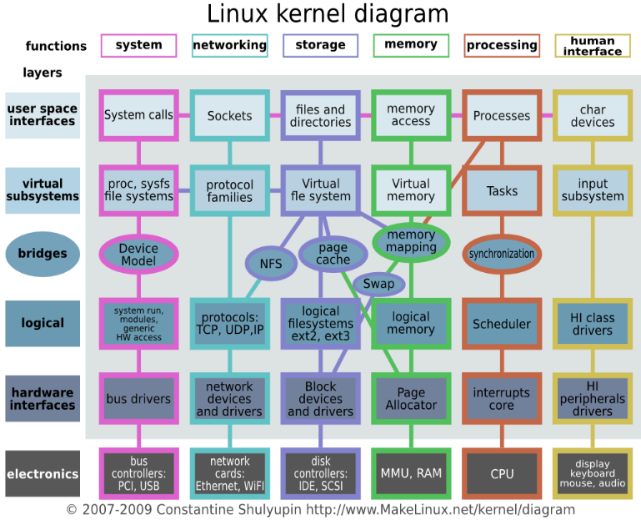 | - Swap.  - Tasks.  - Scheduler.  - Page Cache.  - System calls.  - Page Allocator.  - Virtual memory.  - Synchronization.  - Memory Mapping.

- What is the meaning of the following terms, as used in operating systems? (6 Marks)
- Multi-Processing.
- Multi-Tasking.
- Multi-User.

- In details describe all the stages a process go through in Linux Operating Systems environment (5 Marks)

SECTION B (Answer Any Two Questions).
Question (2) - (15 Marks)
- List FIVE major distributions of Linux Operating Systems. (5 Marks)

- Explain how users and files security, with respect to permissions, is implemented in Linux Operating System. (6 Marks)

- What does the following acronym stand for? Explain. (4 Marks)
- M.B.R.
- B.I.O.S.
- G.R.U.B.
- S.C.S.I.
Question (3) - (15 Marks)
- Which command are used to achieve the following? (7 Marks)
    - Concatenate files.
    - Rename files and directories.
    - Change the permissions of file
    - Display information about user.
    - Assigning a new user a password.
    - Print your current working directory.
    - Switching from a normal user account to a root account.

- State and briefly describe, FOUR files system types, used in the various Linux Operating Systems. (8 Marks)
Question (4) - (15 Marks)
- Define the Linux operating Systems shell. (1 Marks)
- Describe any FIVE types of shells, used in Linux OS. (5 Marks)
- Considering the directories shown in the figure below, state the purpose, or describe each directory. (9 Marks)
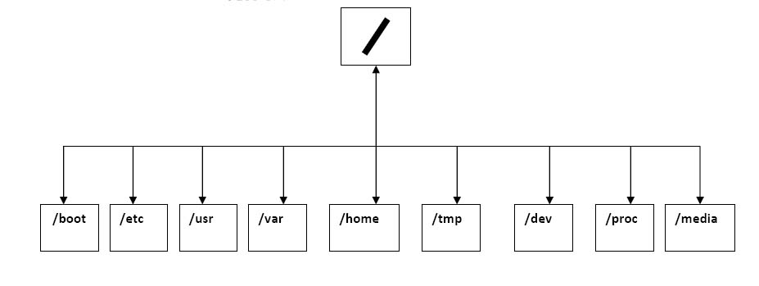

Question (5) - (15 Marks)

- With respect to the secondary storage devices used in computers;
- Explain the meaning of fragmentation. (1 Marks)
- Why is necessary to defragmenting internal hard disc drive? (1 Marks)

- The table below shows a list of combinations of permissions used alongside the Linux commands chmod; State the permissions descriptions for each, and hence explain how the permissions control access for user groups and files. (7 marks)
 |  | Permissions Descriptions
0 | - - -
1 | --x
2 | -w-
3 | -wx
4 | r--
5 | r-x
6 | rw-
7 | rwx

- With reference to Linux kernel architecture, discuss functions of the following components. (2 marks)
- Scheduler.
- Interrupt core.
- Swap partition.
- Virtual memory.

- What is the functions of the following Linux command? (4 marks)
- $ man.
- $ pwd.
- $ mkdir.
- $ chown.

END

