
UNIVERSITY EXAMINATIONS
EXAMINATION FOR SEPTEMBER/DECEMBER 2021/2022 FOR BACHELOR OF SCIENCE IN COMPUTER SCIENCE

COURSE CODE: RCS 101. COURSE TITLE: DIGITAL LOGICS.
DATE -- / -- /2021 TIME: 2 HOURS

GENERAL INSTRUCTIONS:
Students are NOT permitted to write on the examination paper during reading time.
This is a closed book examination. Text book/Reference books/notes are not permitted.

SPECIAL INSTRUCTIONS:
This examination paper consists Questions in Section A followed by section B.
Answer Question 1 and any Other Two questions.
QUESTIONS in ALL Sections should be answered in answer booklet(s).

- PLEASE start the answer to EACH question on a NEW PAGE.
- Keep your phone(s) switched off at the front of the examination room and NOT on your person.
- Keep ALL bags and caps at the front of the examination room and DO NOT refer to ANY unauthorized material before or during the course of the examination.
- ALWAYS show your working.
- Marks indicated in parenthesis i.e. ( ) will be awarded for clear and logical answers.
- Write your REGISTRATION NO. Clearly on the answer booklet(s).
- For the Questions, write the number of the question on the answer booklet(s) in the order you answered them.
- DO NOT use your PHONE as a CALCULATOR.
- YOU are ONLY ALLOWED to leave the exam room 30minutes to the end of the Exam.
- Calculator will be required.

SECTION A (COMPULSORY)
Question (1) - (30Marks)
- Define the following terms as used in digital systems? (10 Marks)
- Bits.
- DAC.
- ADC.
- Bytes.
- Encoder.
- Counters.
- Registers.
- Decoders.
- Multiplexers.
- De-Multiplexers.

- Derive the output (Q), and simplify the logic circuit below. (4 Marks)

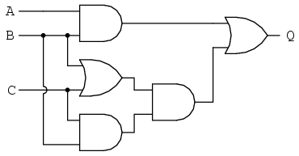
- What are universal logic gates? Give examples (3 Marks)

- State THREE types of analog to digital circuitry. (3 Marks)

- Evaluate the following calculations. Show all the working. (6 Marks)

- 246.753_{dec} - into binary.
- 11100011.011101_{bin} - into Decimal.

- Draw a digital logic circuit, for the Boolean function below. (4 Marks)
$Y_{o} =\left(A+B\right)C+ \overline{B}\left( A+\overline{C} \right)+\left(\overline{A}+B+\overline{C}\right)$

SECTION B (Answer Any Two Questions)

Question (2) - (15 Marks)

- Design a three bits binary to grey code converter, and implement the logic circuit. (7 Marks)
- Convert the following numbers, into the indicate number systems. (8 Marks)
- 1357_{oct} -into decimal number.
- DAD037_{hex} -into octal number.
- 11001100_{bin} -into decimal number.
- 1010000011100010_{bin} -into hexadecimal number.

Question (3) - (15 Marks)

- State and prove the De-Morgan’s theorem. (5 Marks)

- With references to digital logic gates, Name FIVE basic gates, draw each symbols and derive the truth tables for each.
(10 Marks)

Question (4) - (15 Marks)

- Using Karnaugh Mapping or Boolean Simplification, technique of functions simplification, simplify the function below to the simplest term. (9 Marks)

$$Y=\overline{A}\overline{B}\overline{C}\overline{D}+\overline{A}\overline{B}\overline{C}D+\overline{A}\overline{B}CD+\overline{A}B\overline{C}\overline{D}+\overline{A}B\overline{C}D+\overline{A}BCD+AB\overline{C}\overline{D}+AB\overline{C}D+ABCD$$

- Implement the following logic gates using a suitable universal gates.

- NOT gate. (1 Marks)
- AND gate. (2 Marks)
- OR gate. (3 Marks)

Question (5) - (15 Marks)

- Draw the logic circuit for the Boolean function below. (5 Marks)
$Y_{o} =\overline{A}B\overline{C}D+\left(B⨁C\right).AB+\left( A+\overline{B} \right)AB+A\overline{B}C\overline{D}$

- Design a full adder circuit, and draw the circuit using suitable gates. (6 Marks)

- Study the logic circuit below of a synchronous counter.

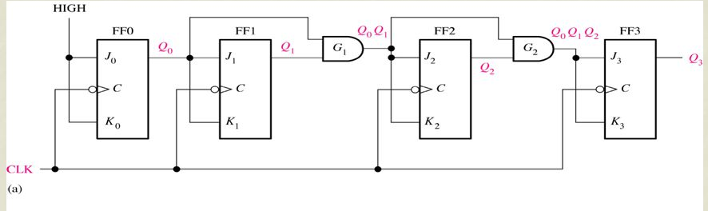

- How many bits is the counter? (1 Marks)
- What is the possible, highest decimal count? (1 Marks)
- What could be done to the circuit to make it a BCD counter? (2 Marks)

