
EXAMINATION FOR SEPTEMBER/DECEMBER 2023/2024 FOR SCHOOL OF COMPUTING SCIENCES
FOUNDATION STUDIES EXAMINATION (DEGREE)
RFC 111: COMPUTER ESSENTIALS
DATE: 6TH DECEMBER 2024 TIME: 2 HOURS

GENERAL INSTRUCTIONS:
Students are NOT permitted to write on the examination paper during examination time.
This is a closed book examination. Text book/Reference books/notes are not permitted.

SPECIAL INSTRUCTIONS:
This examination paper consists Questions in Section A followed by section B.
Answer Question 1 and any Other Two questions.
QUESTIONS in ALL Sections should be answered in answer booklet(s).

PLEASE start the answer to EACH question on a NEW PAGE.

Keep your phone(s) switched off at the front of the examination room.

Keep ALL bags and caps at the front of the examination room and DO NOT refer to ANY unauthorized material before or during the course of the examination.

ALWAYS show your working.

Marks indicated in parenthesis i.e. ( ) will be awarded for clear and logical answers.

Write your REGISTRATION No. clearly on the answer booklet(s).

For the Questions, write the number of the question on the answer booklet(s) in the order you answered them.
- DO NOT use your PHONE as a CALCULATOR.
- YOU are ONLY ALLOWED to leave the exam room 30minutes to the end of the Exam.
- DO NOT write on the QUESTION PAPER. Use the back of your BOOKLET for any calculations or rough work.

SECTION A (COMPULSORY)

QUESTION ONE (30 MARKS)
- Differentiate between Relative and Absolute cell referencing in MS Excel (2 Marks)
- A computer has unique capabilities and characteristics. Discuss any Two ways in which these characteristics help improve your productivity in school or at work (2 Marks)
- Supporting your responses with relevant examples, explain two benefits of computer networking to an institution of higher learning. (2 Marks)
- Describe the following terms in the context of emerging technologies and trends
    - Augmented Reality (2 Marks)
    - Wearable computer (2 Marks)
    - Internet of things (2 Marks)
    - Block chain Technology (2 Marks)
- Assuming you own a business that sells Kitchenware, explain four ways you would use the internet to grow in the market (2 Marks)
- Your sibling has approached you for help in creating a graduation invitation letter, which she intends to print and send to fifty recipients. She has already designed a template invitation letter. Explain to her the procedure that she would follow to create a mail merge document that she would send to the fifty guests. (4 Marks)
- Discuss the following technologies showing two positive and two negative for each on the contemporary way of life
    - E-commerce (2 Marks)
    - E-learning (2 Marks)
- Discuss three provisions that can be made to cater for the needs of the physically challenged in regard to their use of input and output devices. (2 Marks)
- Explain one application area (use) of each type of input hardware below
    - MICR – Magnetic-Ink Character Reader (2 Marks)
    - OMR – Optical Mark Reader ( 2 Marks)

SECTION B (ANSWER ANY TWO QUESTIONS IN THIS SECTION)

QUESTION TWO (15 MARKS)

- Name four utility programs found in system software. (2 Marks)
- Study the Explain the steps you would follow to change all the occurrences of the word “car” with the word “vehicle” in a document. (2 Marks)
- State FOUR main ethical issues in computer use? (4 Marks)
- The table below shows details of soft drinks sales data for a particular company. Use it to answer questions that follow:

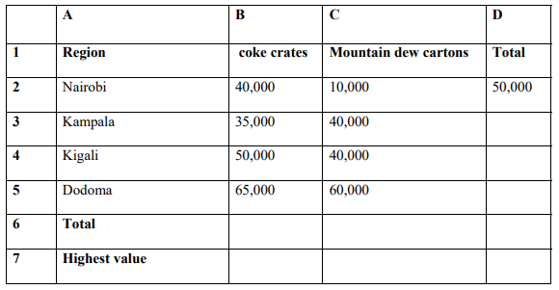
  - Write two different formulae which if placed in C6 will show the total sales figure for the Mountain dew column. (2 Marks)
  - Write a function which if placed in B7 will show the highest sales figure for the coke column. (1 Mark)
  - If the formula placed in cell D2 is copied down the column to cell D5, what will be the formula or function in D5? (2 Marks)
  - Identify the MS Excel feature used to copy the formula used in cell D2 along the range of cells D3:D5. (1 Mark)
  - The data values in columns B and C should be displayed as money amounts. State the formatting operation that you would use to do this. (1 Mark)
QUESTION THREE (15 MARKS)

- Explain the CIA Triad security model (5 Marks)
- Name FOUR components found within the motherboard of a computer (4 Marks)
- Discuss SIX main functions of the Operating System (6 Marks)

QUESTION FOUR (15 MARKS)
- Differentiate between RAM and cache memory (4 Marks)
- Marion was advised to enhance network security by use of firewalls on her computer. Explain two reasons for this advice (4 Marks)
- Explain the function of thesaurus feature used as in used in word processing programs. (2 Marks)
- Give five advantages of information technology and explain how it can help in the economic development of the country. (5 Marks)

QUESTION FIVE (15 MARKS)

- Discuss five ways in which ergonomics can be applied in the academic work
(5 Marks)
- Differentiate between guided media and unguided media. (4 Marks)
- List the technologies that are found in the first four generations of computers. (4 Marks)
- Outline characteristics of each of the following categories of computers;
  - Analog (1 Mark)
  - Hybrid (1 Mark)

