
UNIVERSITY EXAMINATIONS
EXAMINATION FOR JAN /APRIL 2024/2025 FOR BACHELOR OF SCIENCE IN COMPUTER SCIENCE AND BACHELOR OF BUSINESS INFORMATION TECHNOLOGY
RCS 310: Multimedia Systems
DATE _____________ TIME: 2 HOURS
GENERAL INSTRUCTIONS:
Students are NOT permitted to write on the examination question paper during examination time.
This is a closed book examination. Text book/Reference books/notes are not permitted.

SPECIAL INSTRUCTIONS:
This examination paper consists Questions in Section A followed by section B.
Answer Question 1 and any Other Two questions.
QUESTIONS in ALL Sections should be answered in answer booklet(s).

PLEASE start the answer to EACH question on a NEW PAGE.

Keep your phone(s) switched off at the front of the examination room.

Keep ALL bags and caps at the front of the examination room and DO NOT refer to ANY unauthorized material before or during the course of the examination.

ALWAYS show your working.

Marks indicated in parenthesis i.e. ( ) will be awarded for clear and logical answers.

Write your REGISTRATION No. clearly on the answer booklet(s).

For the Questions, write the number of the question on the answer booklet(s) in the order you answered them.
- DO NOT use your PHONE as a CALCULATOR.
- YOU are ONLY ALLOWED to leave the exam room 30minutes to the end of the Exam.
- DO NOT write on the QUESTION PAPER. Use the back of your BOOKLET for any calculations or rough work.

SECTION A (COMPULSORY)
QUESTION 1 (COMPULSORY, 30 MARKS).
a) Using the screenshot of Riara university website as a case study, differentiate between hypertext and hypermedia. (4 Marks)
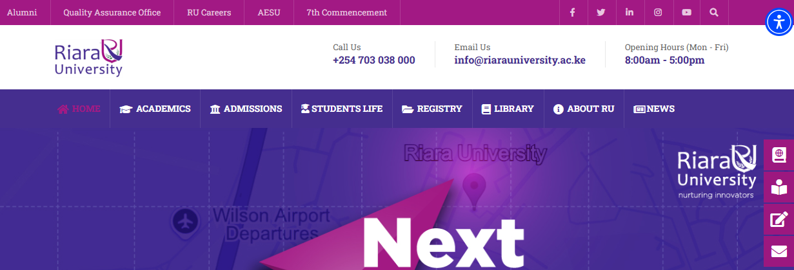
b) Describe the different categories of multimedia and for each category, provide examples of applications for each. (6 Marks)
c) Highlight the importance of video standards in broadcasting and streaming (4 Marks)
d) Discuss the differences between bitmap images and vector images and provide examples of situations where each would be best used in multimedia projects. (6 Marks)
e) Explain the impact of video compression in multimedia highlighting the advantages of video compression for multimedia applications. (4 Marks)
f) Discuss the key features that make a user interface effective in multimedia projects. (6 Marks)

SECTION B (ANSWER ANY TWO QUESTIONS)
QUESTION 2 (15 MARKS)
- Describe the process of creating a digital audio file. Explain the steps involved in recording, editing, and saving an audio file. (5 Marks)
- Highlight the essential features of multimedia hardware. (4 Marks)
- Explain the concept of hybrid systems in multimedia workstations and describe how they differ from traditional systems. (6 Marks)

QUESTION 3 (15 MARKS)
- You are creating an animated video for both mobile viewing and cinema. Describe the factors you would consider when choosing between 2D and 3D animation for these platforms. (8 Marks)
- Discuss the importance of sound editing in multimedia applications. How does sound editing contribute to the quality of multimedia projects? (7 Marks)

QUESTION 4 (15 MARKS)
- Discuss the role of multimedia authoring tools in creating interactive content. Explain four main types of authoring tools and their applications in multimedia production. (8 Marks)
- Explain the concept of human-computer interaction (HCI) in multimedia applications. (3 Marks)
- Discuss the factors that designers need to consider to enhance HCI. (4 Marks)
QUESTION 5 (15 MARKS)
- Discuss how animation can be used in multimedia applications. (2 Marks)
- Provide three examples of real-life multimedia projects that use animation effectively. (6 Marks)
- Explain how the sampling rate affect multimedia data, specifically in audio and video highlighting the considerations that affect the choice of sampling rate. (7 Marks)

