
UNIVERSITY EXAMINATIONS
EXAMINATION FOR MAY/AUGUST 2023/2024 DIPLOMA IN COMPUTER SCIENCE

RCS 031: LINUX.

DATE: 14 /08/2024. TIME: 2 HOURS
GENERAL INSTRUCTIONS:
Students are NOT permitted to write on the examination paper during reading time.
This is a closed book examination. Text book/Reference books/notes are not permitted.
SPECIAL INSTRUCTIONS:
This examination paper consists Questions in Section A followed by section B.
Answer Question 1 and any Other Two questions.
QUESTIONS in ALL Sections should be answered in answer booklet(s).

PLEASE start the answer to EACH question on a NEW PAGE. You will lose 5 MARKS if this is not done.

Keep your phone(s) switched off at the front of the examination room and NOT on your person.

Keep ALL bags and caps at the front of the examination room and DO NOT refer to ANY unauthorized material before or during the course of the examination.

ALWAYS show your working.

Marks indicated in parenthesis i.e. ( ) will be awarded for clear and logical answers.

Write your REGISTRATION No. clearly on the answer booklet(s).

For the Questions, write the number of the question on the answer booklet(s) in the order you answered them.
- Write your REGISTRATION No. clearly on the answer booklet(s).
- DO NOT use your PHONE as a CALCULATOR.
- YOU are ONLY ALLOWED to leave the exam room 30minutes to the end of the Exam.

SECTION A (COMPULSORY).

Question (1) - (30Marks)

- Name five distributions of Linux Operating Systems. (5 marks)

- Define the following terms as used in Operating systems. (5 marks)
- Firmware.
- Directories.
- Proprietary.
- Partitioning.
- Open source.

- Discus the following parts of Linux operating system shown in the diagram below. (8 marks)

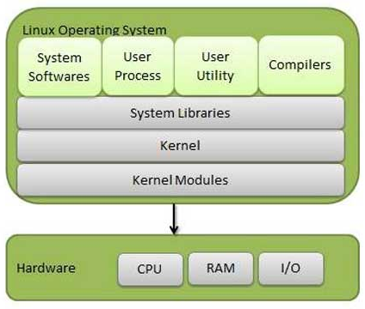

- List Five Linux file systems. (5 marks)

- What is the difference between multi-task and multi-user Operating System. (4 marks)

- What does the following acronym stand for? (3 marks)

- M.B.R.
- B.I.O.S.
- G.R.U.B.

SECTION B (Answer Any Two Questions).
Question (2) - (15 Marks)

- Describe the Linux booting process showing the main procedures involved, until the system is ready for use. (12 marks)

- Which Linux commands would you use in a command line interface to achieve the following tasks? (8 marks)

- Display network information of a host/system.
- Remove directories/folders/file in a system.
- Log into a remote host/system.
- Rename files in a system.
Question (3) - (15 Marks)
- With reference to Linux operating Systems, define shell. (2 marks)

- Name FIVE variations of shells, which have been used in Linux OS. (5 marks)

- Explain why it is importance to create more than one partitions while installing Linux operating systems? (3 marks)

- Why is necessary to defragmenting internal hard disc drive? (2 marks)

- What’s the purpose of Swap partition in the Linux OS system? (2 marks)

- Discus how users and files security, with respect to permissions, is implemented in Linux Operating System. (6 marks)

Question (4) - (15 Marks)
- Linux Operating systems are made up of various directories, describe each of the directories listed below. (12 marks)
- /lib
- /bin
- /opt
- /var
- /dev
- /home

- Discus important features of Linux operating systems that make it the OS of choice by many IT administrators. (5 marks)

- Discus three user based, group permission types to files & directories used in Linux.
(3 marks)
Question (5) - (15 Marks)
- With reference to the figure of Linux kernel architecture shown below, discuss functions of the components listed below. (10 marks)

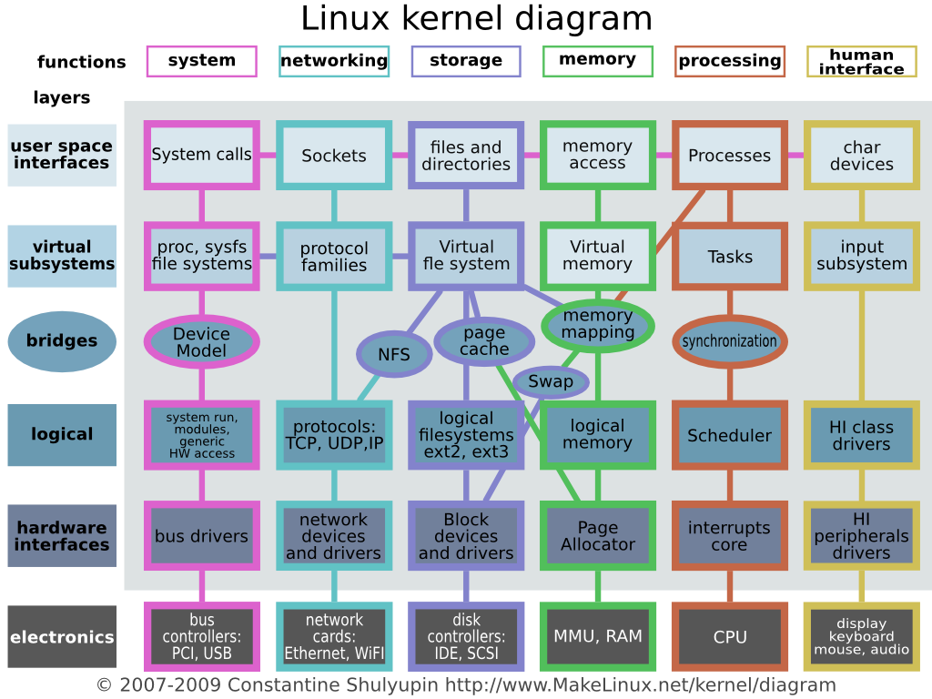

- Swap.
- MMU.
- Sockets.
- Scheduler.
- Page cache.
- SCSI / IDE.
- Directories.
- System calls.
- Interrupt core.
- Virtual memory.
- Logical memory.
- Memory Mapping.

- What is the functions of the following Linux command? (10 marks)

- $ ls
- $ cp
- $ cd
- $ top
- $ pwd
- $ ping
- $ touch
- $ mkdir
- $ chown
- $ killall proc

END

