
UNIVERSITY EXAMINATIONS
EXAMINATION FOR MAY-AUGUST 2020/2021 FOR BACHELOR OF SCIENCE IN COMPUTER SCIENCE
ONLINE EXAMINATION
Course Code: RCS 303 Course Name: WIRELESS NETWORKS

DATE _____________ TIME: 2 HOURS
GENERAL INSTRUCTIONS:
This examination paper consists of Questions that will be done online.
SPECIAL INSTRUCTIONS:
- Your WEBCAM SHOULD BE ON 5 minutes before the start of the exam and during the entire EXAM PERIOD up to submission
- DO NOT use your PHONE as a CALCULATOR.
- Can ONLY LEAVE THE EXAM SESSION once you COMPLETE and SUBMIT the examination.
____________

QUESTION ONE (30 MARKS)
  - Explain the meaning of the following terms in the Wireless Network Systems (WNS):

(i) ZigBee (2 Marks)
(ii) RFID (2 Marks)
(iii) Middleware (2 Marks)

(b) Discuss the main differences between Wireless Information Networks and Wireless Pervasive Networks (4 Marks)
(c) Explain THREE critical issues that should be included in wireless network policy for Riara University’s (RU) effective and efficient operations (Give examples) (6 Marks)
(d) The performance of a wireless network is strongly influenced by two major characteristics: the bandwidth of the network (that is, how many bits/sec it can transport) and the latency (that is, how many seconds it takes for the first bit to get from the client to the server). Compare and contrast TWO examples of services, one that exhibits high bandwidth but also has high latency with one that has both low bandwidth and low latency (4 Marks)

(e) One disadvantage of an IP broadcast subnetting in a wireless network is the capacity wastage when multiple hosts attempt to access the channel at the same time. Discuss how it is possible for a sequence of packets transmitted through a wide area wireless network to arrive at their destination in an order that differs from that in which they were sent in comparison to a local WLAN network (6 Marks)

(f) Describe the FOUR critical differences in physical mediums between Wi-Max, Wi-Fi, Zigbee and Bluetooth wireless networks (4 Marks)

____________

QUESTION TWO (20 Marks)

(a) Using a sketch diagram, define the role and importance of each layer in Wireless Network five layers OSI protocol suite (10 Marks)

(b) Discuss THREE main Wireless Networks applications at RU for the wireless network physical address, network address, and domain name (6 Marks)

(c) Define the applications for the TWO wireless Internet Protocols – UDP and TCP (4 Marks)

____________

QUESTION THREE (20 Marks)

(a) Figure 3.1 is a wireless network project concept for connecting two Riara University (RU) buildings across Mbagathi Road. Compare and contrast THREE challenges you may face when implementing the new project. (include mitigation procedures) (6 Marks)



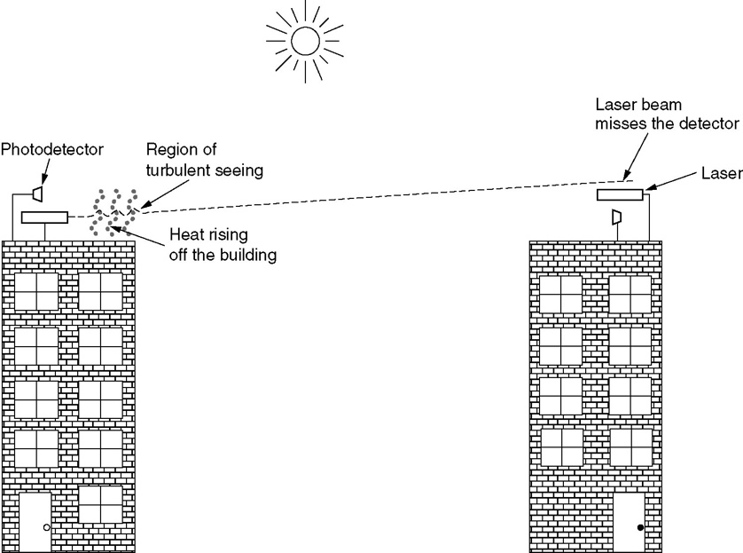
New Campus
Main Campus
Mbagathi Road
Host 2
Host 1

Figure 3.1 New RU Wireless Network Project Design

  - Figure 3.2 is a sample of car-park ticket recently obtained from a mall in Nairobi. Describe FOUR ways in which the car-park management applies wireless network technologies (4 Marks)



Figure 3.2 Park N-Go Car-Part Ticket

(c) In a largely wireless network environment, such as Kenya, where everyone who has a personal mobile device is connected to Internet, instant public referendums on important pending legislation will become possible. Ultimately, existing legislatures could be eliminated to let the will of the people be expressed directly. The positive aspects of such a direct democracy are fairly obvious; discuss FIVE of the negative aspects. (10 Marks)

____________
QUESTION FOUR (20 Marks)

(a Discuss THREE main advantages of wireless network data processing in comparison to the ethernet and/or fibre optic networks (6 Marks)

(b) Discuss two applications for each of these wireless network in resource sharing medium: (6 Marks)
(i) Wireless Access Points
(ii) Wireless Access Routers
(iii) Satellite Communication

(c) Describe how Wi-Fi Wireless Networks implement fault tolerance and recovery processes (4 Marks)

(d) Explain how GSM Wireless Networks manage signal collisions in the data processing (4 Marks)

____________

QUESTION FIVE (20 Marks)

- Explain how a smartphone user who arrives at SGR railway station that s/he has never visited before is capable of using wireless networking with the same device IP Address
(5 Marks)
(b) Discuss how the smartphone user could be provided with information about the local services and amenities at that SGR railway station without entering the station’s name or attributes (10 Marks)
(c) Explain what happens to your device MAC address and the IP address when your wireless device is moved from one WLAN location to another WLAN location (5 Marks)

