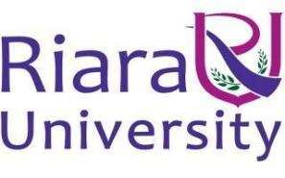
UNIVERSITY EXAMINATIONS
EXAMINATION FOR SEPTEMBER /DECEMBER 2025/2026 FOR BACHELOR OF SCIENCE IN COMPUTER SCIENCE
RBCS 7425: SOFTWARE QUALITY ASSURANCE
DATE: 5TH DECEMBER 2025 TIME: 2 HOURS
GENERAL INSTRUCTIONS:
Students are NOT permitted to write on the examination paper during examination time.
This is a closed book examination. Text book/Reference books/notes are not permitted.
SPECIAL INSTRUCTIONS:
This examination paper consists Questions in Section A followed by section B.
Answer Question all questions in section A and two questions in Section B .
QUESTIONS in ALL Sections should be answered in answer booklet(s).

PLEASE start the answer to EACH question on a NEW PAGE.

Keep your phone(s) switched off at the front of the examination room.

Keep ALL bags and caps at the front of the examination room and DO NOT refer to ANY unauthorized material before or during the course of the examination.

ALWAYS show your working.

Marks indicated in parenthesis i.e. ( ) will be awarded for clear and logical answers.

Write your REGISTRATION No. clearly on the answer booklet(s).

For the Questions, write the number of the question on the answer booklet(s) in the order you answered them.
- DO NOT use your PHONE as a CALCULATOR.
- YOU are ONLY ALLOWED to leave the exam room 30minutes to the end of the Exam.
- DO NOT write on the QUESTION PAPER. Use the back of your BOOKLET for any calculations or rough work.
SECTION A (COMPULSORY)
QUESTION ONE [30 MARKS]
1. Explain the following concepts as applied in software testing:
a) System Testing (2Marks)
b) Regression Testing (2Marks)
c) Alpha Testing (2Marks)
d) Grey Box Testing (2Marks)
e) Test Harness (2Marks)

2. Explain the difference between Quality Control (QC) and Quality Assurance (QA) in the context of software engineering (6 Marks)

3. Software metrics provide a quantitative basis for assessing quality. Briefly explain THREE types of product metrics that can be used as indicators of software reliability and maintainability. (6Marks)

4. Discuss the following key concepts in Software Quality Assurance, highlighting their importance in ensuring software reliability and maintainability:
a) Validation (2Marks)
b) Verification (2Marks)
c) Cost of Quality (CoQ) (2Marks)
d) Coding Standards (2Marks)
e) Static Analysis (2Marks)

QUESTION TWO [15MARKS]
1. The software process provides the framework for managing projects. Describe the FOUR fundamental activities that are common to all software processes, regardless of the project's size or complexity. (7 Marks)

2. The Capability Maturity Model Integration (CMMI) defines a set of process areas. With the aid of a well-labeled diagram, describe t four levels of the CMMI and state one key process focus for each level. (8 Marks)

QUESTION THREE [15MARKS]
1. The figure below shows McCall’s software quality factors. Study it and complete the table.
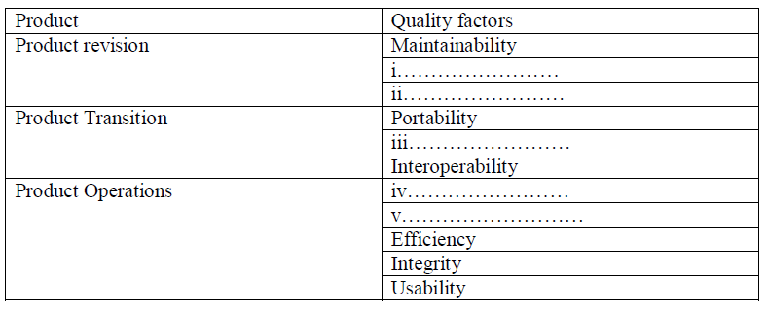
Fill in the gaps in the following definition of software quality with appropriate words:(6 Marks)
"Software quality is defined as conformance to …i…… stated functional and …ii… requirements, explicitly documented development …iii…, and implicit …iv… that all professionally developed software should meet."

3. Formal Technical Reviews (FTRs) are a key SQA activity. Which of the following are NOT recommended guidelines for conducting an effective FTR? Justify your choice. (6 Marks)
a) Focus on discovering errors, not fixing them.
b) Limit debate; don't let it become a problem-solving session.
c) The producer must not speak during the review to remain objective.
d) All review members must have preparatory work checked before the meeting.

4. Software Quality Assurance (SQA) is comprised of several major activities. List THREE key SQA activities beyond technical reviews and testing. (3 Marks)

QUESTION FOUR [15 MARKS]
1. Discuss the FIVE different perspectives (views) of quality as identified by Garvin, which are highly relevant to software products. (5 Marks)

2. Describe the V-Model for software testing. Your description should include a well-labeled diagram and an explanation of how testing phases correspond to development phases. (10 Marks)

QUESTION FIVE [15 MARKS]
1. Describe the Agile Testing process model, highlighting how it differs from traditional testing models and its key principles. (5 Marks)

2. Define the following terms as used in Software Testing: (5 Marks)

a) Test Case
b) Test Oracle
c) Incident
d) Debugging
e) Test Plan

3. Explain the purpose and process of Performance Testing. Describe TWO specific types of performance tests. (5 Marks)

