
UNIVERSITY EXAMINATIONS

EXAMINATION FOR SEPTEMBER/DECEMBER 2023 /2024 FOR DIPLOMA IN COMPUTER SCIENCE / INFORMATION TECHNOLOGY

RCS 017: OBJECT ORIENTED PROGRAMMING C++/JAVA
DATE: 4TH DECEMBER, 2023 TIME: 2 HOURS
GENERAL INSTRUCTIONS:
Students are NOT permitted to write on the examination paper during examination time.
This is a closed book examination. Text book/Reference books/notes are not permitted.

SPECIAL INSTRUCTIONS:
This examination paper consists Questions in Section A followed by section B.
Answer Question 1 and any Other Two questions.
QUESTIONS in ALL Sections should be answered in answer booklet(s).

PLEASE start the answer to EACH question on a NEW PAGE.

Keep your phone(s) switched off at the front of the examination room and NOT on your person.

Keep ALL bags and caps at the front of the examination room and DO NOT refer to ANY unauthorized material before or during the course of the examination.

ALWAYS show your working.

Marks indicated in parenthesis i.e. ( ) will be awarded for clear and logical answers.

Write your REGISTRATION No. clearly on the answer booklet(s).

For the Questions, write the number of the question on the answer booklet(s) in the order you answered them.
- DO NOT use your PHONE as a CALCULATOR.
- YOU are ONLY ALLOWED to leave the exam room 30minutes to the end of the Exam.
- DO NOT write on the QUESTION PAPER. Use the back of your BOOKLET for any calculations or rough work.

SECTION A (COMPULSORY)

QUESTION ONE - COMPULSORY (30 MARKS)

- Define the following terms: (6 Marks)
- Object
- Class
- Object oriented programming.
- With the aid of a diagram, distinguish between base class and derived class as applied in object oriented programming. (4 Marks)
- State 4 advantages of using modules in program development. (4 Marks)
- Java provides a robust and object oriented way to handle exception scenarios. What is an exception? Write a simple Java program to demonstrate handling of arithmetic exception using try and catch mechanism. (6 Marks)
- Explain the following terms employed in Java program. (6 Marks)
- Comments
- Reserved words
- Modifiers
- Explain the difference between primitive and non-primitive data types. (4 Marks)
SECTION B (Answer ANY Two Questions)
QUESTION TWO (15 MARKS)
- Using a suitable example, explain the relationship between superclass and subclass as used in implementing the concept of inheritance in object oriented programming.
(5 Marks)
- Differentiate between the following as used in object oriented programming
- Overriding and overloading (4 Marks)
- Super class and sub class (4 Marks)
- State a single characteristic that identifies an overloaded method? (2 Marks)

QUESTIONS THREE (15 MARKS)
- Define array as used in Java programming. (2 Marks)
- Explain how you declare an array in Java. (4 Marks)

- Shown below is a program that utilizes an array. Interpret it. (4 Marks)

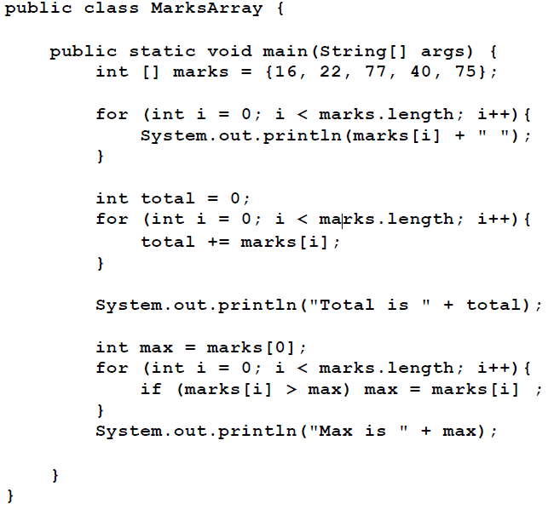
- Write a Java program to output integers 5,10,15,20,25,30,35,40,45,50 using for loop control structure. (5 Marks)

QUESTION FOUR (15 MARKS)

- Briefly describe the following collections as used in Java collections class.
(3 Marks)
- Lists
- Stacks
- Queue
- Explain the function of the following methods used with arrayLists in Java.(6 Marks)
- add(int index, E element)
- get(int index)
- remove(int index)

- Write a Java program that implements a class named NumType with a data member named value and method named read that accepts an integer from the keyboard. The program determines whether the integer is odd or even and displays an appropriate message. Use the if statement. (6 Marks)

QUESTION FIVE (15 MARKS)

- Describe the following terms as used in Graphical User Interface in Java. (5 Marks)
- Events
- Listeners.
- Event handlers
- Event-driven programming.
- Exception Objects.

- Study the following Java program segment and answer the questions that follow.

public class Student {
name;
int age;
String gender;
double IdNo;
public Student(String name) {
this.name = name;
}
public void studAge(int studAge){
age = studAge;
}
public void studGender(String studGender){
gender = studGender;
}
public void studId(double ){
IdNo = studId;
}
public void printStudent(){
System.out.println ("Name: " + name);
System.out.println ("Age: " + age);
System.out.println ("Gender: " + gender);
System.out.println ("Id Number: " + IdNo);
}
}

- Explain two access modifiers used in the program segment. (4 Marks)
- Identify the constructor method (2 Marks)
- Identify any two class methods in the segment. (2 Marks)
- Identify two errors in the program. (2 Marks)

--------------------------- THE END ---------------------------

