
UNIVERSITY EXAMINATIONS
EXAMINATION FOR JANUARY/APRIL 2025/2026 FOR BACHELOR OF SCIENCE IN COMPUTER SCIENCE AND BACHELOR OF BUSINESS INFORMATION TECHNOLOGY
RBCS 7311 : WIRELESS NETWORKS
DATE 14TH APRIL 2026 TIME: 2 HOURS
GENERAL INSTRUCTIONS:
Students are NOT permitted to write on the examination question paper during examination time.
This is a closed book examination. Text book/Reference books/notes are not permitted.

SPECIAL INSTRUCTIONS:
This examination paper consists Questions in Section A followed by section B.
Answer Question 1 and any Other Two questions.
QUESTIONS in ALL Sections should be answered in answer booklet(s).

PLEASE start the answer to EACH question on a NEW PAGE.

Keep your phone(s) switched off at the front of the examination room.

Keep ALL bags and caps at the front of the examination room and DO NOT refer to ANY unauthorized material during the course of the examination.

ALWAYS show your working.

Marks indicated in parenthesis i.e. ( ) will be awarded for clear and logical answers.

Write your REGISTRATION No. clearly on the answer booklet(s).

For the Questions, write the number of the question on the answer booklet cover page in the order you answered them.
- DO NOT use your PHONE as a CALCULATOR.
- YOU are ONLY ALLOWED to leave the exam room 1 hour to the end of the Exam.
- DO NOT write on the QUESTION PAPER. Use the back of your BOOKLET for any calculations or rough work.

SECTION A: Answer ALL questions in this section.

QUESTION ONE (30 Marks)
- Discuss the meaning of following terminologies in relations to Wireless Networks (10 Marks)

- Reliability of Wireless Networks
- Wireless Networks Protocol
- Wireless Network Access Point
- Wireless Networks Middleware
- Wireless Satellite Communications

- Describe the FOUR critical differences between Wi-Max, Wi-Fi, ZigBee and Bluetooth wireless networks (4 Marks)

- Explain THREE critical issues that should be included in organization wireless network policy for effective and efficient deployment (Give examples for each issue stated). (6 Marks)

- One disadvantage of an IP broadcast subnetting in a wireless network is the capacity wastage when multiple hosts attempt to access the channel at the same time. Explain how it is possible for a sequence of packets transmitted through a wide area wireless network to arrive at their destination in an order that differs from that in which they were sent in comparison to a local LAN network (4 Marks)

(e) Starlink satellite technology is an emerging service provision for small office home office (SOHO) in Kenya today. Discuss the THREE main advantages of satellite wireless network data processing in comparison to the access point deployment systems (6 Marks)

SECTION B: Answer any Two questions. Use short answers (30 Marks).

QUESTION TWO (15 Marks)

- The performance of a wireless network is strongly influenced by five major characteristics: the bandwidth of the network (that is, how many bits/sec it can transport) and the latency (that is, how many seconds it takes for the first bit to get from the client to the server). Compare and contrast TWO examples of a network that exhibits high bandwidth but also has high latency with one that has both low bandwidth and low latency
(6 Marks)

(b) Describe how the Wireless Networks implement fault tolerance and recovery processes (4 Marks)

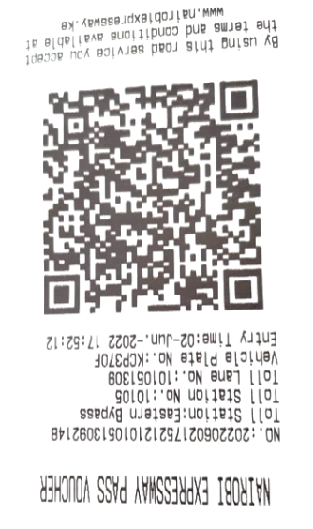
(d) Figure 2.1 below is a sample of a ticket recently obtained from one of the toll stations along the Nairobi Moja Expressway Road services. Describe FIVE ways in which the management have adopted the emerging communication technologies (5 Marks)

Figure 2.1. Nairobi Expressway
Payment Ticket

QUESTION THREE (15 Marks)
- Explain how a smartphone user who arrives at Standard Gauge Railway (SGR) station that s/he has never visited before would be capable of using the same wireless network IP Address without alighting from the SGR coach (5 Marks)

(b) Discuss how the smartphone user could be provided with information about the local services and amenities at that SGR railway station without entering the station’s name or attributes (5 Marks)

(c) In a largely wireless network environment, such as Kenya, where everyone who has a personal mobile device is connected to Internet, instant public referendums on important pending legislation will become possible. Ultimately, existing legislatures could be eliminated to let the will of the people be expressed directly. The negative aspects of such a direct democracy are obvious; discuss the FOUR positive aspects. (5 Marks)

QUESTION FOUR (15 Marks)
(a) Wireless Network devices and services are known to leave traceable digital footprints whenever they have been used. Discuss FIVE ways into which a digital service may be tracked. (include the mitigation procedures) (5 Marks)

(b) Figure 4.1 is a proposal for Wireless Network Project concept designed for connecting an upcoming Riara University (RU) multi-storey SCS Annex Block across the Main Campus. Compare and contrast FOUR challenges your ICT team may face when implementing the new project (7 Marks)
(c) Recommend two practical solutions to improve signal coverage in (b) and justify your choices
(3 Marks)


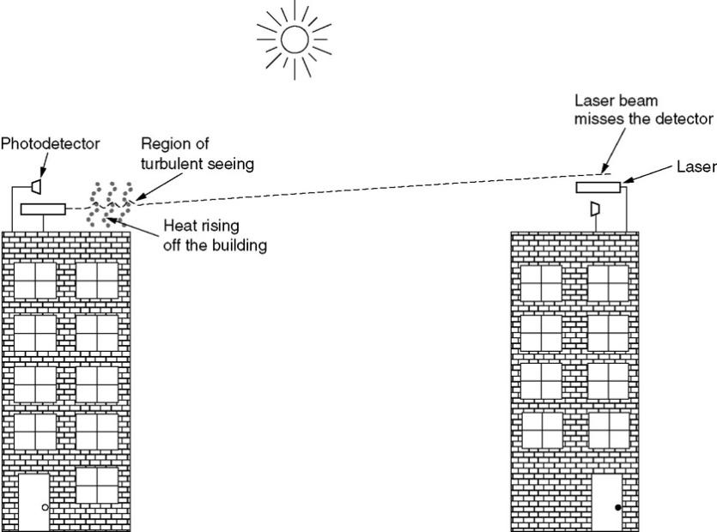
School of Science and Computing
Annex Block
Main RU
Campus
Access Point B
Access Point A
Raila Odinga Road

Figure 4.1 New RU Wireless Network Project Design

QUESTION FIVE (15 Marks)
Case Study 5.1: You are a new wireless network intern with Riara University project team who is aiming to deploy a future-ready, hybrid wireless infrastructure across its proposed 50-hectare Mombasa Campus. The network must support 20,000 concurrent users (students, faculty, and staff), seamless mobility for IoT-enabled smart classrooms and research labs, secure high-bandwidth applications (e.g., VR learning and real-time data analytics), and resilience against urban interference and cyber threats. The project design should leverage a mix of indoor/outdoor coverage, integrate legacy and emerging technologies, and align with national spectrum under Communication Authority of Kenya regulations, and sustainability goals.
(a) Outline the historical evolution of wireless networks from early spectrum allocations to modern applications (e.g., Bluetooth, ZigBee, RFID, WiFi, WiMAX, Cellular, and Satellite). Explain, with examples, how spectrum usage constraints influence technology selection for campus zones such as lecture halls (high density) versus remote research sites (long-range coverage) (5 marks)
(b) Analyze the performance of Wi-Fi technologies (IEEE 802.11 a/b/g/n/ac/ax, including 802.11aa, ab, z, bb, and Li-Fi) and wireless MAC protocols (CSMA/CA, OFDMA, MU-MIMO) in high-density campus scenarios. Compare their strengths and limitations using key metrics such as throughput, latency, and QoS support, and propose an optimal hybrid configuration for academic buildings versus outdoor areas (10 marks)

