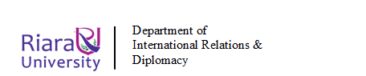
RIARA SCHOOL OF INTERNATIONAL RELATIONS & DIPLOMACY
NURTURING INNOVATORS
SEPTEMBER-DECEMBER 2023 TRIMESTER
FINAL EXAMINATION FOR DIPLOMA PROGRAM
RFC 041: ENVIRONMENTAL SUSTAINABILITY
DATE: 28TH NOVEMBER 2023 DURATION: 2 HOURS
GENERAL INSTRUCTIONS:
- Students are NOT permitted to write on the examination paper during reading time.
- This is a closed book examination. Text book/Reference books/notes are not permitted.
SPECIAL INSTRUCTIONS
- Write your REGISTRATION NO. Clearly on the answer booklet(s).
- Answer Question One and ANY other TWO questions.
- Questions in all sections should be answered in answer booklet(s)
- PLEASE start the answer to EACH question on a NEW PAGE.
- For the questions, write the number of the question on the answer booklet(s) in the order you answered.
- Write on both sides of each leaf and indicate number of each question at the top of each page.
- Write the answers in a paragraph form unless stated otherwise.
- Marks allocated to each question are shown at the end of the question.
- All rough work must be done on the answer booklet and crossed through!
- Use supplementary pages only when you have exhausted those in this book.
- Fasten the supplementary pages to the inside back cover of this booklet.

SECTION A: COMPULSORY (30 MARKS)

QUESTION ONE
- Define the following Terms:
- Environmental Sustainability (2 marks)
- Non-point source pollution (1marks)

- It is said that for sustainable development to materialize it requires the contributions of all stakeholders. Describe, giving examples, the roles of the following key stakeholders:
- Government; (5 marks)
- Private sector; and (5 marks)
- Public (5marks)
- Environmental conflict is one of the key causes of political instability in many regions in the world. In East African region such conflicts have manifested themselves in different border areas, a recent one is shown in the diagram below.
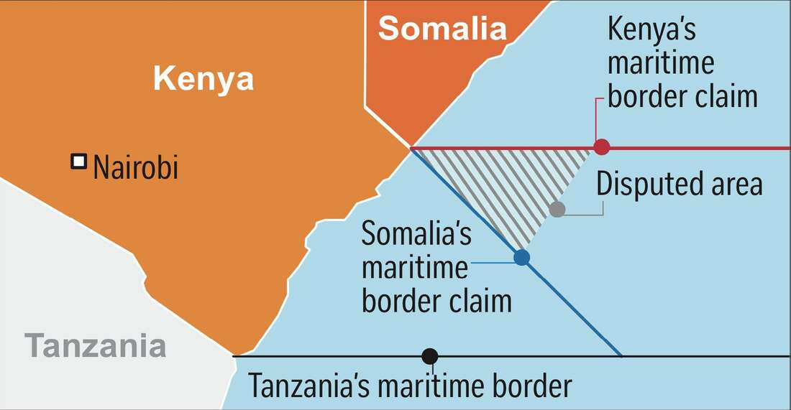
- Categorize the conflict shown in the diagram
(1 mark)
- Explain a major risk Kenya will likely face in regard to the ICJ ruling in the above conflict? (3 marks)
- Assuming the case was not take to ICJ and the two countries agreed to have a bilateral conflict resolution. You were appointed by Kenya as one of the lead in the conflict resolution team for the above conflict, suggest at most three ways of resolving such conflict in order to restore the good diplomatic relations between the two countries
(3 marks)
- Explain factors responsible for waste management crisis in Kenya and how this can be mitigated
(6 marks)

SECTION B: CHOOSE TWO QUESTIONS FROM THIS SECTION (40 MARKS)

QUESTION TWO
Elaborate any FIVE sustainable development goals and highlight the targets of each SDGs
(20 marks)

QUESTION THREE
Environmental Management and Coordination Act has revolutionized environmental management in Kenya in several ways. Explain (20 marks)

QUESTION FOUR
- Densely populated areas are suffering major issues in the field of solid waste and waste water management.
- Relate this statement with the current situation in Kenya (8 marks)

- Suggest any three sustainable methods each for the solid waste and waste water management system (6 marks)

- Explain the significance of carbon footprint and suggest some methods for reducing the carbon footprint of your house ( 6 marks)

QUESTION FIVE
- Discuss the relationship between Law and Environment. (10 marks)
- Suggest and explain five ways in which global south countries can adopt in order to achieve environmental sustainability. (10 marks)

