
UNIVERSITY EXAMINATIONS
EXAMINATION FOR JANUARY/APRIL 2025/2026 MASTERS OF SCIENCE IN COMPUTER SCIENCE

MRDC 9121: STATISTICS FOR DATA SCIENCE I

DATE 9TH APRIL 2026 TIME: 2 HOURS

GENERAL INSTRUCTIONS:
Students are NOT permitted to write on the examination question paper during examination time.
This is a closed book examination. Text book/Reference books/notes are not permitted.

SPECIAL INSTRUCTIONS:
This examination paper consists of FOUR questions. Attempt Any Three Questions.
QUESTIONS selected should be answered in answer booklet(s).

PLEASE start the answer to EACH question on a NEW PAGE.

Keep your phone(s) switched off at the front of the examination room.

Keep ALL bags and caps at the front of the examination room and DO NOT refer to ANY unauthorized material during the course of the examination.

ALWAYS show your working.

Marks indicated in parenthesis i.e. ( ) will be awarded for clear and logical answers.

Write your REGISTRATION No. clearly on the answer booklet(s).

For the Questions, write the number of the question on the answer booklet cover page in the order you answered them.
- DO NOT use your PHONE as a CALCULATOR.
- YOU are ONLY ALLOWED to leave the exam room 1 hour to the end of the Exam.
- DO NOT write on the QUESTION PAPER. Use the back of your BOOKLET for any calculations or rough work.

QUESTION ONE (TWENTY MARKS)
- (i). The regression equation from an analyst’s diary is given as
$$\hat{Y}=26.8+1.48x$$
While the following information was also extracted

Predictor | Coefficient | Standard Error | t-Value
Constant | 26.753 | 2.373
$$x$$ | 1.4756 | 0.1063
Fill in the missing values. (2 Marks)

(ii) From the diary the analysis of variance table was given as

Source | Degrees of freedom | Sums of Squares | Mean Sum of Squares | F-Ratio
Model | 1
Error | 13 | 94.8
Total | 14 | 1500

Fill in the missing values in this table. (3 Marks)
(ii). Can you conclude that the model defined a useful linear relationship?
(use $α=0.05$). (3 Marks)
(iv). What is the estimated variance? (2 Marks)

- Differentiate the following terms as used in regression analysis
- Coefficient of determination and correlation coefficient. (2 Marks)
- Maximum likelihood estimator and least square estimator. (2 Marks)

- State and explain the three assumptions under simple linear regression
(6 Marks)

QUESTION TWO (TWENTY MARKS)
A particular savings and loan corporation is interested in determining how well the amount of money in a family savings account can be predicted using three indicators: annual income, numbers in the family unit and area in which the family lives. Supposed that there are two specific areas of interest to the corporation. The data obtained is as follows, where

$Y=$ amount in all savings account in $ 1000
$x_{1}=$annual income in $1000
$x_{2}=$number in the family unit
$$x_{3}=\left\{\begin{matrix}0 if in area 1 \\ 1 otherwise\end{matrix}\right.$$

$Y$ $x_{1}$ $x_{2}$ $x_{3}$
0.5 19.2 3 0
0.3 23.8 6 0
1.3 28.6 5 0
0.2 15.4 4 0
5.4 30.5 3 1
1.3 20.3 2 1
12.8 34.7 2 1
1.5 25.2 4 1
0.5 18.6 3 1
15.2 45.8 2 1

Given that

$${(X'X)}^{−1}=\left[\begin{matrix}\begin{matrix} 3.6039 & −0.0389 \\ −0.0389 & 0.0016\end{matrix} & \begin{matrix}−0.5574 & −0.9830 \\ 0.0007 & −0.0108\end{matrix} \\ \begin{matrix}−0.5574 & 0.0007 \\ −0.9830 & −0.0108\end{matrix} & \begin{matrix}0.1203 & 0.2152 \\ 0.2152 & 0.8915\end{matrix}\end{matrix}\right]$$

- Fit a multiple linear regression model to this data. (6 Marks)
- Write the analysis of variance. (6 Marks)
- Is the model adequate (take $α=0.05$). (2 Marks)
- Perform a test of significance of the individual parameter at $α=0.05$and comment on your results. (4 Marks)
- Find $R^{2}$ and comment on your results. (2 Marks)

QUESTION THREE (TWENTY MARKS)
The following data was obtained from an investigative research on the velocity of enzymatic reaction, where the substrate was treated with Puromycin at several concentration.

Substrate concentration (ppm) Velocity (counts/min²)
0.02 47
0.06 97
0.11 123
0.22 152
0.56 191
1.10 200

The analysts proposed to use the following model,

$E\left(y_{i}\right)=F\left(x_{i}β\right)=\frac{β_{1}x_{i}}{β_{2}+x_{i}}$

on the data
- Linearize the above model. (4 Marks)
- Using the linearized model above, obtain the parameter estimates.
(14 Marks)
- Are the least square estimator in the transformed model equal to the least square estimates for the original model? Explain. (2 Marks)

QUESTION FOUR (TWENTY MARKS)
- If $E\left(y\right)=Xβ$ ,
- show that $\hat{β}$ is an unbiased estimator of $β$. (3 Marks)
- the covariance matrix of $\hat{β}$ is given by$σ^{2}{(X^{'}X)}^{−1}$. (4 Marks)

- Data on the connection between radioactive waste exposure and cancer mortality was published. The data was collected from 9 counties that were located near an Atomic Energy Commission facility in Hanford, Washington. The data give the index of exposure and the cancer mortality rate during 1959-1964 for nine counties affected. Higher index of exposure values represents higher levels of contamination
Variable description; County Name, Exposure Index and Cancer mortality per 100,000 many years. The data was as follows
County exposure Mortality
1 2.49 147.1
2 2.57 130.1
3 3.41 129.9
4 1.25 113.5
5 1.62 137.5
6 3.83 162.3
7 11.64 207.5
8 6.41 177.9
9 8.34 210.3

Output from fitting the simple linear regression for predicting Mortality from exposure is shown below:

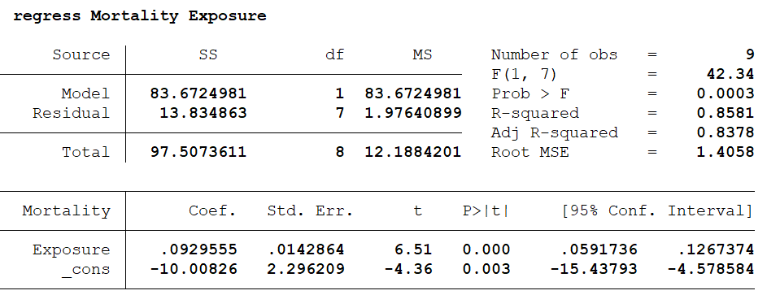

- State the hypothesis for testing the overall model. (1 Mark)
- What is the expected mortality rate for a county with exposure index of 3? (2 Marks)
- Interpret the estimated slope of the fitted model. (2 Marks)
- What is the correlation between mortality and exposure? (2 Mark)
- Is there a significance linear relationship between Mortality and Exposure? Support your comment citing results. (3 Marks)
- Explain the difference between $R^{2}$ and Adjuste $R^{2}$, and justify the value of Adj $R^{2}=0.8378$. (3 Marks)

