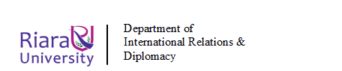

RIARA SCHOOL OF INTERNATIONAL RELATIONS & DIPLOMACY
NURTURING INNOVATORS
SEPTEMBER-DECEMBER 2021 TRIMESTER
EXAMINATIONS FOR DIPLOMA IN INTERNATIONAL RELATIONS & DIPLOMACY
DAY PROGRAMME
RFC 041: ENVIRONMENTAL SUSTAINABILITY
DATE: 29TH NOVEMBER 2021 TIME: 2 HOURS

GENERAL INSTRUCTIONS:
Students are NOT permitted to write on the examination paper during reading time.
This is a closed book examination. Text book/Reference books/notes are not permitted.

SPECIAL INSTRUCTIONS:
1 Write your REGISTRATION NO. Clearly on the answer booklet(s).
2 Answer Question One and ANY other TWO questions.
3 Questions in all sections should be answered in answer booklet(s).
4 Marks allocated to each question are shown at the end of the question.
5 PLEASE start the answer to EACH question on a NEW PAGE.
6 For the questions, write the number of the question on the answer booklet(s) in the order you answered them.
7 Write your answers in paragraph form unless stated otherwise.
8 Keep your phone(s) SWITCHED OFF at the front of the examination room.

9 Keep ALL bags and caps at the front of the examination room and do not refer to any unauthorized material before or during the course of the examination.
10 You are only allowed to leave the examination room 30minutes to the end of the Examination.

SECTION A IS COMPULSORY (30 MARKS):
QUESTION ONE
a) Define the following Terms:
  - Sustainable Development

(2 marks)
  - Environmental Sustainability (2 marks)
  - Pollution (2 marks)
  - Greenhouse effect (2 marks)

- The diagram below shows how the rays of the sun reach different parts of the Earth. Compare the insolation at points A and B (2 marks)
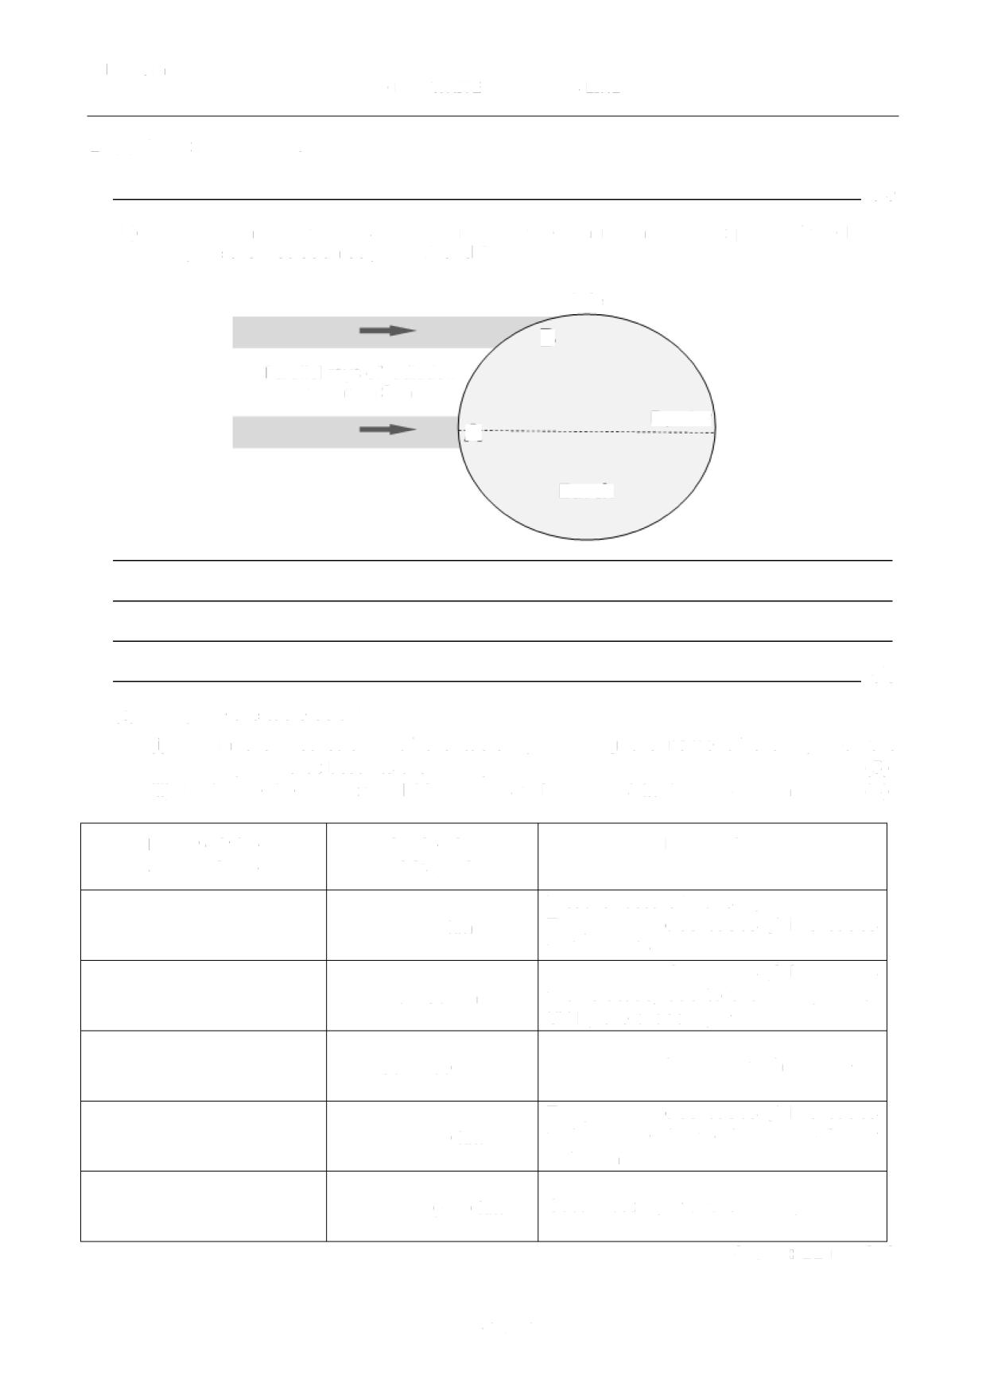
B
Parallel rays of radiation
From the sun
Equator
A
Earth

- As an Environmental expert you have been requested by a promoter to prepare an EIA for an Integrated Resort Scheme (IRS) project consisting of 150 Villas, an 18 Hole International Level Golf Course and a Marina. The project is situated at Watamu at about 100 metres from the Watamu National Marine Park. The area is under coconut, cashew nuts and orange cultivation and there are about 20 artisanal fishermen registered for the region.

- Identify the potential key environmental impacts (positive/negative) that would require further analysis and provide a short description of each impact identified (10 marks)

- What measures could be taken to reduce the negative impacts identified?
(5 marks)

- List FIVE Kenyan environmental regulations that the investor will adhere to and highlight the issues that will be addressed by the respective regulations
(5 marks)
SECTION B: ANSWER ANY TWO QUESTIONS (40 MARKS):

QUESTION TWO
“Development and Environment have long been considered to be contradictory” Discuss
(20 marks)
QUESTION THREE
Explain ways in which covid-19 is shaping Environmental sustainability in Global South countries
(20 marks)
QUESTION FOUR
Explain factors hindering sustainable development in Eastern Africa region
(20 marks)

QUESTION FIVE
- Discuss the relationship between Law and Environment (10 marks)
- Densely populated areas are suffering major issues in the field of solid waste and waste water management. Relate this statement with the current situation in African countries (10 marks)

