
UNIVERSITY EXAMINATIONS
EXAMINATION FOR MAY/AUGUST 2023/2024 FOR BACHELOR OF SCIENCE IN COMPUTER SCIENCE
RCS 207: DATABASE SYSTEMS

DATE: 12TH AUGUST 2024 TIME: 2 HOURS
GENERAL INSTRUCTIONS:
Students are NOT permitted to write on the examination question paper during examination time.
This is a closed book examination. Text book/Reference books/notes are not permitted.

SPECIAL INSTRUCTIONS:
This examination paper consists Questions in Section A followed by section B.
Answer Question 1 and any Other Two questions.
QUESTIONS in ALL Sections should be answered in answer booklet(s).

PLEASE start the answer to EACH question on a NEW PAGE.

Keep your phone(s) switched off at the front of the examination room.

Keep ALL bags and caps at the front of the examination room and DO NOT refer to ANY unauthorized material before or during the course of the examination.

ALWAYS show your working.

Marks indicated in parenthesis i.e. ( ) will be awarded for clear and logical answers.

Write your REGISTRATION No. clearly on the answer booklet (s).

For the Questions, write the number of the question on the answer booklet (s) in the order you answered them.
- DO NOT use your PHONE as a CALCULATOR.
- YOU are ONLY ALLOWED to leave the exam room 1 hour to the end of the Exam.
- DO NOT write on the QUESTION PAPER. Use the back of your BOOKLET for any calculations or rough work.
SECTION A (COMPULSORY)
QUESTION ONE (COMPULSORY, 30 MARKS).
- Study the customers table below and write Sql statements to do the following
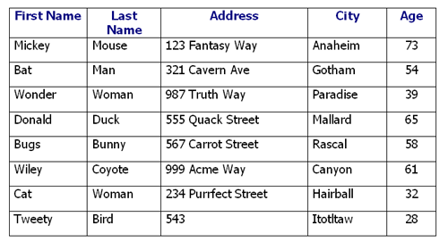
  - To select firstName, address, city for customers living paradise (3 Marks)
  - To select firstName, address, city for customers who don’t live in mallard, whose age is above 50 years (4 Marks)
  - To select firstName, address, city for customers who live in mallard and rascal whose age is between 40 to 60 (4 Marks)
- Introduce a field in the above table that would serve as a primary key (1 Mark)
- List two reasons why normalization is important (2 Marks)
- Explain the term ternary relationship and illustrate such a relationship using a diagram (4 Marks)
- Using a well labeled diagram, describe how end users interact will a database. (4 Marks)
- Explain any FOUR Functions and Service of a DBMS (8 Marks)

SECTION B (ANSWER ANY TWO QUESTIONS)

QUESTION TWO
Case Study
The Kenya Hockey League has many teams, each team has a name, a city, a coach, a captain, and a set of players. Each player belongs to only one team, each player has a name, a position (such as left wing or goalie), a skill level, and a set of injury records. A team captain is also a player. A game is played between two teams (referred to as host_team and guest_team) and
has a date (such as May 11th, 2017) and a score (such as 4 to 2).

Required.
- Draw an entity relationship diagram for the above scenario showing cardinality and participation constraints (6 Marks)
- Draw a logical design of the above system and propose some possible fields (4 Marks)
- Explain the term referential integrity and how it can be implemented by the DBMS in the database schema above. (2 Marks)

- List three different views that would be implemented in such a system assuming that the application will be hosted online. (3 Marks)

QUESTION THREE (15 MARKS)
- Describe the 3 types of SQL Statements giving one example of each (6 Marks)
- Differentiate between the following three terms giving an example for each; candidate key, composite key, foreign key (6 Marks)
- Highlight Three disadvantages of Database Management Systems (3 Marks)

QUESTION FOUR (15 MARKS)
- With the aid of a diagram discuss the ANSI-SPARC Architecture (8 Marks)

- Explain the meaning of the SQL statement below and the expected result for the same
SELECT COUNT(*) AS TotalEmployees FROM Employee; (2 marks)
- Explain the reason why it is not ideal to implement the ER diagram below in a database
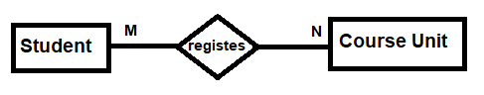 (2 marks)

- Using a diagram demonstrate how you can resolve the above problem (3 Marks)

QUESTION FIVE (15 MARKS)
- Given the scenario below for data extracted from a students’ university records, draw a functional dependency diagram. (6 Marks)
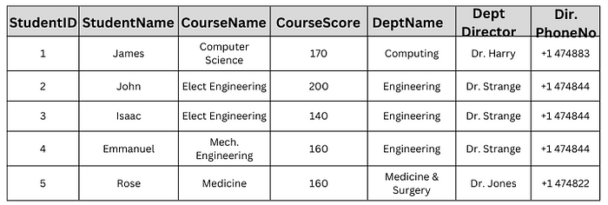
- From the functional dependency diagram, draw a logical schema showing all the field, including the primary and foreign keys. (5 marks)
- Describe the four normal formal forms and what is achieved in each NF. (4 marks)

