
UNIVERSITY EXAMINATIONS
EXAMINATION FOR MAY/AUGUST 2022/2023 FOR DIPLOMA IN INFORMATION TECHNOLOGY/COMPUTER SCIENCE

COURSE CODE: RCS 019
COURSE UNIT: INTRODUCTION TO STATISTICS

DATE: 7th AUGUST, 2023 TIME: 2 HOURS

GENERAL INSTRUCTIONS:
Students are NOT permitted to write on the examination paper during exam time.
This is a closed book examination. Text book/Reference books/notes are not permitted.
SPECIAL INSTRUCTIONS:
This examination paper consists Questions in Section A followed by section B.
Answer Question 1 and any Other Two questions.
QUESTIONS in ALL Sections should be answered in answer booklet(s).

PLEASE start the answer to EACH question on a NEW PAGE.

Keep your phone(s) switched off at the front of the examination room.

Keep ALL bags and caps at the front of the examination room and DO NOT refer to ANY unauthorized material before or during the course of the examination.

ALWAYS show your working.

Marks indicated in parenthesis i.e. ( ) will be awarded for clear and logical answers.

Write your REGISTRATION No. clearly on the answer booklet(s).

For the Questions, write the number of the question on the answer booklet(s) in the order you answered them.
- Scientific CALCULATOR is required. DO NOT use your PHONE as a CALCULATOR.
- YOU are ONLY ALLOWED to leave the exam room 30minutes to the end of the Exam.
- DO NOT write on the QUESTION PAPER. Use the back of your BOOKLET for any calculations or rough work.

SECTION A (COMPULSORY)
QUESTION 1 (30 Marks)
- Define ( 2 Marks)
- Open Data Source
- Consumer Price Index

- The following table shows the lengths of 80 leaves from a particular tree, given to the nearest centimetre
Lengths(cm) | 1-2 | 3-4 | 5-7 | 8-9 | 10-11
No. of leaves(f) | 8 | 20 | 38 | 10 | 4

Draw a cumulative frequency curve and a cumulative frequency polygon. ( 3 Marks)

- A large bag of sweets claims to contain 72 sweets, having a total mass of 852.4g. A small bag of sweets claims to contain 24 sweets, having a total mass of 282.8g. What is the mean mass of all the sweets together? ( 3 Marks)

- Describe the five stages in statistical investigation in the correct order. ( 5 Marks)

- Give three reasons why statistics is important. ( 3 Marks)

- Outline three limitations of statistics (3 Marks)

- Differentiate between: ( 4 Marks)
- Inferential Statistics and Descriptive Statistics
- Chronological and Geographical Data Classification

- State two precautions when using secondary data sources. ( 2 Marks)

- Calculate the median and mode values for the set: {3, 12, 10, 7, 5, 14, 2, 9, 12}
( 2 Marks)

- Describe the output of the Python 3 code segment shown below. Include a diagram.
( 3 Marks)
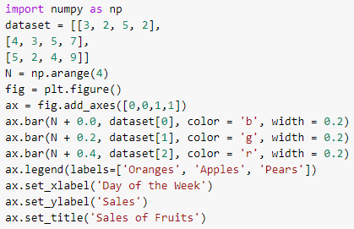

SECTION B (Answer ANY Two Questions)

QUESTION 2 (15 Marks)
- Define and give examples of: ( 2 Marks)
- Statistical fallacy
- Mesokurtic type of Kurtosis

- Describe the two broad classifications of secondary data sources. ( 2 Marks)

- Interpret the following correlation diagram ( 2 Marks)
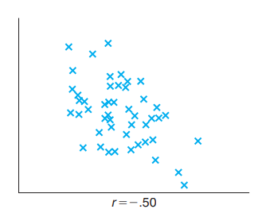

- State two considerations when drawing a bar diagrams. ( 2 Marks)

- Differentiate between: ( 4 Marks)
- Qualitative and quantitative data classification
- read_csv( ) and read_excel( ) as used in Python

- Using Sturge’s rule K=1+3.322log(N) where N is the number of observations, calculate the class interval of the salary of 200 employees in a commercial undertaking in which it varies between Ksh. 400 and Ksh.8, 800.
( 3 Marks)

QUESTION 3 (15 Marks)
- Define ( 3 Marks)
- Sampling Size
- Controlling Bias
- Non-stationary Time Series

- Determine the relative frequency of the following seven scores. ( 3 Marks)
52 17 21 42 16 12 24

- Describe the measures of central tendency in the context of the three types of distributions namely symmetrical, negatively skewed and positively skewed.
( 3 Marks)

- Differentiate ( 4 Marks)
- Correlation and Causation
- summary( ) and describe( ) functions in R and Python respectively

- State a disadvantage of using median in analysing your unit marks at the end of the semester in relation to the other measures of central tendency. ( 2 Marks)

QUESTION 4 (15 Marks)
- Define the following terms. ( 3 Marks)
- Sample Space
- Data Exploration
- Multivariate Time Series Analysis

- Given Mean = 62, Mode =50, Median=67, and Standard Deviation =4.35. Using Pearson’s first or second Coefficient of Skewness, determine if the measure was positively or negatively skewed. ( 3 Marks)

- Determine the standard deviation from the mean of the set of numbers: {30, 34, 26, 24, 29, 53, 55, 40}. ( 3 Marks)

- Distinguish between: ( 4 Marks)
- Positive and negative correlations
- Simple and multiple correlations

- Sketch and interpret the scatter diagram of the following data. ( 2 Marks)
PRICE ( KSH) | COMMODITY DEMAND
3 | 40
4 | 30
5 | 20
6 | 10
7 | 20
8 | 30
9 | 40
10 | 2030

QUESTION 5 (15 Marks)
- Define ( 3 Marks)
  - Continuous Variable
  - Correlation Analysis
  - Time Series Analysis

- Differentiate between Secular Trend and Cyclical Variation time series components
( 2 Marks)

- Find the z-score for a value of 36 for a set of values has a mean of 34 and a standard deviation of 3. ( 2 Marks)

- Describe the following types of sampling. ( 2 Marks)
  - Stratified Sampling
  - Systematic Sampling

- Here is a sample data in an unordered array: 20, 12, 25, 18, 13, 22, 15, 16, 18.
(6 Marks)
Calculate:
- First quartile
- Third quartile
- Interquartile range

