
UNIVERSITY EXAMINATIONS
EXAMINATION FOR MAY-AUGUST 2022/2023 CERTIFICATE INFORMATION TECHNOLOGY
COURSE CODE: RCT 006 - WEB APPLICATIONS
DATE: __________ TIME: 2 HOURS
GENERAL INSTRUCTIONS:
Students are NOT permitted to write on the examination paper during exam time.
This is a closed book examination. Text book/Reference books/notes are not permitted.
SPECIAL INSTRUCTIONS:
This examination paper consists Questions in Section A followed by section B.
Answer Question 1 and any Other Two questions.
QUESTIONS in ALL Sections should be answered in answer booklet(s).

PLEASE start the answer to EACH question on a NEW PAGE.

Keep your phone(s) switched off at the front of the examination room.

Keep ALL bags and caps at the front of the examination room and DO NOT refer to ANY unauthorized material before or during the course of the examination.

ALWAYS show your working.

Marks indicated in parenthesis i.e. ( ) will be awarded for clear and logical answers.

Write your REGISTRATION No. clearly on the answer booklet(s).

For the Questions, write the number of the question on the answer booklet(s) in the order you answered them.
- DO NOT use your PHONE as a CALCULATOR.
- YOU are ONLY ALLOWED to leave the exam room 30minutes to the end of the Exam.
- DO NOT write on the QUESTION PAPER. Use the back of your BOOKLET for any calculations or rough work.

SECTION A (COMPULSORY)
QUESTION ONE (30 Marks)
- Explain Three advantages of wireless network compared to wired computer network. [3 Marks]
- List Five sections that make up a HTML document structure. [5 Marks]
- Write a JavaScript statement that would display your full name on the page document. [2 Marks]
- Explain Five benefits of using internet in businesses . [5 Marks]
- Differentiate between a front-end and a back-end parts of a web application. [2 Marks]
- Explain the following stages during a web application development process
- Analysis,
- Design
- Development,
- Testing and review,
- Deployment,
- Maintenance [6 Marks]
- Explain the use of the following HTML tags.
- <p>
- <hr>
- <table>
- <image>
- <a> [5 Marks]
- Explain Two uses of JavaScript during web application development. [2 Marks]

SECTION B (Answer ANY Two Questions)
QUESTION TWO (15 Marks)
- Explain the following methods of inserting CSS into a web page.
- Internal
- External
- Inline [3 Marks]
- Differentiate between a Domain Name Server and Internet Services Provider [2 Marks]
- Define the following list using the appropriate html tags
- Africa Countries
- Kenya
- Nigeria
- Europe Countries
- England
- Italy [6 Marks]
- Differentiate between rowspan and colspan as used in HTML. [2 Marks]
- Explain the outcome of the following CSS statements
- p{ color : green; }
- a: active { color: orange; } [2 Marks]

QUESTION THREE (15 Marks)
- Explain Five factors you would consider in determining the cost of developing a web application for a client. [5 Marks]
- Define the following table using the appropriate html tags.
Emp No. | Employee Name. | Department | Net Salary
1000 | Peter | HR | 60000
1001 | Joyce | Sales | 45000
[3 Marks]
- Differentiate between ID and Name selectors in CSS. [2 Marks]
- List Three looping control structures in programming. [3 Marks]
- State Two layout overflow options in CSS. [2 Marks]

QUESTION FOUR (15 Marks)
- Differentiate between relative path name and absolute path name. [2 Marks]
- List Five input elements you can place on a HTML form. [5 Marks]
- Differentiate between do while and while loop control structures. [2 Marks]
- Write a CSS script that makes the font color of a heading 2 to be red and aligned at the center. [2 Marks]
- Explain Four benefits of having an application running on the web compared to desktop-based applications. [4 Marks]
QUESTION FIVE (15 Marks)
- List Any Four JavaScript events through which JavaScript code can be executed. [4 Marks]
- Differentiate between logical and comparison operators in JavaScript [2 Marks]
- Explain the uses of comments in programming. [2 Marks]
- Write HTML script that would generate the form below

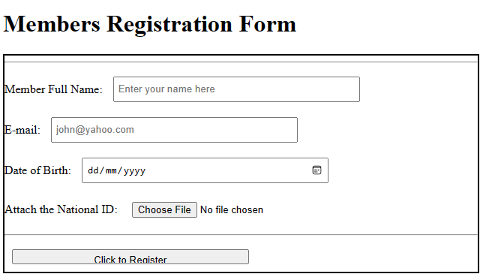
[5 Marks]
- Differentiate between a local and a global variable scope. [2 Marks]

