
UNIVERSITY EXAMINATIONS
EXAMINATION FOR MAY/AUGUST 2021 FOR DIPLOMA IN COMPUTER SCIENCE
RCS 034 INTRODUCTION TO MOBILE COMPUTING
DATE: 2ND AUGUST 2021 TIME: 2 HOURS
GENERAL INSTRUCTIONS:
Students are NOT permitted to write on the examination paper during exam time.
This is a closed book examination. Text book/Reference books/notes are not permitted.

SPECIAL INSTRUCTIONS:
This examination paper consists Questions in Section A followed by section B.
Answer Question 1 and any Other Two questions.
QUESTIONS in ALL Sections should be answered in answer booklet(s).

PLEASE start the answer to EACH question on a NEW PAGE.

Keep your phone(s) switched off at the front of the examination room and NOT on your person.

Keep ALL bags and caps at the front of the examination room and DO NOT refer to ANY unauthorized material before or during the course of the examination.

ALWAYS show your working.

Marks indicated in parenthesis i.e. ( ) will be awarded for clear and logical answers.

Write your REGISTRATION No. clearly on the answer booklet(s).

For the Questions, write the number of the question on the answer booklet(s) in the order you answered them.
- DO NOT use your PHONE as a CALCULATOR.
- YOU are ONLY ALLOWED to leave the exam room 30minutes to the end of the Exam.
- DO NOT write on the QUESTION PAPER. Use the back of your BOOKLET for any calculations or rough work.

Section A
Question One (30 Marks)
- You have been have hired to create a mobile application for Riara University. Explain which mobile development technique you would use. (4 marks)
- Using examples explain any three main obstacles that occur in mobile communications? (6 marks)
- Outline the importance of the information that is stored on a SIM card. (6 marks)
- Explain the following snippet of code in detail. (6 marks)
public View getView(int position, View convertView, ViewGroup parent) {
View gridViewAndroid;
LayoutInflater inflater = (LayoutInflater) mContext.getSystemService(Context.LAYOUT_INFLATER_SERVICE);
if(convertView == null) {
gridViewAndroid = new View(mContext);
gridViewAndroid = inflater.inflate(R.layout.gridview_layout, null);
TextView textViewAndroid = (TextView) gridViewAndroid.findViewById(R.id.android_gridview_text);
ImageView imageViewAndroid = (ImageView) gridViewAndroid.findViewById(R.id.android_gridview_image);
textViewAndroid.setText(gridViewString[position]);
imageViewAndroid.setImageResource(gridViewImageId[position]);
}
else{
gridViewAndroid = (View) convertView;
}
return gridViewAndroid;
}}
- (i) What is the primary goal of GSM? (2 Marks)
(ii) Outline any three security services offered by GSM. (4 marks)

- Using examples differentiate context aware computing and human computer interaction. (HCI) (2 marks)

SECTION B (OPTIONAL 2 OUT OF 4)
Question Two (20 marks)
- Explain the android development snippet of code that is shown below? (5 marks)

protected void onCreate(Bundle savedInstanceState) {
super.onCreate(savedInstanceState);
setContentView(R.layout.gridview_image_text_example);

CustomGridViewActivity adapterViewAndroid = new CustomGridViewActivity(GridViewImageTextActivity.this, gridViewString,gridviewImageId);
androidGridView = (GridView)findViewById(R.id.grid_view_image_text);
androidGridView.setAdapter(adapterViewAndroid);
androidGridView.setOnItemClickListener(new AdapterView.OnItemClickListener() {

@Override
public void onItemClick(AdapterView<?> parent, View view,
int i, long id) {
Toast.makeText(GridViewImageTextActivity.this, "GridView Item: " + gridViewString[+i], Toast.LENGTH_LONG).show();
}
});
- Explain in detail the architecture in the figure below: (5 marks)
Context Input
Explicit Input
Context Aware Application
Explicit Output

- Explain the uber application using the Context-Aware applications and explain how it works with reference to the context aware application stack by identifying the five layers in the stack and explaining the function of each layer. (10 marks)

Question Three (20 marks)
- What is a “distributed system”? (2 marks)
- Explain the following challenges of distributed systems. . (8 marks)
  - Heterogeneity
  - Openness
  - Security
  - Scalability
- Why is multiplexing in Mobile computing? (4 marks)
- Explain any three multiplexing techniques using illustrations. (6 marks)
Question Four (20 marks)
- Identify the cellular systems generations and outline the main characteristics of each.
(4 marks)
- Outline three advantages of a cellular system? (3 marks)
- Explain the functions of the cellular components represented in the figure below.
(6 marks)
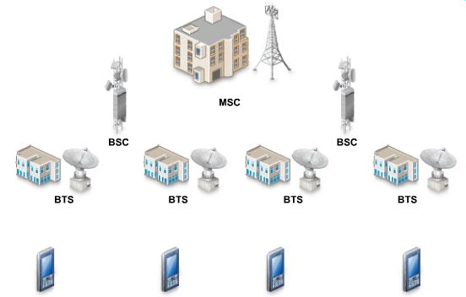
- D. Outline two differences between GSM and CDMA technology. (4 marks)
- E. Explain the following terms: (3 marks)
  - SIM
  - IMEI
  - IMSI

Question Five (20 marks)
- What do the following directories in the resource folder hold: (5 marks)
- Drawable/
- Color/
- Anim/
- Menu/
- Layout/
- Using an illustration differentiate relative layout from linear layout. (4 marks)
- Explain the components in the simple XML layout outlined below: (6 marks)
<?xml version="1.0" encoding="utf-8"?>
<LinearLayout xmlns:android="http://schemas.android.com/apk/res/android"
android:layout_width="match_parent"
android:layout_height="match_parent"
android:gravity="center_horizontal"
android:orientation="vertical">
<ImageView
android:id="@+id/android_gridview_image"
android:layout_width="50dp"
android:layout_height="50dp"
android:layout_marginTop="15dp" />
<TextView
android:id="@+id/android_gridview_text"
android:layout_width="wrap_content"
android:layout_height="wrap_content"
android:layout_marginTop="5dp"
android:textSize="12sp" />
</LinearLayout>
- Define the term “ transmission media” (1 marks)

- Outline two advantages and two disadvantages of wireless communication. (4 marks)

