

RIARA SCHOOL OF INTERNATIONAL RELATIONS & DIPLOMACY
NURTURING INNOVATORS
SEPTEMBER–DECEMBER 2024 TRIMESTER
EXAMINATIONS FOR BACHELOR OF ARTS IN INTERNATIONAL RELATIONS & DIPLOMACY
DAY PROGRAMME
RFC 041: ENVIRONMENTAL SUSTAINABILITY
DATE: 7TH DECEMBER, 2024 TIME: 2 HOURS

GENERAL INSTRUCTIONS:
Students are NOT permitted to write on the examination paper during reading time.
This is a closed book examination. Text book/Reference books/notes are not permitted.

SPECIAL INSTRUCTIONS:
1 Write your REGISTRATION NO. Clearly on the answer booklet(s).
2 Answer Question One and ANY other TWO questions.
3 Questions in all sections should be answered in answer booklet(s).
4 Marks allocated to each question are shown at the end of the question.
5 PLEASE start the answer to EACH question on a NEW PAGE.
6 For the questions, write the number of the question on the answer booklet(s) in the order you answered them.
7 Write your answers in paragraph form unless stated otherwise.
8 Keep your phone(s) SWITCHED OFF at the front of the examination room.

9 Keep ALL bags and caps at the front of the examination room and do not refer to any unauthorized material before or during the course of the examination.
10 You are only allowed to leave the examination room 30minutes to the end of the Examination.

SECTION A: ANSWER ALL QUESTIONS IN THIS SECTION (30 MARKS)
QUESTION ONE
- Define the following Terms:
i) Environmental Sustainability (1^{1/}₂ marks)
ii) Point source pollution (1^{1/}₂ marks)
- Differentiate the following terms
- Development and sustainable Development (2 marks)
- Biotic and Abiotic components of environment ( 2 marks)

- Environmental conflict is one of the key causes of political instability in many regions in the world. In East African region such conflicts have manifested themselves in different border areas, an example of one is shown in the diagram below.
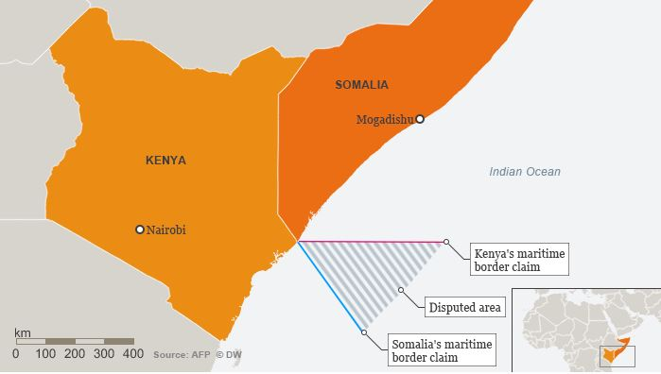
- Name the type of environmental conflict shown in the diagram above
(1 mark)
- You have been appointed by Kenya as one of the arbitrators in the resolution committee for the above conflict, suggest at most three ways of resolving such conflict without compromising the good diplomatic relations that exists between the two countries
( 6 marks)

- Environmental Management and Coordination Act of 1999 in Kenya gave forth to several environmental regulations in Kenya since its enactment in 1999 for environmental protection and conservation.
State and explain three of these regulations that are helping Kenya in achieving environmental sustainability (6 marks)

- ‘International investors have hired expert to conduct Environmental Impact Assessment for an Integrated Resort Scheme (IRS) project consisting of 150 Villas, an 18 Hole International Level Golf Course and a Marina. The project is situated at Watamu at about 100 metres from the Watamu National Marine Park. The area is under coconut, cashew nuts and orange cultivation and there are about 20 artisanal fishermen registered for the region.

- Identify the potential key environmental impacts that would require further analysis and provide a short description of each impact identified.
(10 marks)

SECTION B- ANSWER ANY TWO QUESTIONS (40 MARKS)

QUESTION TWO
As a major sector in the economy, the hotel sector accounts for a significant amount of the overall resource consumption and generates a substantial portion of waste to the environment.
Critically propose five suitable waste minimization techniques which hotel operators should adopt to mitigate the pressure on the environment. Use relevant examples to illustrate your answer ( 20 marks)

QUESTION THREE
- Complete the table below.
- Fill in the first column of the table by inserting the name of the layer of the atmosphere that best fits the description. (5 marks)
- Underline the correct word (decreases or increases) in the last column.
(3 marks)

Layer of the  atmosphere | Altitude above  Earth's surface | Properties
 | 0 - 10 km | Weather occurs in this layer. Temperature decreases / increases  with altitude.
 | 10 - 50 km | Temperature decreases / increases with altitude, due to the absorption of  UV by the ozone layer.
 | 50 - 100 km | Temperature decreases with altitude.
 | 85 - 500 km | Temperature decreases / increases with altitude, due to absorption of solar  radiation.
 | 500 - 10,000 km | Outermost layer of the atmosphere.

- Discuss the relationship between environment and poverty (12 marks)

QUESTION FOUR
- “Development and Environment have long been considered to be contradictory” Justify (10 marks)
- Explain ways in which covid-19 shaped Environmental sustainability in the world (10 marks)
QUESTION FIVE
- Evaluate five factors hindering sustainable development in Eastern Africa region (10 marks)
- Using suitable examples, examine the role of the UN Environment in environmental sustainability (10 marks)

