
UNIVERSITY EXAMINATIONS

EXAMINATION FOR MAY/AUG 2020/2021 DIPLOMA IN COMPUTER SCIENCE/DIPLOMA IN INFORMATION TECHNOLOGY/DIPLOMA IN BUSINESS INFORMATION TECHNOLOGY

RCS 011, RIT 012, RBM 010 & RCT 001: INTROUCTION TO INFORMATION TECHNOLOGY / FUNDAMENTALS OF COMPUTING

DATE: 11TH AUGUST 2021 TIME: 2 HOURS

GENERAL INSTRUCTIONS:
Students are NOT permitted to write on the examination paper during exam time.
This is a closed book examination. Text book/Reference books/notes are not permitted.

SPECIAL INSTRUCTIONS:
This examination paper consists Questions in Section A followed by section B.
Answer Question 1 and any Other Two questions.
QUESTIONS in ALL Sections should be answered in answer booklet(s).

PLEASE start the answer to EACH question on a NEW PAGE.

Keep your phone(s) switched off at the front of the examination room.

Keep ALL bags and caps at the front of the examination room and DO NOT refer to ANY unauthorized material before or during the course of the examination.

ALWAYS show your working.

Marks indicated in parenthesis i.e. ( ) will be awarded for clear and logical answers.

Write your REGISTRATION No. clearly on the answer booklet(s).

For the Questions, write the number of the question on the answer booklet(s) in the order you answered them.
- DO NOT use your PHONE as a CALCULATOR.
- YOU are ONLY ALLOWED to leave the exam room 30minutes to the end of the Exam.
- DO NOT write on the QUESTION PAPER. Use the back of your BOOKLET for any calculations or rough work.

SECTION A

QUESTION ONE COMPULSORY (30 MARKS)
- Define a computer. (2 Marks)
- Distinguish between data and information. (4 Marks)
- Explain two advantages of using an application suite. (4 Marks)
- Explain five functions of system software. (10 Marks)
- Atieno is in the process of creating a chart using a spreadsheet software. State four types of charts she can create depending on her needs. (4 Marks)
- Peter was trying to print a letter on a letterhead. Unfortunately, part of his letter was printed on top of the pre-printed portion of the letterhead. Explain how Onyango would deal with the problem. (6 Marks)

SECTION B (ANSWER ANY 2 QUESTIONS)

QUESTION TWO (20 MARKS)
- State six functions available in spreadsheet software. (6 Marks)
- You want to underline a sentence. Your insertion point is within the sentence but when you click the underline button, only one word is underlined. Explain the reason for this and show how the problem can be corrected. (4 Marks)
- Mary, a computer student intends to send a common letter to many recipients. Describe two documents in a word processing program that he must create in order to achieve his objective. (6 Marks)
- You have created a 100-page report in word and you intend to apply different formats to different parts of the document. Explain how you will achieve this objective. (4 Marks)

QUESTION THREE (20 MARKS)
- A Payroll consists of Basic Pay, Allowances, Gross Salary, Deductions and Net Salary. The Allowances are 23% of the Basic Pay while the Deductions are 12% of the Gross Salary.

Copy the given worksheet and indicate in each cell what will be inserted, that is - a value or a formula. In the case of a formula, write down the formula in the cell using cell references only. (10 Marks)
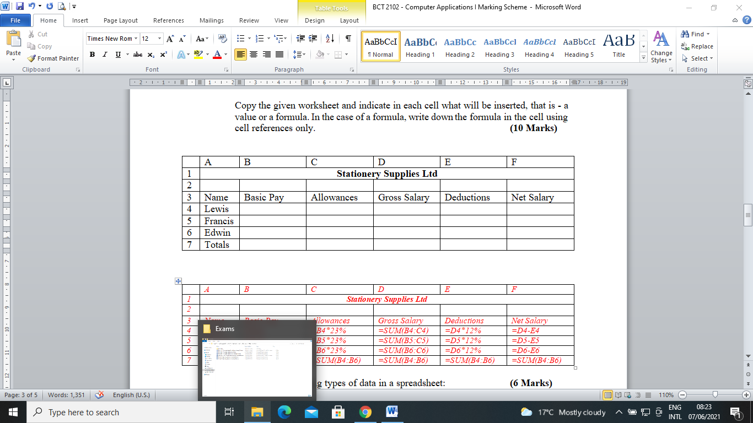
- The following worksheet is an extract from a spreadsheet. Use it to answer the questions that follow.
 | A | B | C | D | E
1 | ABC Construction Company
2 | Building Construction Material
3 | Item Name | Quantity | Cost per Item | Total Cost | Remark
4 | Cement | 100 | 750
5 | Nails | 40 | 120
6 | Timber | 1000 | 15
7 | Metallic Doors | 30 | 2500
8 | Metallic Windows | 80 | 1500
9

- Using cell references only, write a formula that would be used to compute each of the following
    - Total cost of cement (2 Marks)
    - Total cost of all items (2 Marks)
- Given that any item whose quantity is below 100 is assigned a “Reorder” otherwise “Ok” remark, write a formula using cell references only that would assign the correct remark for cement. (6 Marks)

QUESTION FOUR (20 MARKS)

Outline the steps required to complete the mail merge process. (6 Marks)

Explain three advantages of using spreadsheet applications. (6 Marks)

Distinguish between footnotes and endnotes as used in word processing applications. (4 Marks)

Find the binary equivalent of the decimal number 10.625. Show your workings. (4 Marks)

QUESTION FIVE (20 MARKS)

Explain the purpose of a table of index in a word document. (2 Marks)

Describe the process of creating such a table in a word document. (6 Marks)

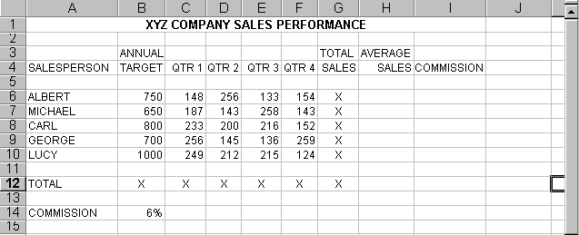Refer to the worksheet below as you answer the questions that follow.

- Use cell references to write the formula you would use to calculate the average sales for Albert. (2 Marks)
- Use cell references to write the formula you would use to calculate the commission for Albert and show how the formula can be copied correctly to get commissions for Michael, Carl, George and Lucy. (4 Marks)
- You are asked to compare QTR 1 and QTR 3 sales for all salespersons in the above table using a chart:
- Identify the range you will use and explain how you would select it. (4 Marks)
- State the type of graph you would use. (2 Marks)

END OF EXAM

